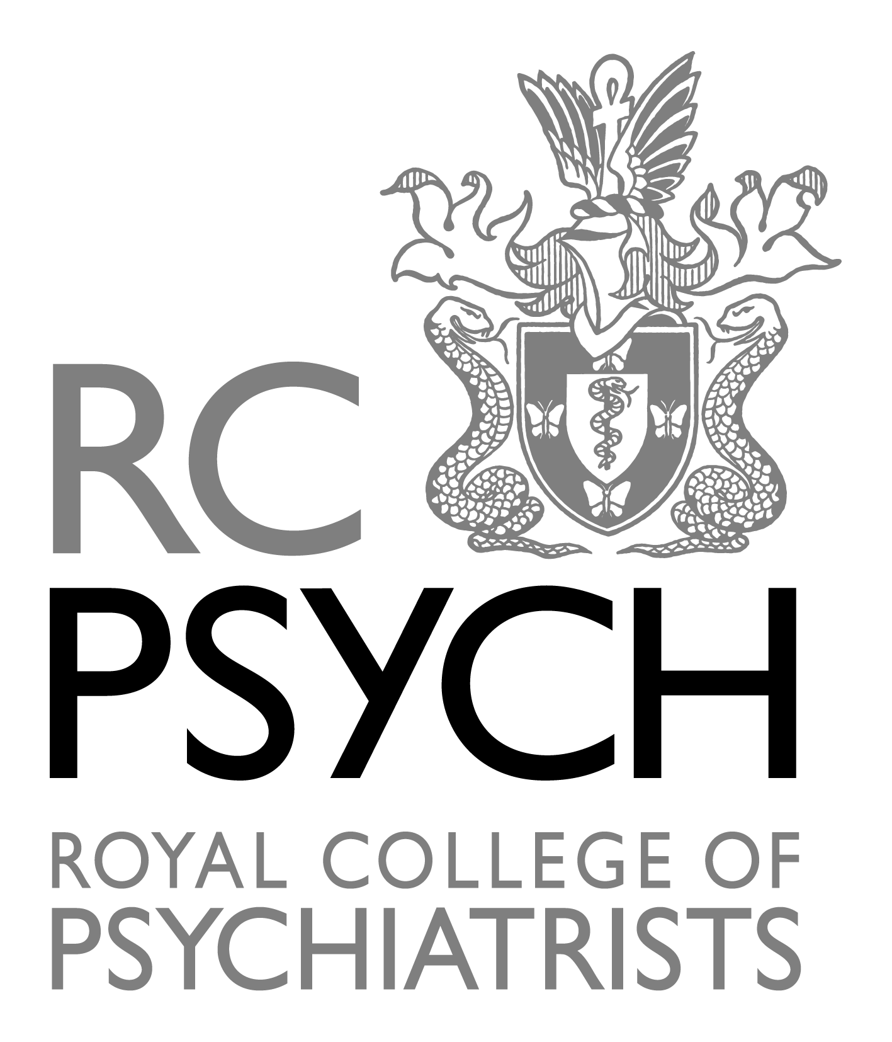

South Eastern Division
Foundation Year and Medical Student Poster Prize Spring 2024

Open to all Foundation Year Doctors and Medical Students working or studying in the South Eastern Division, who are Affiliates or Members of the Royal College of Psychiatrists.

You are invited to submit a poster and abstract on any area of psychiatry.

A limited number of posters will be chosen to be displayed at the Spring Meeting on Wednesday 8 May 2024 and the abstract printed in the Programme and Abstracts Booklet. Posters must not exceed 750 mm x 1000 mm – portrait.

A maximum of 20 posters will be considered for the competition and these will be allocated on a first-come-first-served basis. Only 1 poster may be submitted per applicant.

Please send your entry form and abstract by Wednesday 17th April 2024 to Gareth Griffiths via email: gareth.griffiths@rcpsych.ac.uk

You can become an Affiliate Member by going to:
Foundation Year Doctors –
https://www.rcpsych.ac.uk/become-a-psychiatrist/foundation-drs/foundation-doctor-associates?searchTerms=foundation%20associate

Medical Students
https://www.rcpsych.ac.uk/become-a-psychiatrist/med-students/becoming-a-student-associate

Entry form and regulations attached

Foundation Year and Medical Student Poster Prize Regulations

South Eastern Division

- The South Eastern Division Foundation and Medical Student Poster Prize (FYMS) will be awarded annually on the occasion of the South Eastern Division Spring or Autumn meeting. It will take the form of a competition in which medical students and foundation doctors will be invited to submit a poster and an abstract. The selected posters will be displayed at the annual Spring or Autumn Conference and their respective abstracts published in the Programme and Abstracts Booklet. This should be on any aspect of psychiatry e.g. a piece of research being undertaken, a new research project about to start, service development or an audit. The number of posters will be limited to 20 and these will be selected from those which qualify according to the date of their arrival at the Division Office.
- A prize of £200 and prize certificate will be award to the overall winner and, if applicable, a £200 prize and certificate to the presentation demonstrating greatest Innovation/Service Improvement. Certificates for 2nd and 3rd place will be issued.
- All entrants must be Student Associates or Members of the Royal College of Psychiatrists on the closing date and working or studying within the South Eastern Division area on the date of submission.
- All entrants must be explicit in the abstract about their contribution to the submitted work and that of all other names contributors. Presenters must have made a substantial contribution to the work to qualify for selection. Only one poster may be submitted per applicant.
- There is an expectation that anyone submitting an application will be able to attend the Conference and be available pre the event, and during the day to speak to the Judges. All selected entrants (up to two per submission) must pay to register for the Conference though there are 5 free places available on a first come first served basis. Where no authors are available to present, the poster will be withdrawn from the competition.
- Entries will be assessed by a panel of three judges, at least one of whom will be a member of the Executive Committee. Applicants must be available on the day to discuss their submission with the judges.
- Posters must take the form of sheets which fit on to a display board no larger than 750mm x 1000mm – portrait.
- Abstracts should be produced on 1 sheet of A4, 2.5cm margins in Arial 12pt typeface. Handouts which mirror the poster presentation but give greater detail may be displayed by the poster on the day (it is the entrants responsibility to supply and transport all handouts).
- The areas marked will be (1) Scientific content, (2) Innovative ideas, (3) Methodology, (4) Clinical application and (5) Quality of presentation.
- The prize(s) will be awarded only if, in the opinion of the judges, at least one entry is of a sufficient standard to merit the prize.
- The judges’ views will be final. The judges will not be available for correspondence with entrants on any subject related to the assessment of entries.
- Winners will be expected to give a 5 minute presentation during the meeting. All agreed submissions must have this prepared in case they are winners.

Royal College of Psychiatrists - South Eastern Division
Foundation and Medical Student Poster Prize
Entry Form Spring 2024

Name _____________________________________________________

Address____________________________________________________

___________________________________________________________

Contact telephone number _____________________________________

Email address _______________________________________________

Royal College of Psychiatrists Membership/Student Associate number ________

Name of Contributor who will present with you __________________________

Foundation Doctors

Job Title ________________________________________________________

Based at ________________________________________________________

Medical Students

I am studying at ______________________________________Medical School

Declaration

- I understand that, if I am chosen to present, I must comply with the attached regulations and submit my abstract by email to gareth.griffiths@rcpsych.ac.uk by Wednesday 22 April 2024

- I confirm I have played a major part in the research I am presenting

- I confirm that, if chosen to present, I will be available on 8 May 2024 to discuss my/our entry with the competition Judges

Signed _______________________ Date: __________________________

Email: gareth.griffiths@rcpsych.ac.uk

