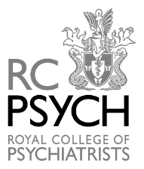

OBITUARIES

COUNCIL MEETING – 6 October 2023

(Since the Council meeting on the 7 July 2023)

Ademola, Adedolapo Adeniyi
Member

Belas, Reginald John
Fellow ~ Over 40 Years member

Doig-Inglis, Lynne Louise
Affiliate

Earp, James Daniel
Member

Hanna, Gabra Elea Gabra
Member

Mohamed, Mohamed Bahgaat
Member

Titievskii, Alexei Vladimirovich
Specialist Associate

