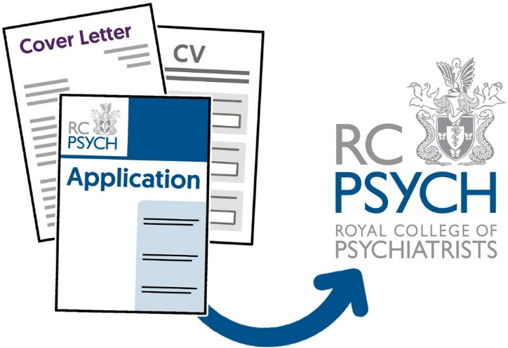
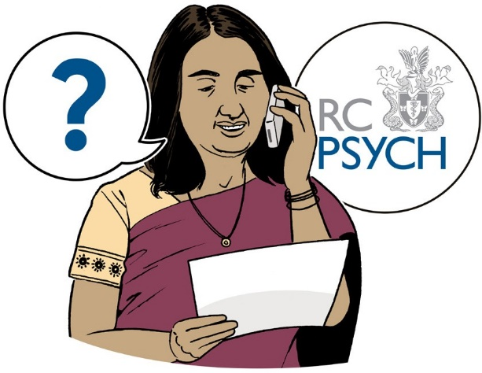

Application form

easy read

Please fill out this form and then send it to us with your cover letter, CV, and diversity monitoring form.

Send them in an email to:
HRrecruitment@rcpsych.ac.uk
Or send by post to:
21 Prescot Street, London,
E1 8BB

If you have any questions you can call us on:
0208 618 4000

1
1

2

This is the job you are applying to do. This section is filled out by the employer.
Position applied for

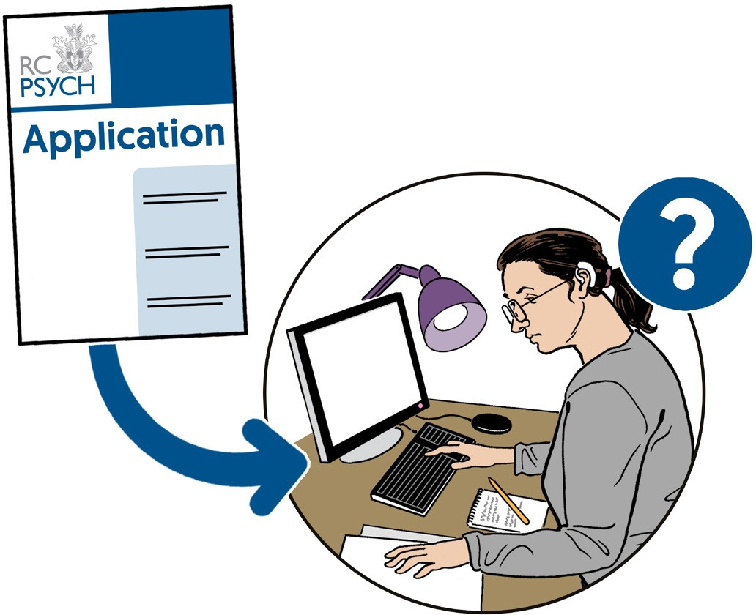

Position
Extra information
Head of Quality Improvement

35 Hours per week

Location: London

Working Pattern: Hybrid

Permanent
£59,274 - £65,158 per annum
Length of contract
Pay

3

Fill in this section with your personal information. It asks for your name, address, and ways to contact you.
Personal details

Title (Mr/Miss/Mrs/Ms)
First name
Last name
Address
Postcode
Mobile phone number
Home phone number
Email address

4
Please fill in this section with
details of where you work now. If you do not have a job now you do not need to fill this section in.
This section asks for your notice period. This is the time between telling your employer you want to leave your job and your last
day. This is often 2 weeks.
Employment record

Employer
My job
Job address
Postcode

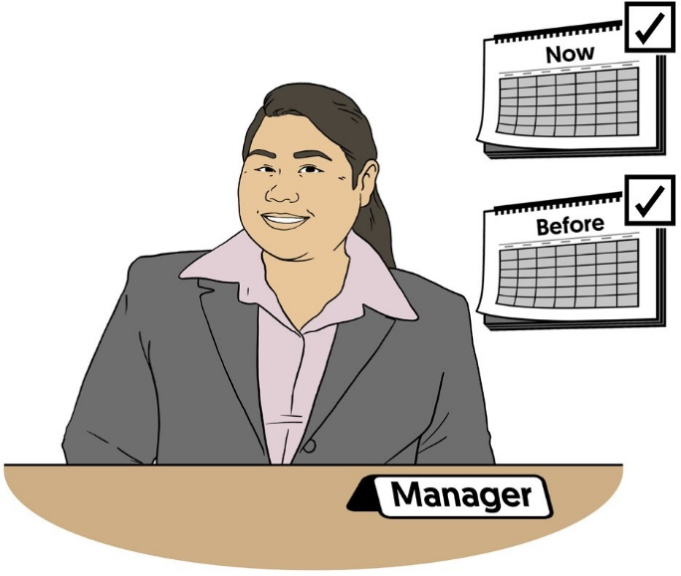

Date job started

Notice period
Work phone number
Can we call you at work?
No
Yes

References are the names and contact details of people who know you. They let future employers check you have worked where you said you did and that you are a good employee.
References

We advise you to put your employer at the job you have now, and from jobs you have had before.

5

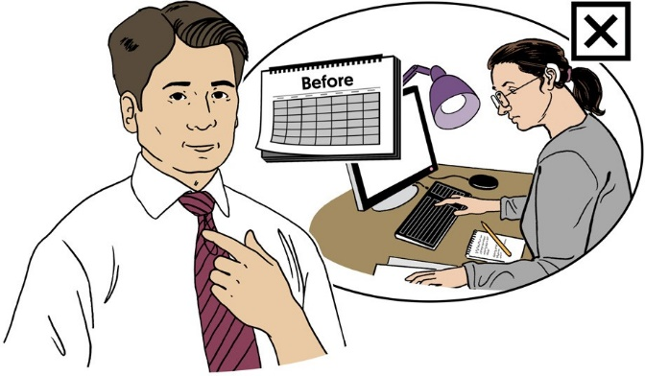
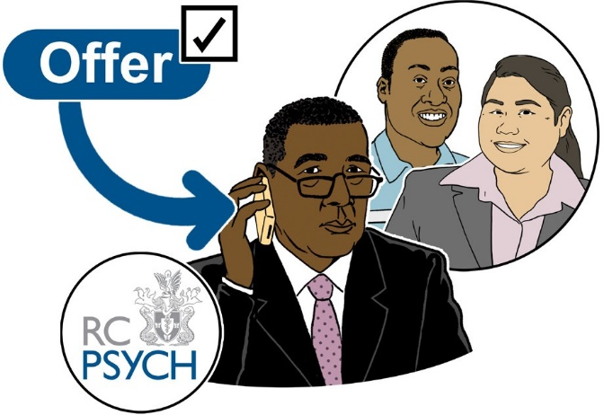
If you have not had a job before you can put someone who knows you, who can give a personal reference.

A personal reference is when they talk about who you are as a person and your skills.

Your references can not be from anyone you are related to.

We will only contact your references after we have offered you a conditional offer and you have agreed to it.

6

7

A conditional offer means that you will be given the job if the information on your application is true.

Reference 1
Company name
Name of employer
My job title
Company address
Postcode
Phone number
Email address
Date I started this job
Date I finished this job

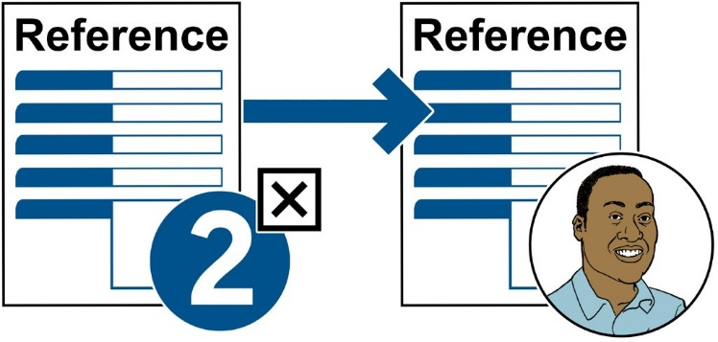

Use the next page if you want
to give a personal reference. You do not need to do this if you have already given 2 references.
8
Reference 2
Company name

Name of employer
My job title
Company address
Postcode
Phone number
Email address
Date I started this job
Date I finished this job

If you do not know what to put
in the start and end date above that is ok. You can leave them empty.
9
Personal reference
Organisation (if there is one)

Name of reference
My relationship to them
Reference address
Postcode
Phone number
Email address
Start date (if there is one)
End date (if there is one)

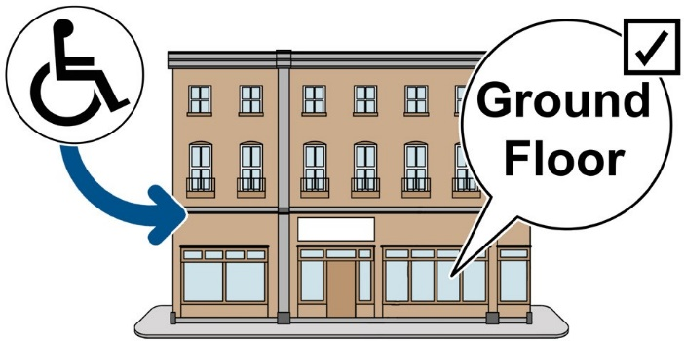
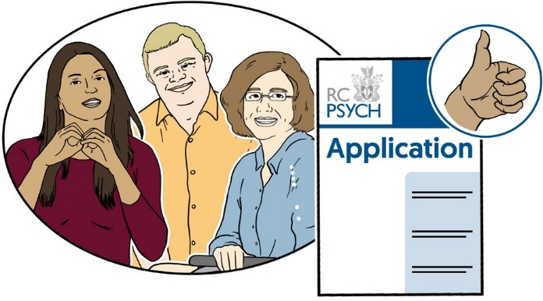

List any other information you would like us to know that you think would help your application.

Do you have a disability that means you need help at the interview or at work?
Health

These are called reasonable adjustments and can be things like having the interview on a ground floor for someone in a wheelchair.

A disability or health problem will not stop you from getting the job. People with disabilities are welcome to apply.

10

11
We are part of the Disability confident employer scheme. This means that anyone who applies, who has a disability, will get an interview if they meet
the minimum needs for the job.
The minimum needs could
be things like having the right work experience or knowledge of the job.
If you have a disability, please
use the box below to tell us about it, or about any help you may need.
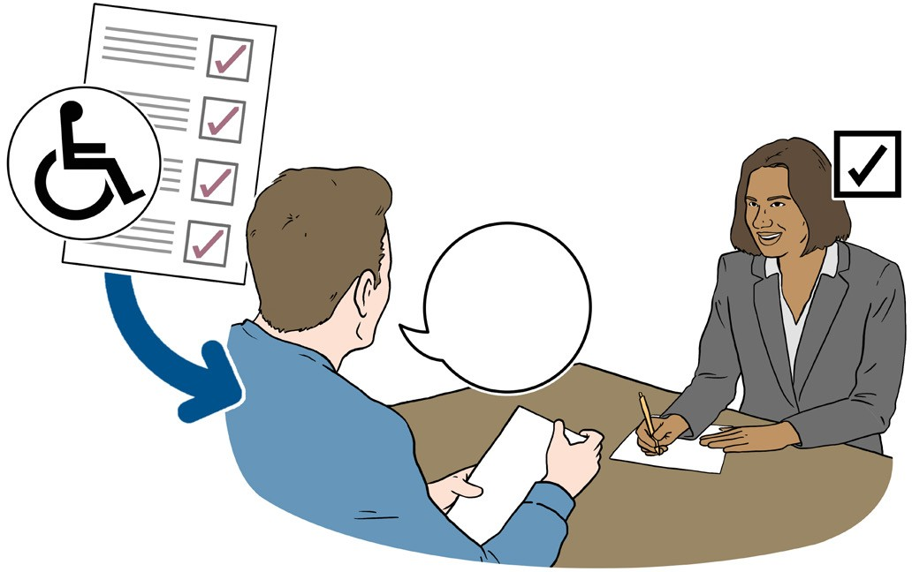

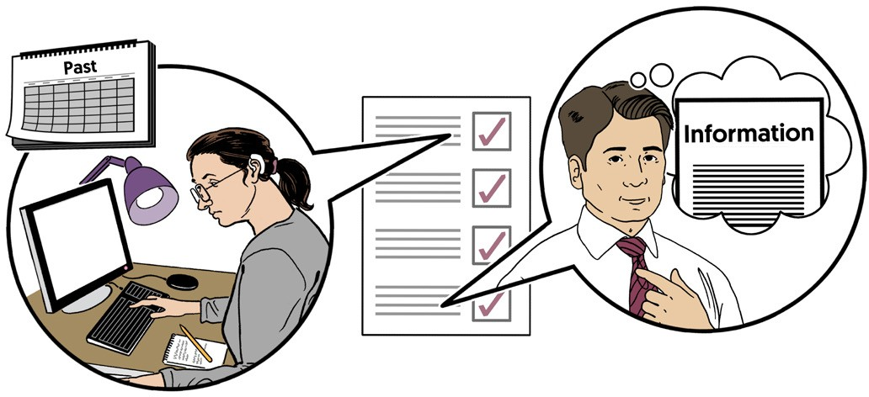

Disability

12
Questions

Question 1
How did you find out about this job?

Question 2
Have you applied to work with us before?

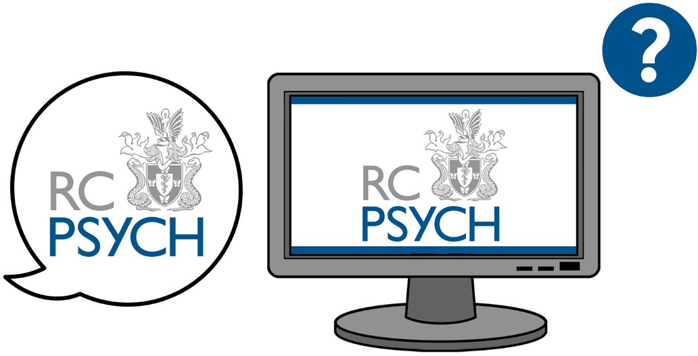

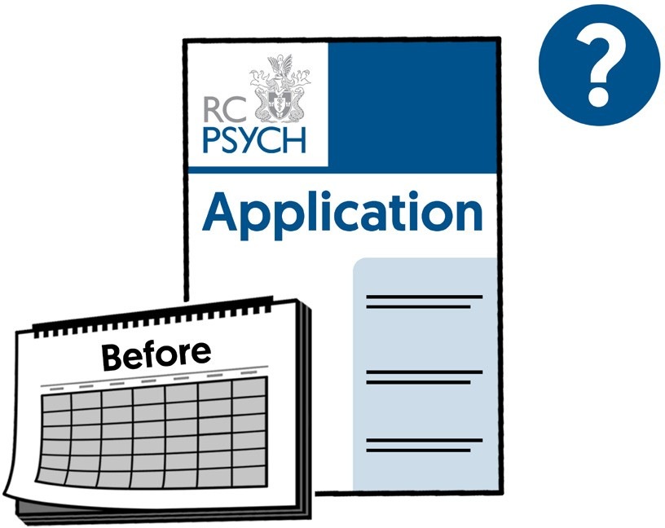

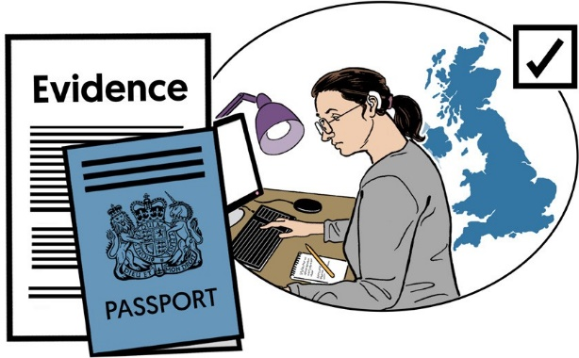
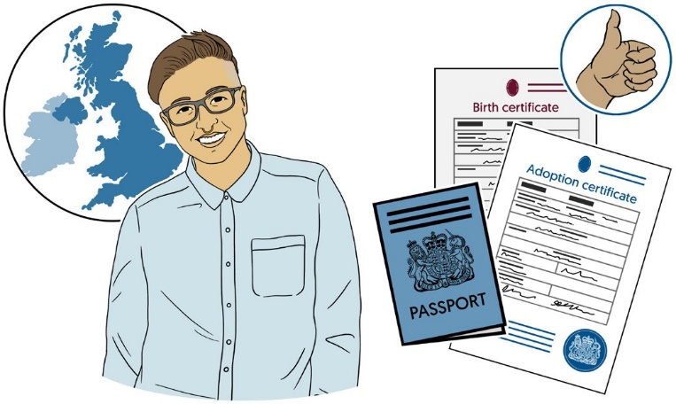
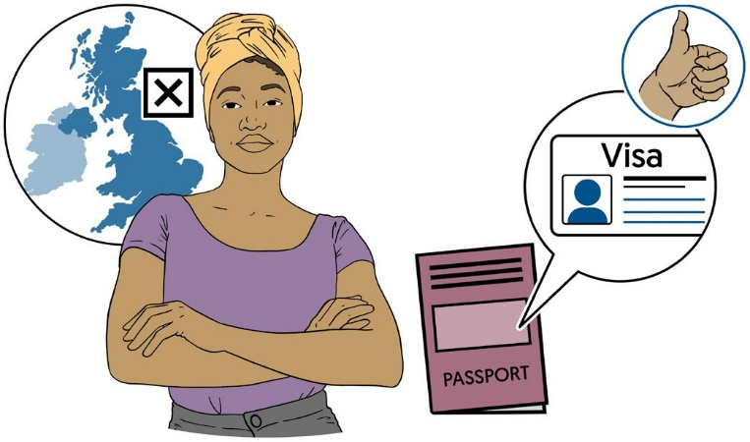

Question 3
Are you legally allowed to work in the UK?

Yes
No

You will be asked to bring evidence of this if you are offered the job.

If you are a British citizen the proof will be things like your passport, birth certificate, or adoption certificate.

If you are not a British citizen you will need to have a visa. This is a document from the government that says you are allowed to work in the UK.

13

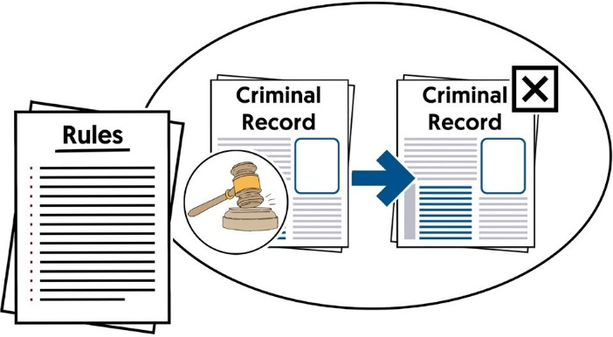

This section asks if you have any convictions. A conviction if when you have been found guilty of a crime.
Criminal convictions

You only need to tell us about convictions that are not spent. This means they are still on your criminal record.

Spent convictions are convictions that are no longer on your criminal record. You do not need to tell us about these.

The time between being convicted and the conviction being spent is decided by
a set of rules called the Rehabilitation of Offenders Act 1974.

14

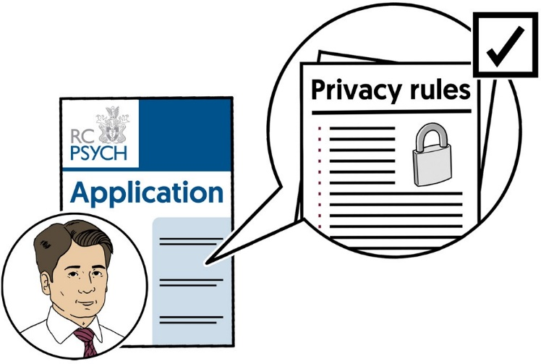
We will follow our privacy rules
with the personal information you put in this application.
15
Data protection

Unspent convictions will not stop you from getting the job. People with convictions are welcome to apply.
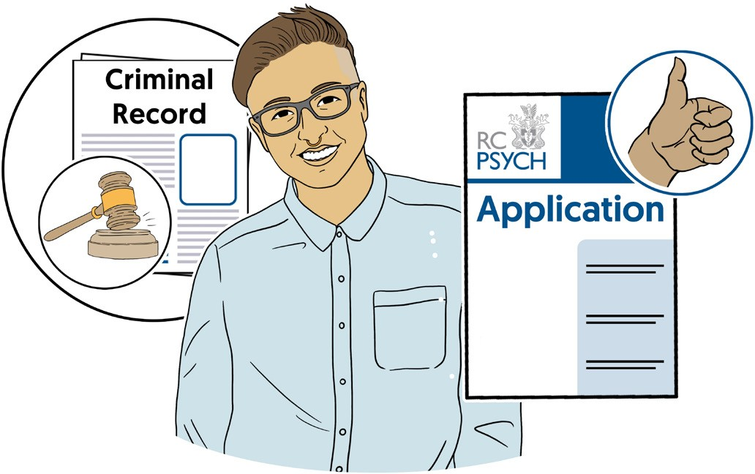

Details of any criminal convictions which are not spent

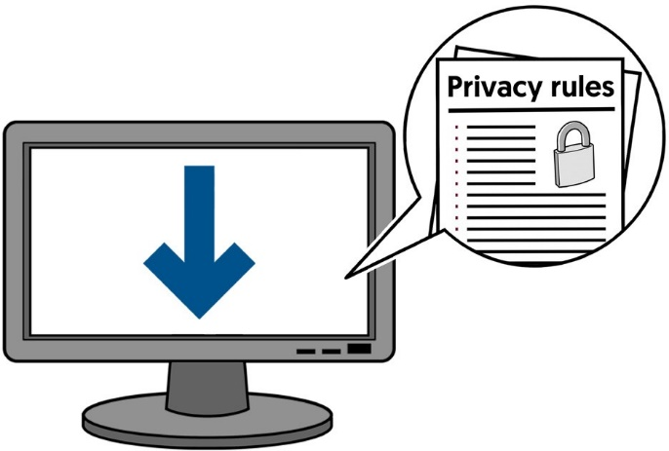
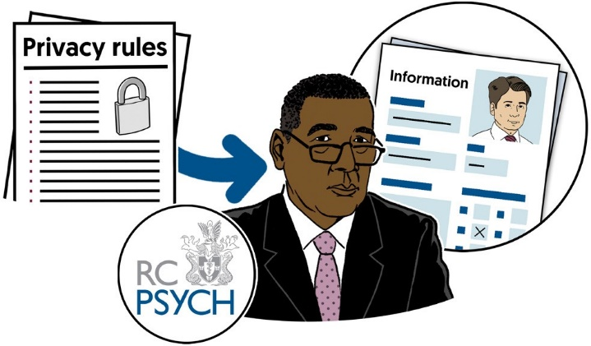
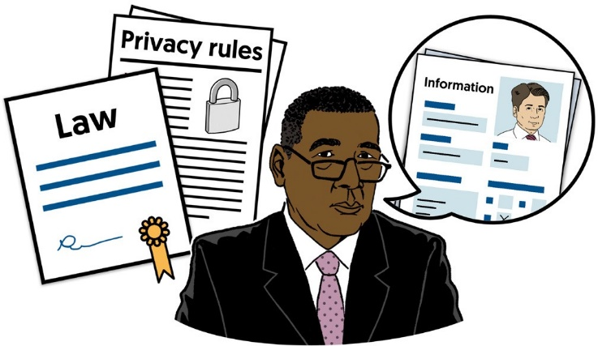
Our privacy rules are about what we do with your information, who can see it, and how long we will keep it.

You can download our privacy rules from our website:

www.rcpsych.ac.uk

If you have any questions about what we do with your information you can email:

dataprotection@rcpsych.ac.uk

We will only use your personal information for what we have said we will. We will follow our rules and the law.

16

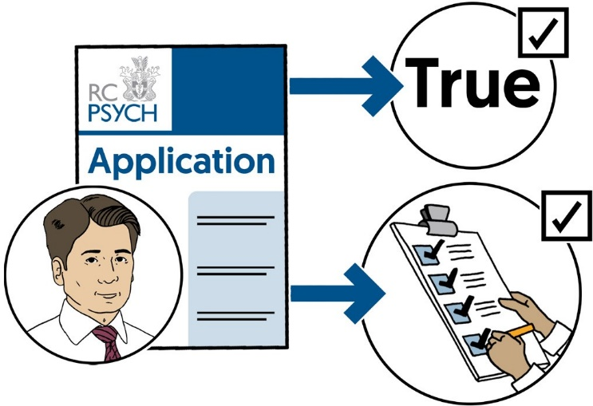
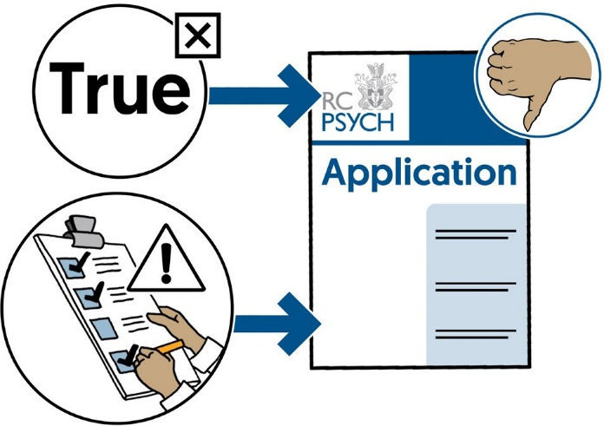

A declaration means you are saying something and agreeing that it is true.
Declaration

When you put your signature at the end of this section you are agreeing that the following declaration is true.

Declaration
The information I have given on this application form is true and complete. This means I have not left out any information I have been asked for.

I understand that if the information on my application is not true or I have left important information out, then my application may be rejected.

17

I understand that if I have been given the job but my application was not true and complete then I may lose my job.
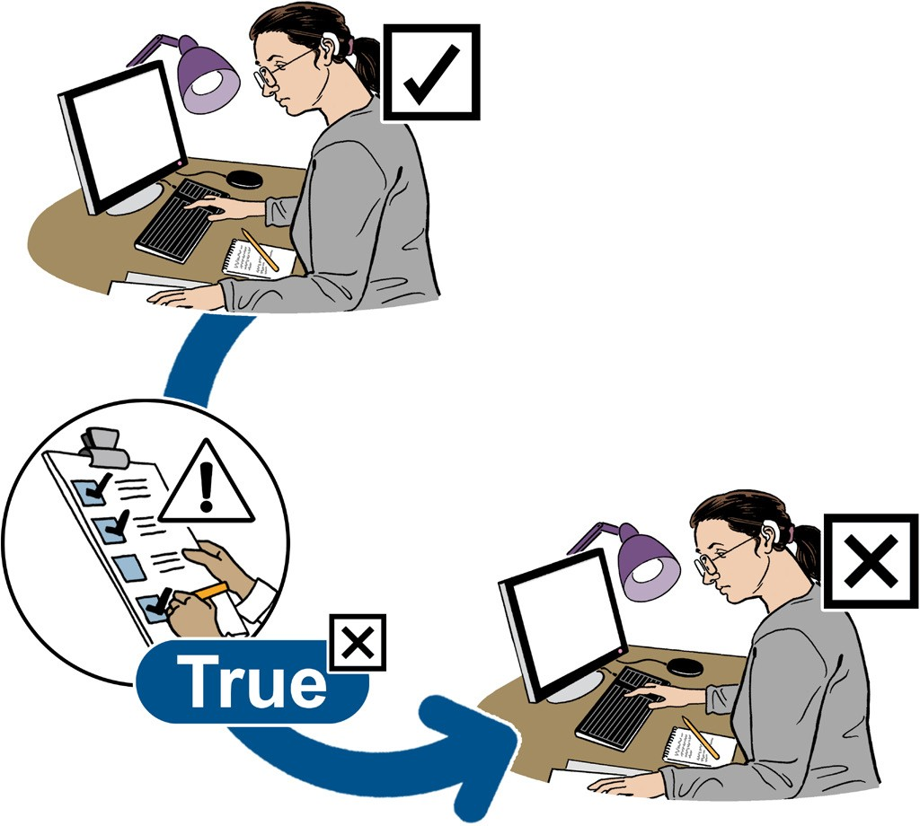

I agree to this declaration
Date
Signature

18

www.rcpsych.ac.uk

Images & Design © CHANGE
19

