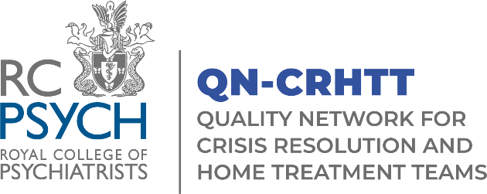

Application for Membership of the QNCRHTT Accreditation Committee (AC)

The AC meetings will be on the following dates in 2024:
- 18 January, 13:00 – 16:00
- 18 April, 13:00 – 16:00
- 15 July, 13:00 – 16:00
- October and December dates TBC

Please return your completed form to QNCRHTT@rcpsych.ac.uk

Name:

Profession:
☐ Psychiatrist
☐ Nurse
☐ Occupational Therapist
☐ Psychologist
☐ Social Worker
☐ Peer-support worker
☐ Healthcare Assistant/Support worker
☐ Other (please specify below)
……………………………………………………………..

Job Title:
……………………………………………………………..
Service Name and Organisation:

Telephone number:

Email Address:

Please explain why you would like to join the committee, including details of relevant experiences, interests or skills that you can bring to the group (please refer to the QNCRHTT constitution document for a list of roles and responsibilities and a person specification).
Please use the space provided below and continue on to the next page if necessary.

Please return your completed form to:
QNCRHTT@rcpsych.ac.uk

If you have any queries, please contact: Karishma.Talwar@rcpsych.ac.uk

Thank you for taking the time to complete the application form to the QNCRHTT Accreditation Committee.

