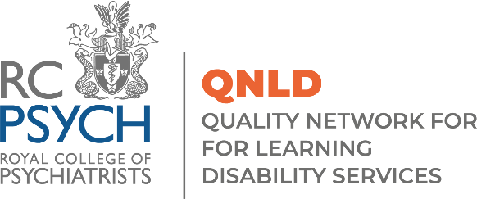

QNLD Special Interest Event
‘Unlocking Pathways’: Navigating legal challenges to discharge planning. Collaborative Strategies for Inpatient and Community Learning Disability Teams
Monday 8 July, 9.30 - 12.30 via Zoom
Draft Programme
09.30 | Welcome and & Introductions  Dr Kiran Purandare, QNLD Advisory Group Chair & Consultant Psychiatrist, Central & North-West London NHS Foundation Trust
09.35 | Collaborative Strategies for clinically led, operationally enabled teams, using a service delivery framework within inpatient Learning Disability services  Amy Shaw, Consultant Nurse, Lancashire and South Cumbria NHS Foundation Trust
10.05 | Navigating legal challenges to MHA 1983 discharge planning  Neil Allen, Barrister, Senior Lecturer and Founder, 39 Essex Chambers, University of Manchester, LPS Law Ltd
10.35 | Break
10.50 | The Inpatient Journey Through Research  Dr Ceri Woodrow, Consultant Clinical Psychologist, Cheshire and Wirral Partnership NHS Foundation Trust
11.20 | TALK TBC
11.50 | TALK TBC
12.30 | Close

To sign up to attend the event please fill in the booking form here

