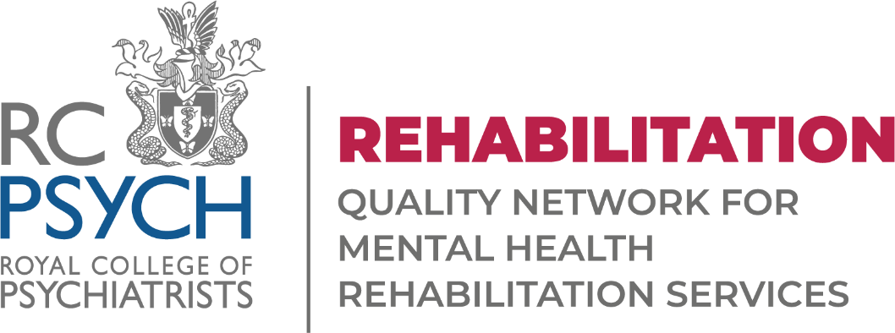
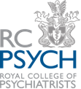

REHAB Annual Forum
Wednesday 7 December 2022
Royal College of Psychiatrists, London, E1 8BB

WORKSHOP AND POSTER PRESENTATION APPLICATION

Return to rehab@rcpsych.ac.uk T: 0208 618 4016

Name of Organisation: |  | Contact Name:
Address: |  | Tel:
 |  | Email:

SESSION INFORMATION

If you would like to present a session, please provide a brief abstract (500 words max.) about the topic of your
session and what the session will entail (e.g. interactive session, presentation with questions etc.):

Title:

Abstract:

Please complete and return your application no later than Friday 7th October 2022.

Thank you!

The Rehab Team

