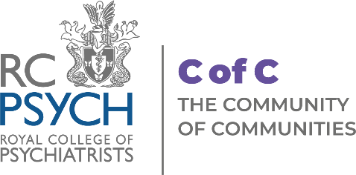

Community of Communities Enquiry Form
Name of Service:
Service Address:
Contact Details:
Type of Service:

Please tell us how you heard about the Community of Communities Network?

Please write a short paragraph about
why are you interested in the becoming a member of Community of Communities?

General Enquiries:
(please provide a brief overview of your enquiry)

Please return completed enquiry forms to CofC@RCPsych.ac.uk

