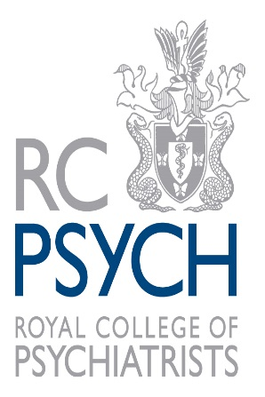

CONSTITUTION FOR FACULTIES OF THE DEVOLVED COUNCIL OF SCOTLAND

The Devolved Council of Scotland has a number of established Faculties for specific branches of psychiatry according to local need and mirroring the work of UK Faculties established under section 1 of Section XXII of the regulations.

The Scottish Faculty Chair and Vice Chair are locally elected by the faculty membership in Scotland. The Scottish Faculty Chair is a member of Devolved Council and is also the Scottish representative on the UK Faculty.

Due to the small size of some Faculties in Scotland, not all Faculties will have a locally elected Executive Group to support the Chair and Vice Chair.
If a Faculty does have an Executive Group, the RCPsych in Scotland does not provide committee management. However assistance can be given in the form of:

- Arranging conferences;
- Circulating information to Faculty members;
- Booking rooms at the College office for meetings; and
- Local FPTP elections.
Where a Faculty has size enough to establish an Executive Group, any agendas and minutes recorded should be sent to the RCPsych in Scotland Office staff for appropriate archiving.

Each Faculty should identify a member (usually the Vice Chair) who will be responsible for triaging consultations and policy documents the College is preparing/responding to.

Local elections shall be conducted by local ballot using FPTP in accordance with the applicable provisions of paragraphs 11 to 18 inclusive of section XXVII. Only members of the College or Specialist Associates shall be able to stand for election or to vote in local ballots. The term of office of all Executive Group members shall be four years.

Faculties within a Devolved Council in the relevant jurisdiction shall provide policy, workforce and education advice and undertake other activities relevant to particular sub-specialties of psychiatry.

The following Faculties are established in Scotland and have elected officers and active Executive Groups:

- The Faculty of Child and Adolescent Psychiatry
- The Faculty of Forensic Psychiatry
- The Faculty of General Adult Psychiatry
- The Faculty of Medical Psychotherapy
- The Faculty of Psychiatry of Intellectual Disability
- The Faculty of Old Age Psychiatry
The following Faculties have elected representatives who represent Scotland at the Devolved Council and UK Faculty:

- The Faculty of Academic Psychiatry
- The Faculty of Eating Disorders
- The Faculty of Liaison Psychiatry
- The Faculty of Neuropsychiatry
- The Faculty of Perinatal Psychiatry
- The Faculty of Rehabilitation and Social Psychiatry

