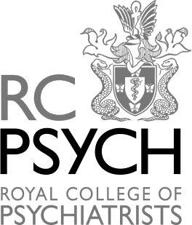

South Eastern Division Poetry Prize 2024

Open to anyone with a connection to mental health who resides in the geographical region of the Royal College of Psychiatrists South Eastern Division.

You are invited to submit an unpublished poem with a theme related to any aspect of mental health.

The poem of the winner will be published on the Royal College of Psychiatrists website and in the Programme and Abstracts booklet for the annual Spring Meeting.

Please send your entry form and poem by Monday 17 April 2024 via email to karen.morgan@rcpsych.ac.uk

Entry form and regulations attached

Royal College of Psychiatrists South Eastern Division

South Eastern Division Poetry Competition - Regulations

- The South Eastern Division Poetry Competition will be awarded annually. It will take the form of a competition in which anyone with a connection with mental health will be invited to submit an unpublished poem with a theme related to any aspect of mental health. All entrants must reside in the geographical region of the Royal College of Psychiatrists South Eastern Division (boundaries can be checked by contacting the South Eastern Division Office).
- All entrants must have some connection with mental health i.e. people who use mental health services or their family/friends, professionals providing care, people working in the mental health sector, i.e. ward clerks, secretaries, cleaners, etc.
- Entries are restricted to a maximum of two poems per entrant and should be produced on 1 sheet of A4, with a maximum of 40 lines.
- There will be one prize, and this will be a book voucher, to be reviewed by the Division’s
Executive Committee from time to time.
Prize - £75 voucher
- The prize will be awarded only if, in the opinion of the judge, at least one entry is of a sufficient standard to merit a prize.
- The judges will be a poet, a service user/carer and a member of the Executive Committee.
- The judges’ views will be final. The judges will not be available for correspondence with
entrants on any subject related to the assessment of entries.
- The aim of the prize is to raise awareness of and stimulate interest in mental health issues amongst local communities using a non-stigmatising and inclusive medium.
- The prize will be presented at the Spring or Autumn Conference each year.
- Only the winners will be notified.
- The poems of the winners will be published on the Royal College of Psychiatrists website and in the Programme and Abstracts booklet for the Spring or Autumn Meeting.

Royal College of Psychiatrists South Eastern Division | 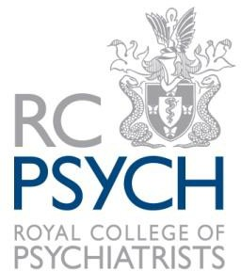

South Eastern Division Poetry Competition – Entry Form 2024

I am submitting an entry for the South Eastern Division’s Poetry Competition Prize.
Name Address

Connection with mental health

Telephone number Email address Title of poem
Only two poems per entrant can be accepted with a maximum of 40 lines. Any entry with more than two poems or 40 lines per poem will be disqualified.
I understand that my entry must be at the South Eastern Division Office (by email) by 17 April 2024 and that the judges’ decision will be final. The South Eastern Division will not enter into any correspondence regarding these awards.
I also agree that should this entry win a prize that the South Eastern Division of the Royal College of Psychiatrists can reproduce it in any of their material i.e. newsletter, meetings programmes, web site etc together with any photographs taken at the award ceremony.
I confirm that I have read and understood the regulations.
The prize will be awarded at the South Eastern Division Conference on 8 May 2024. Winners will be advised by email. Those who are unsuccessful will not be notified. Signed Date Send to: Karen Morgan, Division Committees Manager, karen.morgan@rcpsych.ac.uk

