Suicide Risk Assessment
Suicide Risk Screen
To be completed by nurse or doctor in any patient who:
- scores 11 or more on the Hospital Anxiety and Depression Score (HADS), or
- answers ‘A lot of the time’ or ‘A great deal of the time’ to the statement ‘Worrying thoughts go through my mind’ on the HADS, irrespective of final score,
- raises suicidal concerns for any other reason
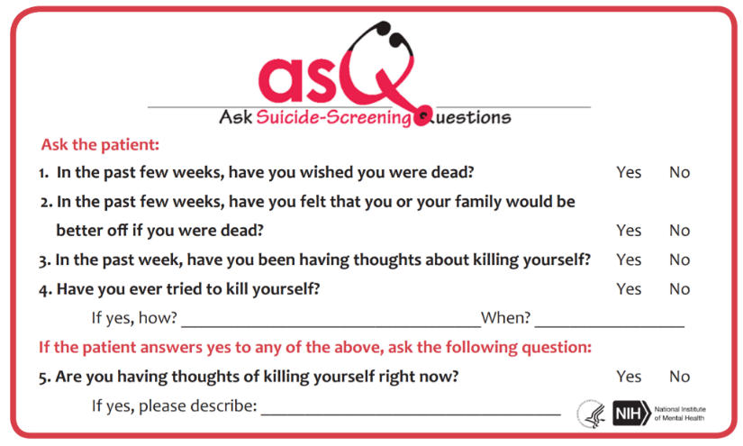
- If patient answers “No” to all questions 1 – 4,
don’t ask question 5. No intervention is necessary.
- If patient answers “Yes” to any of the questions 1 – 4, or refuses to answer, they are considered a positive screen. Ask question #5 to assess acuity:
  - “Yes” to qn. #5 = acute positive screen – refer to Psychiatry as matter of urgency.
  - “No” to qn. #5 = non-acute positive screen (potential risk identified): Patient requires brief suicide safety assessment (see below) AND discussion with Psychiatry.

- Note: clinical judgement always overrides a negative screen

Brief Suicide Safety Assessment
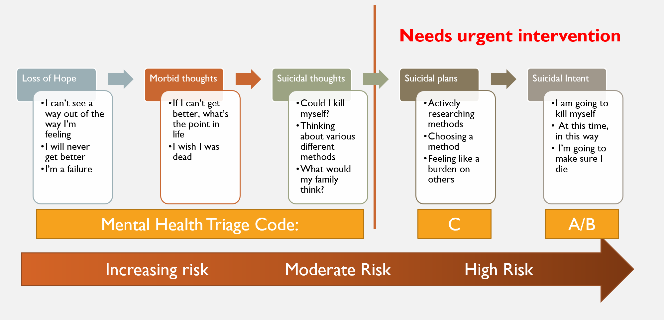
All patients who meet criteria for a non-acute positive screen, require discussion with Psychiatry.
To aid triage, the ward doctor should try to identify where on the following risk scale the patient is. Call Psychiatry for advice if unclear or difficulty.

