Result of 2017 Survey of Services based on Information from Faculty Members
This summer we sent an email to all Faculty members asking for information about their services. On behalf of the Faculty Executive, I would like to thank Josie Jenkinson for her hard work on this survey and also thank all of you who responded.
Here is an outline of the key findings (taken across the UK unless otherwise stated):
- Response rate: 91% of UK Trusts providing OA MH services were represented in the responses.

- Percentage of Trusts providing some ageless services: 49% (compared with 69% in 2012).

- Proportion of trusts providing ageless CMHT or Ageless inpatient services (but disregarding day hospitals, liaison and HTT): 19% .

- Proportion of Trusts who have had some services that were ageless revert back to old age specific: 12% of Trusts in England. (These changes were seen only in England.) The main service that reverted to being Old age specific was the CMHT.

- Other noted changes: Now only 26% of Trusts have day hospitals. 42% of respondents said that there had been a reduction in funding available for older adult services in their organisation over the last 3 years

Opinions of members on the impact of moving to ageless services
Members’ views on the effect of service changes are presented below:
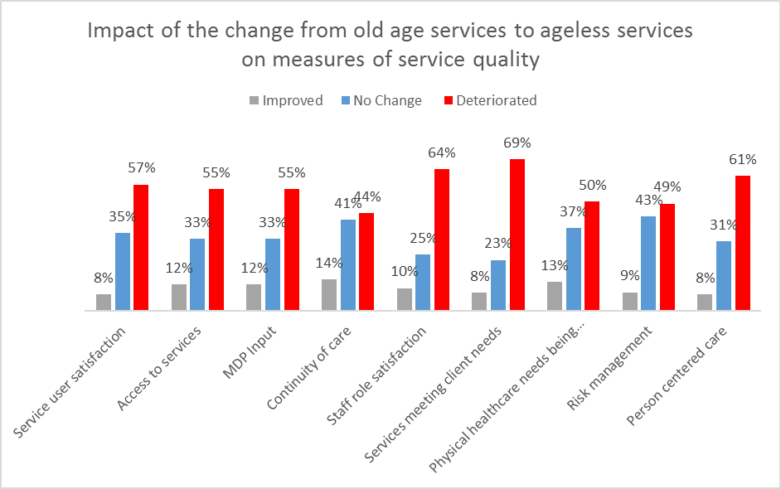

Further Action as result of survey
We plan to undertake more detailed analysis and to break down the results by devolved nations. Once this work is complete we will make this available. If any trainee is interested in helping out with this please email Kitti
We want also to obtain an understanding of what happens when decisions are made to move from ageless to old age specific services. What motivates these decisions? What arguments for reverting back to old age specific services find favour with do commissioners? We will be asking Faculty Members if they would be willing to share with other members their experiences in bringing about a change from ageless to old age specific services, although in this case, rather than publishing views (some of which could possibly be sensitive) our idea would be to maintain a list on the resource page of the Faculty website of anyone who is willing to share experiences on a one to one basis.
We also aim to refine the survey and repeat it in June 2018. We hope to achieve responses from 100% of UK Trusts providing OA MH services.

