MYANMAR BLOG

MONDAY 30TH OCTOBER
A big surprise on arrival was to find that Burmese men wear floor-length skirts called Longyi often in tartan, usually blues and greens – not just the workers but about 75% of professionals. I think it was David Beckham who came from his holidays to the UK wearing the longyi a while back but sadly the trend didn’t seem to catch on.

TUESDAY 31ST OCTOBER
The morning meeting organized by Vipsig Chair Dr. Sophie Thomson leading the venture for the fourth time was a first chance to get to know our fellow psychiatrists and plan the teaching events of the next ten days. Of the six UK consultant psychiatrists in our group, three were born in Myanmar. After a morning of hard concentration another surprise was tea-leaves on the lunch menu, either as tea-leaf salad or tea-leaf rice, useful in combatting jetlag and just what we needed at the time.

The afternoon was free to visit tourist attractions of Yangon, the most famous of which is ShweDagon Pagoda, a wondrous complex of temples perched on the hill, visible throughout the city. People with bare feet ascend the many steps and look on multiple statues of Buddha with great reverence. We watched three monks traversing the terraces at the base of the tallest golden ‘stupa’ and admired the pink costumes of five nuns parading with shaven heads, everywhere people making offerings at the shrines. As dusk fell the many birds were replaced by bats swooping on insects and candles were lit everywhere. Halloween celebrations were not much in evidence in Yangon.

WEDNESDAY 1ST NOVEMBER
At 9.30am our delegation met with the Rector of the medical school, Prof Zaw Wai Soe, and the Professor of Psychiatry, Prof Tin Oo, together with Prof Theingi Myint Pro- Rector of the medical school and Dr Thinn Thinn Hlaing Country Director of THET.

The Rector feels that psychiatry is increasingly important in Myanmar especially for children. Coinciding with ongoing socio-economic changes both adults and children have increased needs. The population is 54 million, there are 1,100 hospitals, but only two or three main mental health centres. More specialists within psychiatry are required. There are no child psychiatrists, and people need help for treatment of PTSH. The Rector explained that there are four areas where help is most needed: basic medical education in psychiatry, postgraduate education in psychiatry, service development and lastly research .Dr Brad Hillier, forensic psychiatrist volunteering for the fourth time, suggested that it might also be possible for mental health services to be offered within existing services such as HIV and TB clinics.

Professor Tin Oo advised that in Myanmar 70 percent of the population lives rurally so teaching for GPs is also very important. GPs tend to have between three to five minutes per patient. There is very little teaching for them on a postgraduate level and little CPD. As medical students they only have one month of training in psychiatry.

The Myanmar government plans to have universal health coverage by 2030 and the first steps are being taken between 2017 and 2021. However, general practitioners won’t go to places where they receive little money so it is suggested that monks, community leaders and community health workers who are working rurally all might need training in mental health – if training of the trainers could be offered then mental health knowledge could be cascaded down to these workers too.

There is already WHO collaboration in the country but such projects have limited funding. There is a need to find how such projects can be expanded further to create a wider impact. The Rector suggested that money could be raised to fund some of this work from the Myanmar side. There is money for undergraduate reform, for example through generous grants from Japan.

We spent the rest of the morning studying the 50-or-so MD theses on mental health topics in the library.

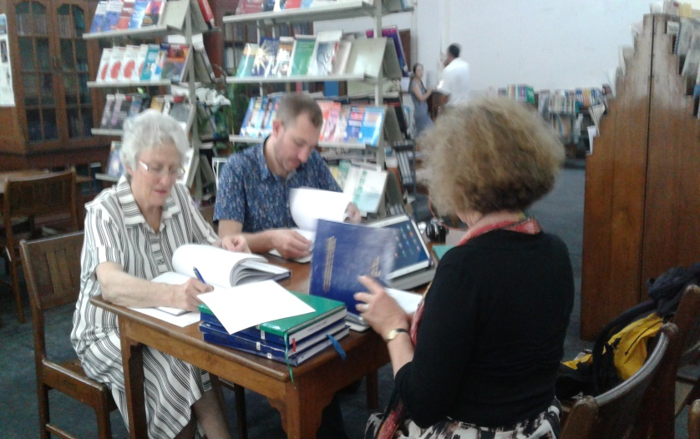

Drs. Thomson, Hillier and Mounty evaluating the research of our Myanmar colleagues

These research projects are obligatory for trainees in postgraduate psychiatry but once bound and submitted rarely published. The ones I examined included A Study on the Burden of care in the relatives of psychotic patients comparing 18 out-patients and 34 in-patients. A research project on Psychoeducation in Bipolar disorder taking two groups of 50 in-patients and using group psychoeducation to try to improve the prognosis. This was inspired by a short literature review had revealed that the course of bipolar illnesses is less benign than previously thought. The third and final thesis I looked at was entitled Religious and Cultural Beliefs Concerning Psychosis by Both Patients and Carers which was a fascinating descriptive study of the beliefs of patients and their carers concerning the cause of their psychoses. Sixteen percent of the sample thought that the causes of psychosis were supernatural and included witchcraft. The paper went on to discuss anthropological and Buddhist beliefs about imbalances causing psychosis and there was mention of ‘the 38 Goodnesses’.

After reading the theses there followed a 90 minute session with the medical students comprising ten-minute presentations from each of us on ‘why I chose psychiatry’ and talking about our sub-specialties.

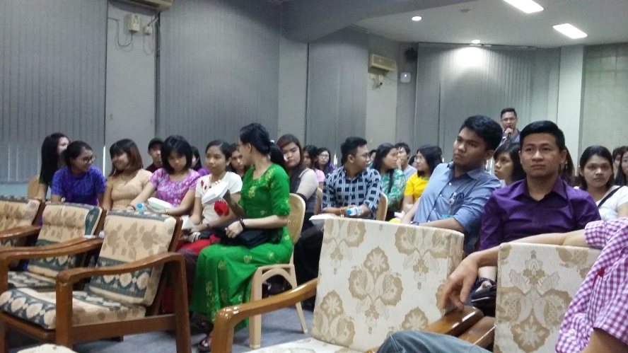

Students at Myanmar Medical School

The mhGAP training in Myanmar became possible through the sterling efforts of Dr Nwe Win Thein in establishing a charity called Mind to Mind Myanmar. Then forging links with the Royal College VIPSIG to enable groups of mhGAP trainers to visit on a yearly basis or twice yearly basis for the past three years to train primary health practitioners in mental health. The emphasis in the teaching is on principles of essential care of women and children; human rights; gender equality and diversity; emphasising access to mental health for people from all minorities, and explaining the convention on rights of people with disabilities.

Dr Thein is one of the foreign medical graduates most committed, to providing psychiatric training to her country of origin that I have met in my 36 years in Psychiatry. The organisation of training in mhGAP in Myanmar fits well with the aims of the College Volunteering Scheme because a group of three to six practitioners may visit at least twice a year for two weeks and train 30 to 60 primary health practitioners in one or two different cities. The College Volunteering Scheme can assist volunteers by contributing up to £500 towards the airfare. The itinerary fits well into a two-week study leave for anyone thinking of volunteering, with two four-day trainings and two one-day workshops possible in the 14 days and allowing four days for arriving and leaving, exploring locally and travel within the country. Some accommodation and food was generously provided by our Burmese hosts including the Rector of the University and also the GP coordinators in the outlying towns.

Prior to our visit Dr Thein explained that although in the West psychiatry relies on evidence-base; in Myanmar the training in the speciality should additionally incorporate spiritual beliefs and acknowledge Buddhist traditional thinking. She described eight components to purifying oneself known as Noble Eight Fold Path. Traditionally, Buddhism practiced in Myanmar is intertwined with and influenced by rituals and animism deriving from ancient India. The Buddhists understand and accept that what you are experiencing now is partly because of what’s happened to you in the past or what you've done in the past. There is a philosophy of calm, or being non-reactive to situations around you and the calm is on three levels: a) by controlling physical actions/ doing; b) by controlling verbal actions/ speech and c) by controlling mental actions/ thoughts this is the hardest level. Here is where meditation is useful in allowing you to be aware of your thoughts and purifying them; through meditation and insight there is eventually, acceptance of things in their true nature as they happen.

THURSDAY 2ND NOVEMBER
On this day our group assisted Professor Athula Sumathipala with a workshop on psychiatric research for the postgraduate psychiatry trainees. The participants seemed to particularly enjoy the small-group work facilitated by our 6 trainers whereby they discussed existing projects that they are involved in. Later they then devised a hypothetical research question, which they brought back to the whole group for discussion. During the course of the day certain local individuals, through their very active participation began to emerge, as potential future leaders in the field of psychiatric research, such as Dr Moan Thawdar Myo Thant who had completed the MSc in Global Mental Health in London 2017.

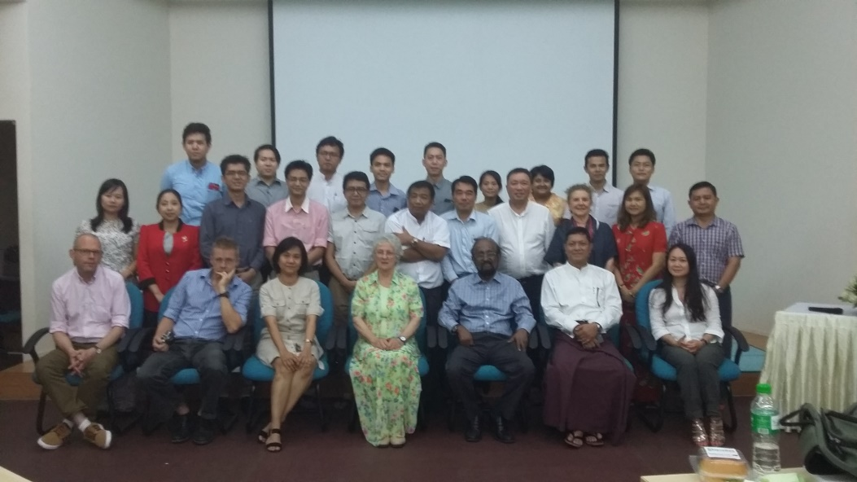

Teaching team with psychiatric trainees at the hospital

FRIDAY 3RD NOVEMBER
This was a full day of teaching and training in basic psychotherapy and CBT with lectures and small-group working led by Dr Sophie Thomson,clinical psychologist Dr Damon Mason, and Professor Athula Sumathipala once again. As on the previous day one or two leaders in this area began to emerge, one of whom had studied CBT in Sydney, Australia. Dr Thet Zawoffered frequent explanations of some of the more difficult concepts. His fellow classmates frequently turning to him for guidance. There was very active participation and enjoyment. During the training English was used predominantly with occasional opportunity for translation by Dr Nwe.

SATURDAY 4th NOVEMBER
Myself, Brad and Nwe were based in Meikhtila 50 miles south of Mandalay, so flew from Yangon and then travelled south by taxi for two-hours. The hotel with training facilities was very pleasant and next to a lake – there were flocks of wild birds overhead constantly. On the night of arrival there was a welcome dinner and after the first day a dinner reception kindly arranged by Dr Khin Soe the GP organiser for the area.

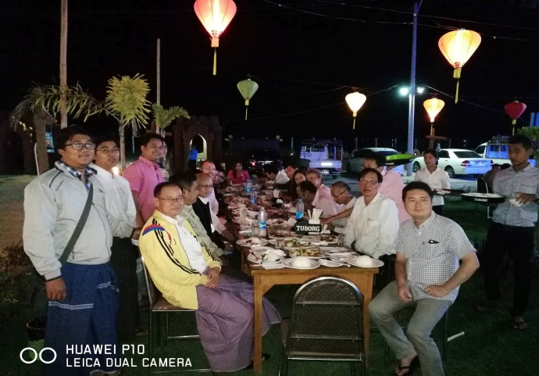

Dr Khin Soe and Meikhtila, family doctors at dinner reception

In the regional centres much more translation was required .We were joined by a local GP and two GPs from Mandalay who had completed the mhGAP training previously. One of them has applied to the postgraduate psychiatric training in Mandalay and the other doing further studies in applied psychology. This meant there was a Burmese trained person together with a UK trainer for each of the three small working groups into which the class was divided. The group largely consisted of local GPs including one who had travelled 400 miles from Chin State and a few military doctors linked with Myanmar’s main airbase located nearby.

Participants began by filling in the Skills and Attitudes Questionnaire and were willing to give case histories of people they had seen with various mental health problems. There were 39 in the class including seven or eight women and 100 percent attendance for the week! I don’t now have access to all the case histories that were submitted. There were only two of the 39 case studies concerned with under 18s and no child cases. Six of the 39 were patients with psychosis and possibly a quarter of the sample involved alcohol and/or drug misuse and their consequences –Another quarter illustrated problems of medically unexplained symptoms and there were a few cases of older patients with dementia.

Day 1
Essential practice and care;- assessment and management of depression; hand technique. We used PowerPoints and videos provided by WHO for the mhGAP. We had a copy of the manual for each student (provided by Mind to Mind Myanmar) and we soon established a daily pattern of learning through small group work with roleplay, Participants were asked to join in a quiz every morning to check the knowledge of the day before. The participants called out the answers enthusiastically and seemingly unanimously. They fed back that they liked the variety of our teaching methods, stating that normally they might be in danger of falling asleep especially after lunch, but because of variety and frequent changes they stayed awake.

On the first day participants in my group complained that patients won’t tell us anything. The examples being: neither the unmarried woman who is pregnant nor the person with HIV – being willing to tell how it came about! There followed wide discussion about confidentiality, having non- judgmental attitude, allowing time for patients to develop trust etc. Not clear from my side what percentage of patients actually attend for repeated visits as they have to pay for each consultation.

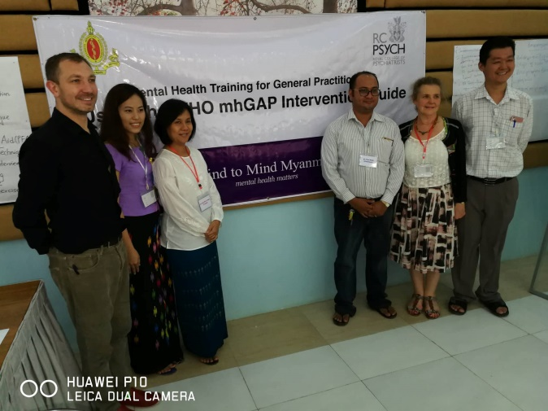

Meikhtila teaching team including local doctors, invaluable as workshop leaders/translators

Day2
Suicide; relaxation techniques; Child mental health
There was surprise and consternation when the suicide figures for the country were given because people genuinely didn’t know the prevalence, particularly as suicide is illegal in Myanmar. This session aroused great interest and much discussion
In relation to child mental health the practitioners stated that they see very few children because in Myanmar children are treated by paediatricians. However, they were greatly interested with regard to their own children and families.

Day3
On the third day, Substance misuse was most popular topic to date especially the alcohol section which seems to be quite a problem in Myanmar, alcohol being relatively inexpensive. A stimulant drug called Yabba (amphetamine)was also mentioned as being problematic.

Motivational Interviewing was greatly inspiring for our participants presented as it was by their local psychiatrist, Dr Kyaw San Htay, a lively entertaining man clearly offering great warmth and support both to his clients and to local GPs. They said they had felt helpless and even angry previously when their substance abusing patients relapsed but now felt empowered and skilled to tackle the situation.

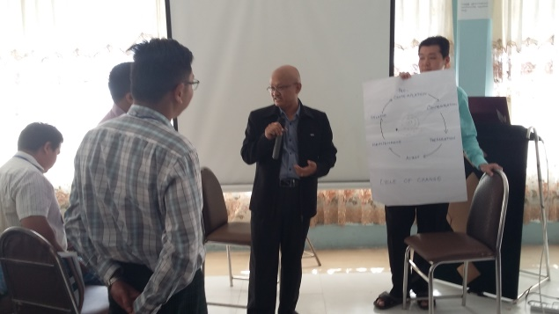

Motivational Interviewing with Dr Kyaw San Htay

Later the military doctors spoke about airmen and soldiers they had encountered who had PTSD and about a woman whose child was killed in front of her in a car accident.
On the way to coffee break that day I noticed a student singing which seemed to indicate how relaxed and genuinely enjoying the course they were. The same day a female student brought jasmine flowers in garlands one of which she pinned to her hair and pinned another one on me with a big smile, saying now you will have aromatherapy all day.

Assessment and treatment of dementia followed in the afternoon. Dementia in Myanmar is regarded by the public as part of ageing, not an illness and the families take care of their elders at home.

Day 4
On the final day I felt that psychosis was a little short-changed because it was the final day and sessions were shorter to allow time for the closing ceremony and photos.
Use of medication and Medically unexplained symptoms which had mentioned earlier when we taught anxiety were also taught on the last day.

Over the course of the four days the GP’s became less anxious, more interested and skilled in how to ask sensitive questions of people; how to gain their trust and help them confide difficult, sensitive pieces of information, and developed the confidence to explore problems further knowing it would be therapeutic rather than harmful to do so

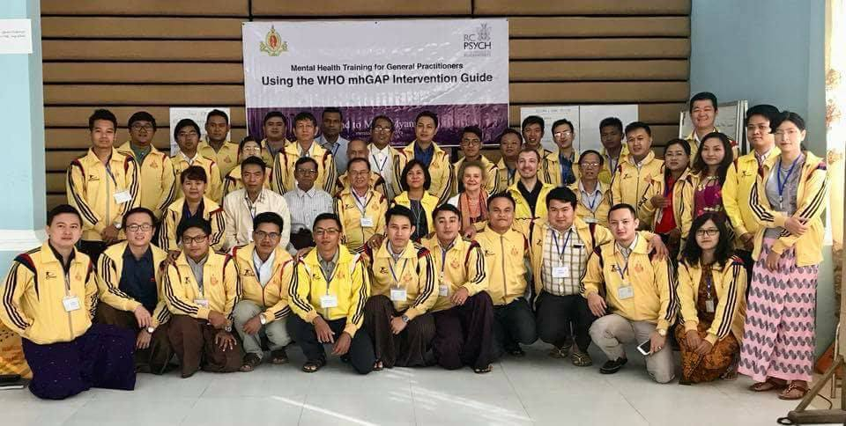

Closing ceremony

We finished at 2pm for photographs and speeches and awards of certificates. The closing ceremony was wonderful with many gifts given on both sides, the participants bringing sweets, snacks and gifts. From Dr Khin Soe Burmese costume Longyi for the men and women as well as yellow track suit tops with mhGAP Myanmar printed on the back for every participant.

Six Cases with Psychosis

- A 36-year-old with psychosis and epilepsy, a man brought his wife with insomnia, auditory and tactile hallucinations and a history of fits. She had no substance misuse but they had socio-economic problems. Management: Refer to psychiatrist.

- A 24-year-old with odd ideas and insomnia came complaining that he could ‘see the future’ The patient had been talking constantly about the future and people were frightened by him and he couldn't do his normal activities. He was, unable to sleep, there was sudden onset, he was religious and no previous history. Was normal in all physical exam, treatment injection of Diazepam and the patient fell asleep.

- Chronic schizophrenia with tardive dyskinesia. A 40-year-old female with difficulties with speech involuntary movements, choreiform and dyskinetic after 17 year treatment for schizophrenia. She had been treated by a psychiatrist at the out-patient department at Meiktila and had been on drugs like Modecate, Fluphenazine repeatedly. The doctor did not know how to treat it.

- A 28-year-old single female who couldn't sleep well on and off for a year and worse for the last four months. Was feeling hopeless and avoiding people including close friends and family members. Had gained 10 kilograms with an increased appetite for two weeks followed by a loss of appetite. She had suicidal thoughts, manic behaviours off and on She had a history of pelvic inflammatory disease diagnosed a year ago with severe back pain. She had previous history of having psychiatric treatment for five years but with no follow-up. She thought that she was okay, but had a history of misunderstandings with her parents. Referred to the psychiatrist for further assessment.

- A 21-year-old male presenting with discomfort in his body and insomnia, sometimes hearing voices at night for the past six months. He had stopped college and was now resting at home. His family had financial problems and there was no substance abuse. His physical health was good. He was referred for counselling.

- A 32-year-old breast-feeding mother with acute psychosis for the previous ten days. Had given birth to her baby four months earlier. She had irrelevant speech and insomnia, was feeling guilty, feeling she had made mistakes with regard to her sister-in-law but her husband said she hadn’t. She is a teacher in a High School on maternity leave for six months. She was feeling unwell and living with her husband’s relatives under the same roof. Apart from this they didn’t have social problems, no substance misuse, no history of previous similar attacks and no major illnesses. After counselling for 15 minutes she was treated with Diazepam and multi-vitamins, and asked to return in five days. After five days she came again and was improved. She continued with the same treatment, returned after another five days and was better, and asked to return again if any other further problems.

Whilst we were working with this group, three other colleagues were doing similar work in another rural city called Pathein. They reported similar experiences of generous hospitality and gratitude for the participants.

I decided to return to Yangon via the city of Bagan, a future world heritage site for its archaeological significance with 38,000 pagodas dating back to the second century A.D. Staying in the Bagan hotel only then was I able to find out more about Aung San Suu Kyi’s visit to Rakhine State accompanied by top members of the military. The local newspapers simply gave that terrorists in Rakhine state had been chased away over the border into Bangladesh and that villagers had also run away. Mention was made of the high level of interest in the issue and appeals by US UK and various Scandinavian countries and their wish to help Myanmar improve the economic problems of Rakhine state where there were cyclones and malnutrition earlier in 2017. BBC news was available on television in the tourist hotels inside Myanmar but not clear how fully ordinary citizens would have access to Western news. We were told that citizens are greatly hurt that Aung Sang Suu Kyi was being held responsible for the crisis and said it was not possible for westerners to understand her position. The parliament is still 25% military and important ministries still under the control of the generals There are more than 18-20 different tribes and major ethnic groups within Myanmar .Since 2010 eight armed militant groups are reported to have made peace but to date there is no ceasefire in Shan State, nor in the ethnic regions Kachin, Rakhine, Chin, Kayah, Kayin and Mon. Clearly the reality on the ground is a lot more complicated than Western media portrays and we can only hope that progress is made towards a peaceful and just solution to the suffering of so many people.

Finally it was a great pleasure and privilege to be part of this group of RCPsych volunteer psychiatrists imparting some skills and knowledge about mental health using the WHO mh GAP. We look forward to the formal research evaluations about the impact of the 4 day trainings as well as the outcome of inspiring workshops about research and CBT with our psychiatric colleagues in Myanmar.

