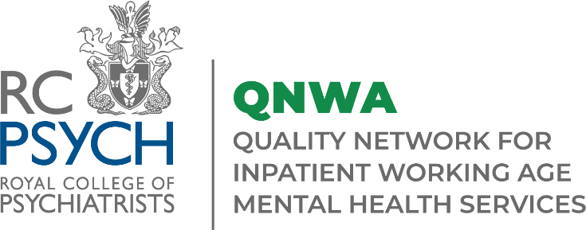

Special Interest Webinar
Complex PTSD in Acute Inpatient Settings
Wednesday 19th July via Zoom

Programme
09:30 | Welcome & Introduction  Dr Declan Hyland, Consultant General Adult Psychiatrist, Mersey Care NHS Foundation Trust
09:35 | Perspectives on Complex PTSD  Dr Mustafa Alachkar, Consultant Psychiatrist and Medical Psychotherapist
09:55 | Using EMDR Therapy in Acute Mental Health Care  Simon Proudlock, Consultant Psychologist and EDMR Europe Trainer, Independent Practice / EMDR Consultancy
10:10 | Attachment-Based CBT Models for Acute Care: a PPI-Informed Approach  Dr Katherine Newman-Taylor, Associate Professor and Consultant Clinical Psychologist (Hon), University of Southampton and Southern Health NHSF Trust
10:25 | Trauma Informed Co-production in Acute Inpatient Settings  Attendees will have the opportunity to network and discuss topics in smaller break out rooms
10:55  11:00 | Closing remarks  Dr Declan Hyland, Consultant General Adult Psychiatrist, Mersey Care NHS Foundation Trust  Close
Register to attend here !
Join the conversation on twitter @rcpsychCCQI #QNWA

