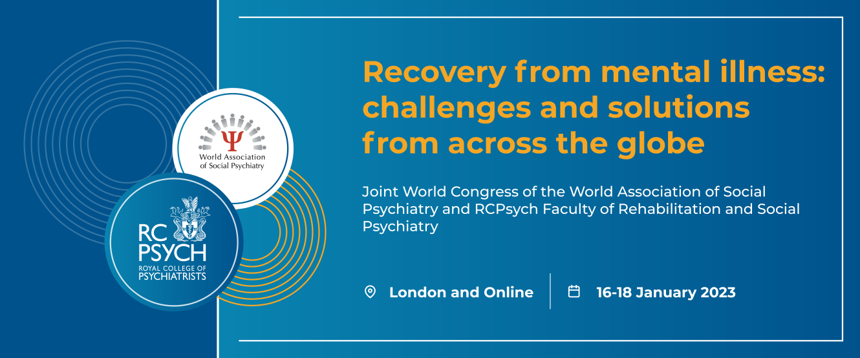

Registration Form

PLEASE PRINT ALL DETAILS CLEARLY

The College’s Data Protection Statement can be viewed at www.rcpsych.ac.uk/dataprotection

- Personal Details

College Membership Number:
Title: | First Name: |  | Surname:
Place of Work:

Mailing Address:

Town: |  | Postcode: |  | Country:
Email: |  |  |  |  | Tel (Daytime):

- Registration Fees

In person
In person (senior doctor) Country Band A | £500.00
In person (senior doctor) Country Band B | £450.00
In person (senior doctor) Country Band C & D | £400.00
In person (trainee, service user, voluntary sector, non-medical staff Country Band A | £400.00
In person (trainee, service user, voluntary sector, non-medical staff Country Band B | £350.00
In person (trainee, service user, voluntary sector, non-medical staff Country Band C *& D | £300.00
Live-streamed online
Virtual (all categories) Country Band A | £200.00
Virtual (all categories) Country Band B | £100.00
Virtual (all categories) Country Band C and D | £50.00

Registration confirmation will be sent via email within 48 hours of processing. If you are unsure if your registration form has been received please contact wasp23@rcpsych.ac.uk

REGISTRATION WILL CLOSE ONE DAY PRIOR TO THE CONFERENCE.

- Payment

PLEASE NOTE THAT THE COLLEGE IS UNABLE TO INVOICE OR ACCEPT CASH PAYMENTS FOR REGISTRATION FEES

Places can only be reserved when payment is received with this form. If an authority is to pay, the delegate should either pay and then claim reimbursement from the authority or enclose payment from their authority.

- BACS: I enclose remittance advice form for £ ................................
Bank details below. Places can only be reserved when remittance is received with this form using reference J2I001 and delegate’s name.

- Credit/debit card: Unfortunately we are not able to take credit/debit card details in hard copy. If you are booking for yourself and wish to pay by card, please do so online. If your Trust is making payment on your behalf and would like to pay by card, please call the Events Team on 020 8618 4150 for payment over the phone.

Bank details
Account name: The Royal College of Psychiatrists
Account number: 40201340
Sort Code: 20-06-05
IBAN: GB31 BARC 2006 0540 2013 40
Swift Code: BARCGB22

RCPsych Events Terms and Conditions

Privacy Policy

The information you provide when registering for an event will be used to:

- Provide you with services or information that you have requested from us such as attendance at one of our events or inclusion in a mailing list.
- Contact you with information about an event that you’re attending.
- Email you about other RCPsych events that may interest you.
- We may share your details with subcontractors if necessary for the purposes of your event registration. For example, if you include accommodation as part of your booking we will share your details with the hotel or if an external company is appointed to produce the badges, your details will be shared with them. External companies will be allowed to use your details for the purpose of your event attendance only.
- We will never share or sell your details to third parties for any other purposes.
- Information about non-members of the College will be held for 6 years.
- You can unsubscribe at any time by emailing CALC@rcpsych.ac.uk or contacting your local division or devolved nation’s office.

Cancellation policy
If you need to cancel your booking, we will be able to refund you as follows:

- 80% up to one month before the first day of the event
- 50% between one month and up to two weeks before the first day of the event
- We will not be able to offer any refunds where cancellation is received with less than two weeks’ notice.

All cancellations must be received in writing.

If the event is online, please ensure you have read and understood the technology requirements. RCPsych assumes no liability if you cannot connect, view or participate in the event.

Please note that online events may be recorded and made available to attendees of the event for a specified time period. If there is an interactive element of the course and you do not wish to appear in the recording then please keep your camera turned off.

RCPsych reserves the right to amend the programme or cancel an event.

If an event has to be cancelled or rescheduled we will contact you as soon as possible to notify you of the change. You will be offered an alternative or a full refund. We cannot reimburse travel, accommodation or other costs related to the event.

RCPsych assumes no liability if an event is cancelled or rescheduled resulting from fire, strike, terrorism, industrial action, pandemic, extreme weather or any cause beyond our control.

The Royal College of Psychiatrists has absolute discretion in the admission of participants and reserves the right to decline any registration.

