RCPsych in Scotland  Addictions Faculty Conference  Friday 27 March 2026  Apex Dunblane Hydro | 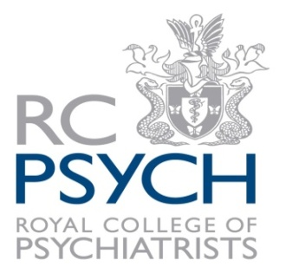

CALL FOR ABSTRACTS

Title of paper:
Name(s) of presenters:

Contact Address (1) | Contact Address (2)
Tel:  Fax:  Email: | Tel:  Fax:  Email:

DETAILS OF PROPOSAL
Abstracts should be no longer than 300 words.

Please return to Susan Richardson at RCPsych in Scotland Susan.Richardson@rcpsych.ac.uk no later than 5pm on Friday 27 February 2026.

