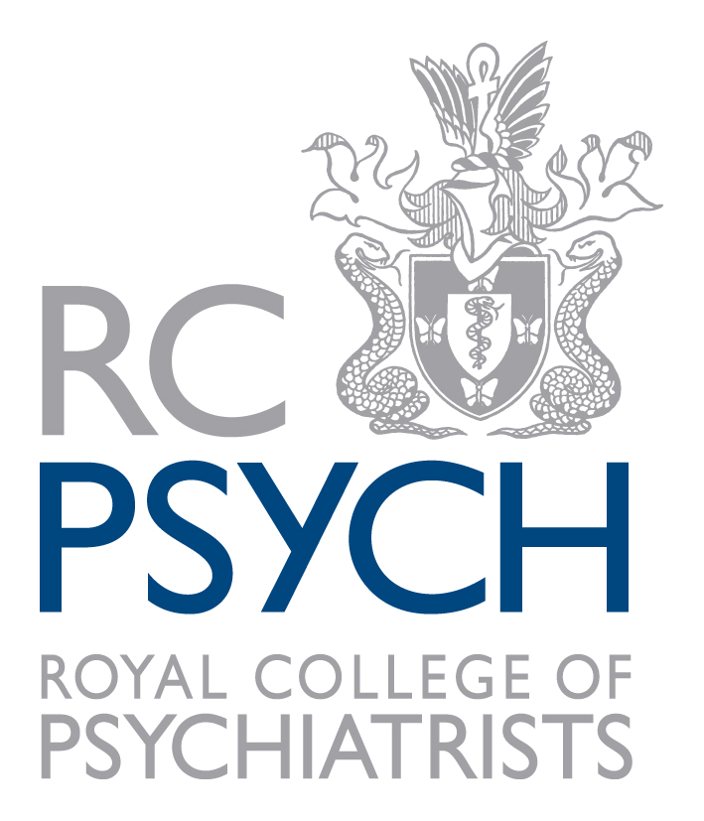

South West Division

Lisa Thomas Poetry Prize 2026 – Entry Form

Please complete all boxes below and submit the following to southwest@rcpsych.ac.uk:

- your signed entry form
- your poem(s)
- your consent form

Full Name:

Address and postcode:

Connection with mental health:

Telephone number:

Email address:

Title of poem(s):

- I confirm that I have read and understood the prize regulations.

- I understand that I must submit a maximum of 2 poems in the style as set out in the regulations to southwest@rcpsych.ac.uk by 27 March 2026.

- I confirm that, should I win a prize, the South West Division of the Royal College of Psychiatrists may reproduce it in any of their material, i.e. newsletter, meeting programme, website etc, together with any photographs taken at the award ceremony.

- I understand that, should I win a prize, I will be invited to receive my award and recite my winning poem to a live audience at the Spring Biannual Meeting on 12 May 2026. I accept that I will need to make my own travel arrangements.

- I have read the Royal College of Psychiatrists’ information on Data Protection and Copyright.

Signed: Date:

