Royal College of Psychiatrists in Scotland
Working Retired Psychiatrists Group Meeting
Wednesday, 16 January 2019
Millennium Hotel, Glasgow
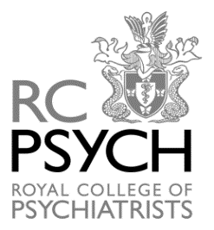

PROGRAMME

10.00 | Arrival and Registration  (Tea & Coffee)
10.15-11.00 | ‘Delivering parity of esteem for children and young people's mental health in Scotland’  Dr Denise Coia, Chair of Taskforce for children and young people's mental health, Convenor of Children in Scotland
11.00-11.15 | Break for tea/coffee
11.15-12.00 | ‘Do NHS Boards need psychiatrists?’  Dr Donald Lyons, Non-executive director NHS Greater Glasgow and Clyde
12.00-12.45 | ‘The writing of "START"- a memoir of life on a CTO, the power of love, the sea, the sky and forgiveness’  Graham Morgan, Writer, volunteer with HUG action for mental health, and engagement and participation at the MWC
12.45-13.00 | Business Meeting
13.00-14.00 | Lunch

