Royal College of Psychiatrists in Scotland  Working Retired Psychiatrists Group Meeting  Wednesday 16 October 2019  The Hilton Carlton, Edinburgh | 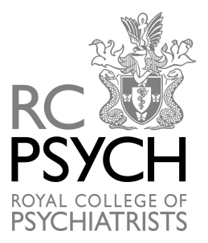

Programme

10.00 | Arrival and Registration  (Tea & Coffee)
10.15-11.00 | A novel approach to the history of medicine: a look at the relationship between fiction and medical history.  Dr Allan Beveridge
11.00-11.15 | Break for tea & coffee
11.15-12.00 | Madness at the Theatre  Prof Femi Oyebode
12.00-12.45 | Writing & blogging about mental illness: finding the words  Dr Rebecca Lawrence
12.45-13.00 | Business Meeting
13.00-14.00 | Lunch

