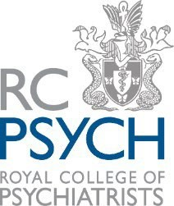
Quality Improvement Annual Conference
12 October 2026 | RCPsych, 21 Prescot Street, London E1 8BB

Programme

09.00-09.15  (15 minutes) | Registration/Welcome
09.15-09.30  (15 minutes) | Introductory Remarks  from the QI Conference Planning Team
09.30-10.15  (45 minutes) | Early Career Professionals Workshop  led by the Aspiring Leaders in Healthcare Network
10.15-10.30  (15 minutes) | Morning Break
10.30-11:00  (30 minutes) | Presentation/Workshop  (TBC)
11.00-12.00  (1 hour) | Quick-Fire QI  3 or 4x short presentations sharing practical, everyday QI tips and tricks (TBC)
12.00-13.00  (1 hour) | Lunch  Networking/Poster Viewing and Judging
13.00-13.20  (20 minutes) | Warm-up Activity/Game  (TBC)
13.20-15.30  (2 hours, 10 mins) | Culture of Care Workshop  (NCCMH)
15.35-15.45  (10 minutes) | Poster Prizes and Close  (Dr Amar Shah)

