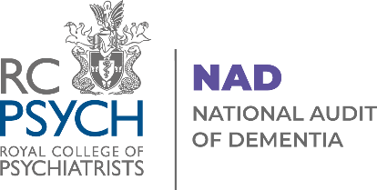

National Audit of Dementia:
Organogram 2023 (December)

Key:
Decision making input
Advisory input

Summary of input

Director (CCQI)

Project Team (CCQI)
Expert Advisers
Implementation Group

Steering Group

Organogram

Project Team

See Page 3 for further explanation of roles/input

Audit Management and Governance

Decision making input Advisory input
Dr Dasha Nicholls  Clinical and Strategic Director (Audits and Research), CCQI |  | - Directs and has overall responsibility for delivery of all CCQI projects  - Sits on Steering Group and Implementation Group  - Attends Contract Review meetings |  | Steering Group  Representation from supporting organisations representing clinicians, service users and other stakeholders, plus expert advisers and CCQI managers |  | - Provides advice and guidance on all aspects of the audit including recruitment and engagement, content development, communications, and reporting  - Meets two-four times a year throughout
Dr Alan Quirk  Head of Clinical Audit and Research |  | - Directs and supervises the work of all audits in CCQI  - Sits on Steering Group and Implementation Group  - Attends Contract Review meetings |  | CCQI Audit Programme Managers |  | Provide peer support and advice to audit Programme Manager and team
Implementation Group  Expert advisers and CCQI managers |  | - Coordinates expert input into audit development and operation  - Meets monthly during development and bimonthly otherwise
Project Team  Programme Manager  Deputy Programme Manager  Project Officers |  | - Responsible for implementing the project, engagement with participants and day to day decision making  - Meet weekly with Dr Quirk to coordinate tasks, report on progress and anticipate and report on feasibility  - Provide regular updates to Implementation and Steering Groups and take forward decisions
Other
CCQI Governance Board |  | Chaired by Royal College of Psychiatrists President, membership includes RCPsych CEO, Dean and Clinical Lead for Accreditation  Provides oversight to all CCQI projects in matters of practice, ethics and methodology, e.g. approves general CCQI guidance on involvement of service users. Not involved in decision making relating to project content and delivery

