Guidance for questions:
Optional Casenote Audit
April 2019
© HQIP 2019

Timeline for data collection
Data collection opens 20 May (collecting data for discharges from April 2019). Data collection deadline is 20 September.
Contacting the Project Team
For any queries, please contact the project team via email: nad@rcpsych.ac.uk
or visit our website: www.nationalauditofdementia.org.uk

Chloë Hood  Programme Manager | chloe.hood@rcpsych.ac.uk  020 3701 2682
Aimee Morris  Deputy Programme Manager | aimee.morris@rcpsych.ac.uk  020 3701 2697
Samantha Ofili  Project Officer | samantha.ofili@rcpsych.ac.uk  020 3701 2707
Jhermaine Capistrano  Project Officer | Jhermaine.Capistrano@rcpsych.ac.uk  020 3701 2650
Lori Bourke  Project Officer | lori.bourke@rcpsych.ac.uk  020 3701 2681
Jessica Butler  Project Administrator | jessica.butler@rcpsych.ac.uk  020 3701 2688

Please note that when contacting the project team about your casenotes, do not at any time disclose any identifiable data about the patient (e.g. name, NHS number). The Project Team are not allowed to have this information.
Before you begin
Accessing the data collection tool:
- Test the online data collection link: http://rcop.formic.com/webforms/
- This will open Formic Web Forms
- Click the ‘login’ button in the top left of the page to get to the login page.
- You will then need to enter the unique username and password for your hospital. These will be sent via post to your nominated audit lead.
If you cannot access the Formic Web Forms page, this is probably due to your local IT settings and you will need to contact your IT department to ask them to approve the link.
Anyone entering data for the organisational checklist or casenote audit, as well as all staff accessing the staff questionnaire online will need access to this website, so please do arrange for this as soon as possible.

Identify the key people you are going to work with:
This is a complex audit which should not be carried out by a single lead. The guidance for each tool gives some suggestions of colleagues who could help you to collect and co-ordinate the return of the different types of data required.

Let us know if we can help
We are available to answer queries within office hours, or you can email us, and we will respond as soon as we can.
We look forward to working with you.

Completing the casenote audit
Each hospital site is expected to submit an audit of casenotes of patients discharged with dementia, identified through ICD10 coding (listed at APPENDIX A). One form is to be submitted online per set of notes audited.
Data collection opens 20st May with a deadline of 20st September 2019.
Each hospital will be asked for:
An audit return of eligible casenotes, for which the minimum sample will be 25 and the maximum 100 patients. This will give larger hospitals the opportunity to return a larger sample. If your hospital cannot identify 25 patients discharged in April, you may continue to identify patients discharged in May.
Input will be required from:
- Your local audit lead;
- The lead for dementia or a senior clinician working in this area;
- Staff who normally undertake casenote audit, i.e. audit department or information services staff, junior doctors, dementia champions or nursing staff.
Data can be submitted online by persons other than the auditors.
Estimated time to complete:
We predict that 2-3 hours will be required to identify the sample and each casenote will take between 15 minutes and 50 minutes to submit, with the first couple of sets taking the longest to do, according to feedback from hospitals.
Organising your sample
For information on organising your sample, please go to the Round 4 web page and view the Sampling guidance for the casenote audit.

How to enter data online
Data collection site
Follow this link: http://rcop.formic.com/webforms/ and enter the username and password sent to the NAD lead at your hospital.
NAD login details
To access the casenote audit tool, you will need to login to your hospital specific account. More than one person can access this account at the same time so please make sure you are aware of other people using the account to avoid duplication.
You will also need your 4-character hospital code. If you are not able to obtain these details from your local audit lead, contact the project team.
Entering Data
Step by step guidance on using the web forms is available on the website.
Please note: when entering data in free text comment boxes, please avoid the use of paragraph breaks (enter on the keyboard) and commas. This affects the download data function.
Question routing
Some questions on the casenote audit are routed, depending on previous answers. This means that some will not appear if a particular response to a previous question is chosen. The routing of questions is detailed on the printable PDF form which you can find on the website.
When submitting data online you will be prompted to return and answer any mandatory questions that have been missed. All questions are mandatory unless marked as optional.

Saving a questionnaire
You can save an incomplete questionnaire and go back to it by clicking “Save” at any point.
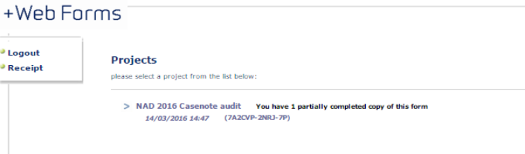
You can access all saved forms when you login by clicking on the text that says “You have X partially completed copies of this form”. All saved forms will then appear below (please see image below).
Please click here

You can continue to work on and save a form until it is ready to submit. If you are leaving a form inactive for more than 5 minutes, we recommend you save the form to come back to later. The website will automatically time out after 20 minutes of inactivity.

Please be very careful when saving forms and returning to them, to ensure you do not enter half of one casenote and half of another.

When you have completed the form, and are happy to send off the data, please press “submit” to send the casenote audit to the Project Team. We cannot see any saved forms, only those which have been submitted.

Please note: submission is final, and data can no longer be retrieved or amended once the casenote audit has been submitted. All data must be submitted by 20`1 September.

Downloading your data
You can download submitted forms to view in an excel spreadsheet by selecting ‘Download data’. Please note: submitted forms cannot be amended.
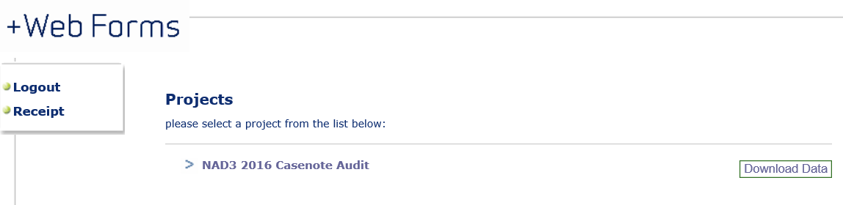
Please click here

Forms which have been saved but have not been submitted, cannot be downloaded.

Please carefully check your data before submission.

If after submission you notice changes that need to be made, please contact the NAD project team at nad@rcpsych.ac.uk. Please tell us: the record ID number, question number for the change and the change to be made. Changes will be made during data cleaning, after data collection has closed. This means, changes requested will not be viewable in the data you download.

All data must be submitted by 21 September.

Guidance for questions
Guidance to individual questions is provided in the tool. Supplementary guidance is below. If you need any further guidance before answering a question, please contact the project team (see page 2).

Primary diagnosis/cause of admission (Q6)
This will be the main reason for admission and treatment. If more than one primary reason is given, enter all.

Fast track discharge (Q9)
Terms in use may vary, but this question is intended to identify those patients where discharge was expedited under an agreed local procedure geared to the best interests of the patient – patients in these circumstances may have had their usual discharge assessment and write ups in the community.
It does not refer to patients discharged before expected assessments and arrangements for other reasons, e.g. operational.

Assessment questions (General)
Please note that details of assessments may be found in nursing and therapy notes, as well as in medical notes. MDT assessment may have been carried out on or after admission, i.e. once the patient becomes well enough.
If there has been no intention to carry out the assessment at any point during the admission and there is no discernible reason, then “No” should be answered.

Cognitive assessment (Q20)
Answer this in relation to validated instruments recommended for cognitive testing – see link in tool for NICE guidance.

Initial screening assessment (Q21)
Q21 asks about any initial screening assessments for delirium. A screening assessment may be undertaken by any (qualified or unqualified) healthcare staff.
If a screening assessment suggests no delirium present (Q21a), you will not be asked Q22. However, if the screening tool suggests there may be delirium present, you will be asked whether a healthcare professional, trained in diagnosing delirium, assessed the person for delirium.
You can use the “other” option to indicate other screening tools for delirium which you may use in your hospital or to indicate “clinical judgement” or that delirium was recorded in patient notes.
Assessment for delirium by a healthcare professional (Q22)
In this round of audit, you will also be able to answer that no initial screening assessment took place, but a healthcare professional did complete an assessment for delirium (i.e. you can answer no to Q21 and still answer Q22). This can be used to indicate for example where a healthcare professional suspected delirium (without use of a screening tool) and went straight to undertaking an assessment to establish whether delirium was present or not.
In Q22, you may use the “other” option to indicate other tools which may have been used in a diagnosis. This option can also be used to indicate “clinical judgement” where a healthcare professional, trained in diagnosing delirium, reviewed the results of the screening assessment and diagnosed (or confirmed no delirium) using their experience and by talking to the patient.

4AT in Q21 and 22
The 4AT tool has been included in both the screening assessment question and the assessment by a healthcare professional to reflect the fact that hospitals use the 4AT in both situations.
If the 4AT was completed once by a healthcare professional (trained in diagnosing delirium) to establish the presence of delirium, you should answer no to Q21 (if no other screening took place) and 4AT to Q22. If it was completed initially by one member of staff, and then additionally by a healthcare professional trained in diagnosing delirium, you should answer 4AT to both Q21 and Q22.

Information: Response option “Unknown” is provided in this round (Q23a-23f)
This can be answered where it is expected that the information was collected but the document is returned to the patient on discharge and a copy is not kept with the notes.
Consent and capacity (Q28a)
This question looks at consent and capacity in the case of referral to a social worker regarding a proposed change in residence after discharge. Response options are based on whether the patient’s consent was gained, or whether capacity to consent was assessed and correct procedure followed (information on NHS website). You do not need to access social care notes to answer this question, as it is concerning the referral to a social worker, and not the outcome of the meeting.
Quality assurance in the casenote audit
You will find comment boxes provided at the end of each section. These can be used for any clarifications or queries you have about your responses. During data cleaning, we may contact you if any further information is needed about these comments.

