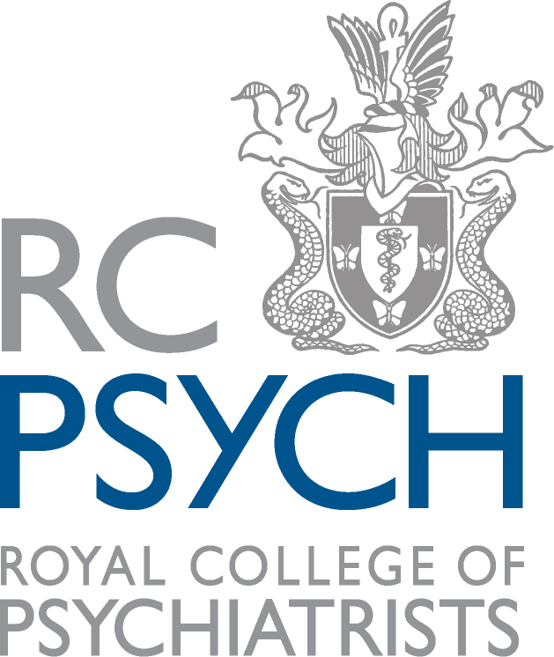

Team membership to Community CCQI networks
In order to maintain membership to the Quality Network for Eating Disorders (QED) as one team, services must comply with the following restrictions.

Where there is more than one team base or there are ‘sub teams’ working in different geographical areas all parts of the service must:
- Come under the remit of the same trust or organisation
- Work to the same operational policy and admission criteria (or equivalent documents)
- Conduct service development meetings together on a regular basis (it is understood that these meetings may only be attended by management staff)
- Have at least one member of the senior management team working across all sites/sub teams

Where there is more than one team base or there are ‘sub teams’ working in different geographical areas it is expected that all parts of the service do at least one of the following:
- Have weekly team meetings to discuss referrals and caseloads
- Have regular whole team meetings to discuss service development

