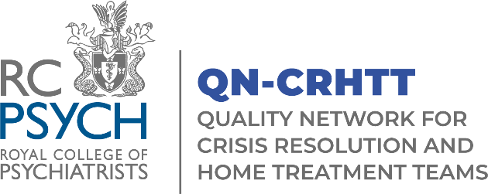

Application for Membership of the QN-CRHTT Accreditation Committee (AC)

Closing date for applications is Sunday 28th September.
Induction into the AC will take place Thursday 09th October 10:00-11:30.
The AC will next meet on Thursday 16th October, 10:00-13:00.

We are very pleased to announce the recruitment to the QN-CRHTT Accreditation Committee.

The Accreditation Committee (AC) considers the evidence gathered about QN-CRHTT member services and makes a recommendation about accreditation status to the Combined Committee for Accreditation. Further details can be found in the terms of reference.

All applicants should be from services who are members of QN-CRHTT and undertaking the review process. We are looking for a range of disciplines including support workers, peer support workers, occupational therapists and assistants, psychologists and assistants, pharmacists, nurses, and psychiatrists. This list is not exhaustive.

Please return your completed form to QN-CRHTT@rcpsych.ac.uk
If you wish to discuss your application please contact Paris.Wilson@rcpsych.ac.uk

Name:

Job Title including Clinical Background:
Team Name and NHS Trust/Organisation:

Direct Telephone number:

Email Address:

Please explain why you would like to join the committee, including details of relevant experiences, interests or skills that you can bring to the group (please refer to the QN-CRHTT Terms of Reference for a list of roles and responsibilities and a person specification).
Please use the space provided below and continue on to the next page if necessary.

