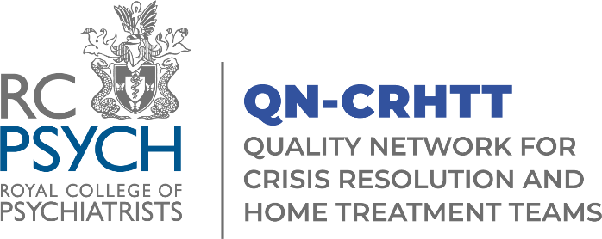

Application for Membership of the QNCRHTT Advisory Group (AG)

Closing date for applications is 12:00 on Friday 30th September 2022.

The Advisory Group will meet from 6th December from 1-4pm, and then 4 times per year following this.

We are particularly looking for representatives who work within the devolved nations, children and adolescent and older age specialities.

Name:

Job Title:
☐Pharmacist
☐Nurse
☐Social Worker
☐ Occupational Therapist
☐ Psychologist
☐Other. Please specify:

What age range do you work with (tick all that apply)
☐Children and Adolescents
☐Working Age Adults
☐Older Adults
Where do you work?
☐England
☐Scotland
☐Northern Ireland
☐Wales
Team name and Organisation:

Telephone number:

Email Address:

How have you promoted Equality, Diversity and Inclusion within your service/Trust/organisation? E.g. facilitating training on cultural differences, celebrating Pride.

Please explain why you would like to join the group, including details of relevant experiences, interests or skills that you can bring to the group (please refer to the terms of reference document for a list of roles and responsibilities and a person specification).

