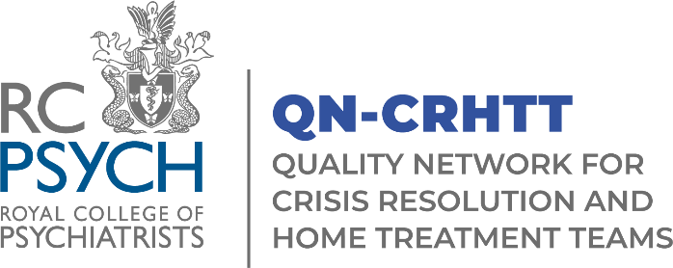

Application for Membership of the QNCRHTT Advisory Group (AG)

Closing dates for applications is Sunday 28th September.
Induction will take place Tuesday 21st October 2025, 10:30-12:00.
The AG will meet on Tuesday 18 November, 2-4pm, and then four times per year following this. Please note all meetings are currently taking place via Microsoft Teams.

We are very pleased to announce the recruitment to the QN-CRHTT Advisory Group.

The Advisory Group (AG) comprises of professionals working across Crisis Resolution and Home Treatment Teams. The purpose of the group is to promote and further develop the work of QN-CRHTT.

All applicants should be from services who are members of QN-CRHTT and undertaking the review process. We are looking for a range of disciplines including support workers, peer support workers, occupational therapists and assistants, psychologists and assistants, pharmacists, nurses, and psychiatrists. This list is not exhaustive.

Please return your completed form to QN-CRHTT@rcpsych.ac.uk
If you wish to discuss your application please contact Paris.Wilson@rcpsych.ac.uk

Name:

Job Title including Clinical Background:

Team Name and NHS Trust/Organisation:

Direct Telephone number:

Email Address:

Please explain why you would like to join the group, including details of relevant experiences, interests or skills that you can bring to the group (please refer to the terms of reference document for a list of roles and responsibilities and a person specification).

