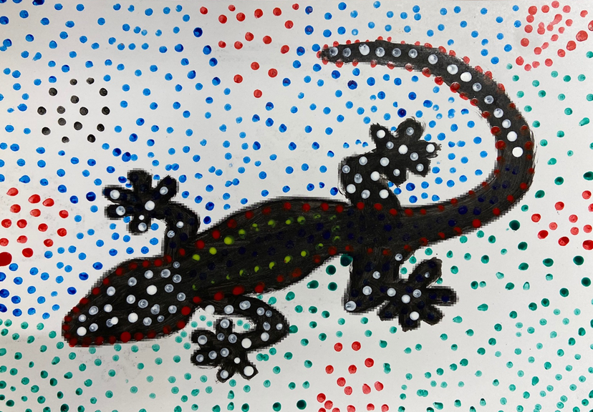
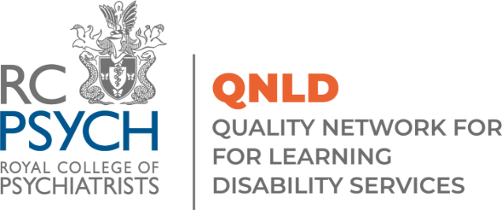
Proposal Form
Special Interest Day – Legal Issues (5th July 2022)

Please send all proposal forms to amy.colwill@rcpsych.ac.uk by Monday 23rd May 2022

Speaker details

Name (s):

Job title/role (s):

Service/Organisation (s):

Email address:

Telephone number:

Address:

Presentation details
Note: Presentations slots are 30 or 40 minutes long

Type of presentation (oral, workshop or poster):
Presentation title:

Summary (no more than 300 words):

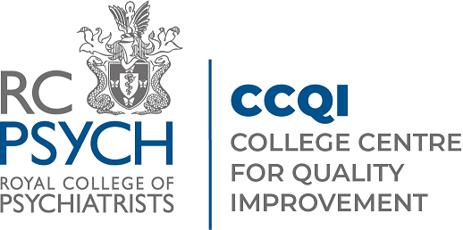
QNLD
The Royal College of Psychiatrists
21 Prescot Street
London
E1 8BB

LD@rcpsych.ac.uk
www.rcpsych.ac.uk/QNLD
© 2022 Royal College of Psychiatrists

