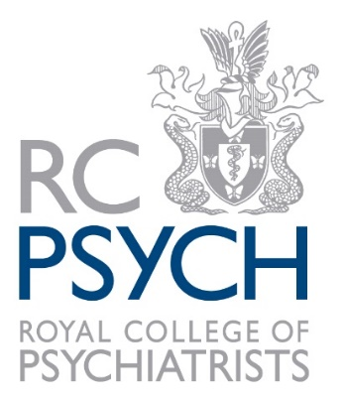
MSNAP Special Interest Day
Young Onset Dementia

15th July 2019
21 Prescot Street, London, E1 8BB

Please return this form by email to MSNAP@rcpsych.ac.uk, or post to MSNAP, Royal College of Psychiatrists, 21 Prescot Street, London, E1 8BB

Registration
Title:
Name:
Job title/ role:
Memory Service/Organisation:
NHS Trust:
Email address:
Phone number:
Access/ dietary requirements:
Your name/ workplace will be published in the conference delegate list. If you do NOT wish this to be published, please tick here: |  |  | ☐
Please choose one option below:
☐ | Staff working in an MSNAP member service (2 free places per service) – FREE
☐ | Additional staff from a member service - £40 per person
☐ | Staff from non-member service - £80 per person
☐ | Service user or carer working with MSNAP – FREE
Payment information – please choose one option below:
☐ | I would like to make a direct payment via credit/debit card (please note we do not take AMEX)
Name of cardholder:
Card number: |  | Expiry date:
☐ | I would like to be invoiced (payment by BACS)
Invoice for the attention of:
Invoice address:
Purchase order number if applicable:

Please note MSNAP is unable to reimburse travel and other expenses, including session fees, for delegates attending this event.
This course is eligible for 5 CPD hours subject to your peer group approval

