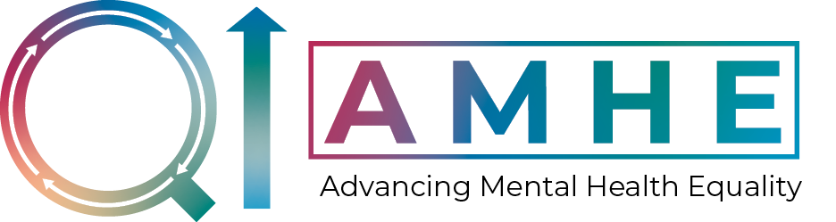

Advancing Mental Health Equality (AMHE) Collaborative –

Learning Set 5 Agenda
Date: Tuesday 6th September 2022, 11:00 – 15:00
Location: Royal College of Psychiatrists, 21 Prescot Street, London, E1 8BB

Time | Item | Speaker
10:30 – 11:00 | Registration and refreshments
11:00 – 11:10 | Welcome and introductions | Tom Ayers  Director of the NCCMH
11:10 – 11:25 | Getting to know each other | Tom Ayers  Director of the NCCMH
11:25 – 11:55 | Question wall | QI Coaches
11:55 – 12:30 | Engaging community assets: Part 1 | QI Coaches
12:30 – 13:15 | Lunch
13:15 – 13:50 | Engaging community assets: Part 2 | QI Coaches
13:50 – 14:50 | Co-production workshop: Power & privilege | Mark Famer and Meera Burgess  Patient and Carer Representatives NCMCH
14:50 – 15:00 | Close | Tom Ayers  Director of the NCCMH

