Personal Journal and Scrapbook
Times are Hard during Covid 19 but We’re Making History
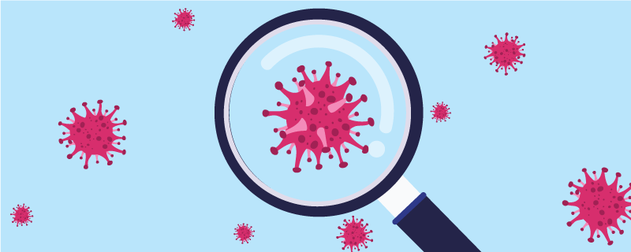
Introduction
Although things are very stressful and uncertain for every one of us right now, we are living through an important period in global history. It may not feel like it but we are all playing our own important part in keeping ourselves and others safe.
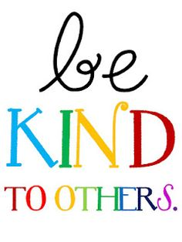
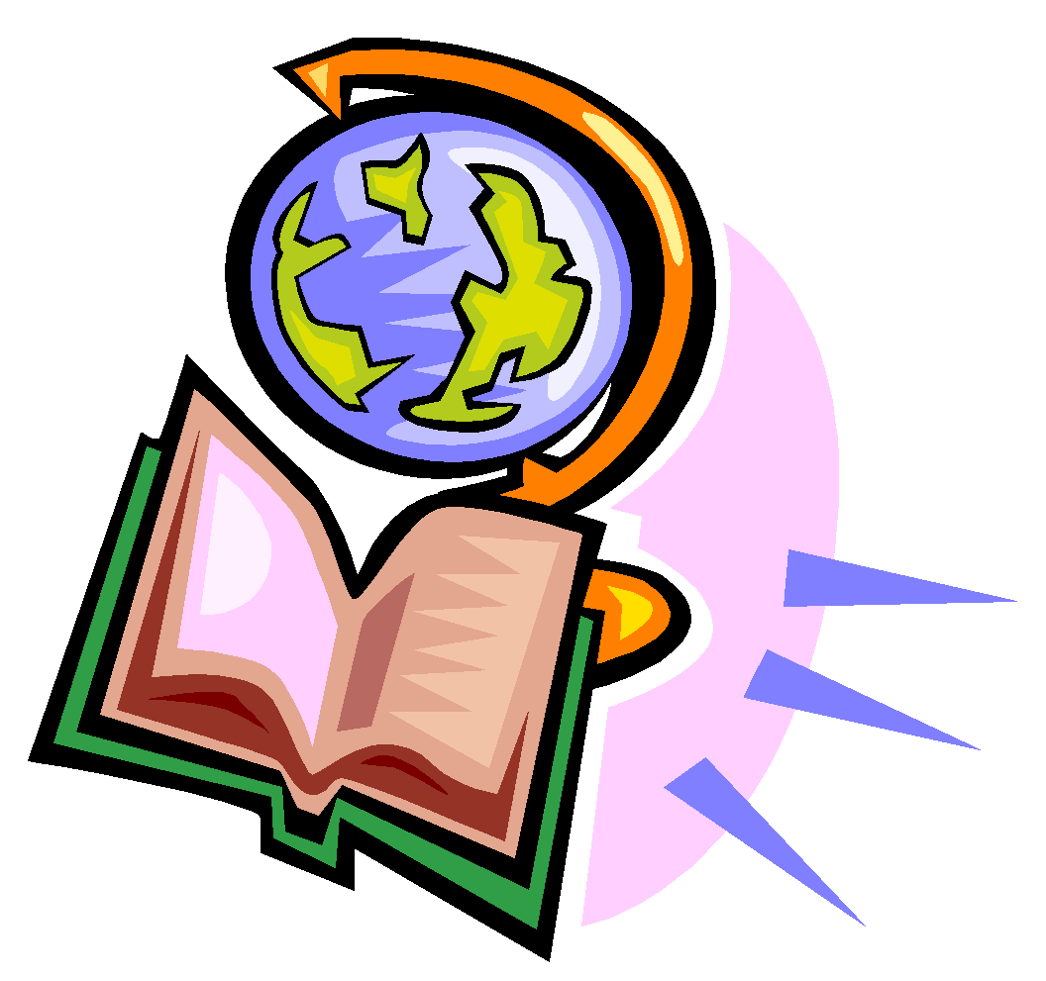
People in the future will be looking back at these times and wanting to know about them. What it was like for people. How they felt. Where they were and how they coped with the situation.
Keeping a kind of diary, journal or scrapbook could be a very useful way of expressing how we are at this moment and recording useful thoughts and information either for ourselves or for others.
It could record the difficulties the restrictions are placing on us all and also capture those small, positive things, which are coming out of these times, the good news stories.
Also, we might want to think about how we might be reviewing our lives for when times begin to settle again?
You might want to write or sketch or use any form of art or photography to express your ideas. (Please remember we have to maintain confidentiality so don’t photograph other patients.) Nevertheless, there are plenty of creative ways to take a series of photos to tell a story.
Or you could perhaps:
- Record your own blog on your phone.
- Write an encouraging letter to your future self.
- Express your thoughts in poetry or song lyrics.

The following pages give some ideas of the kinds of things to consider. Dip in, take what appeals to you, you don’t have to cover everything.

This Pack is the Property of _______________________________________________________
Life on the Ward:
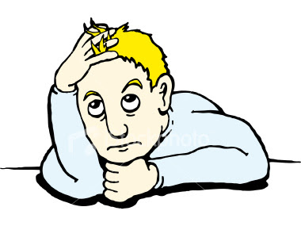
How has life changed on the ward during your admission?
What kinds of things have the ward been doing?
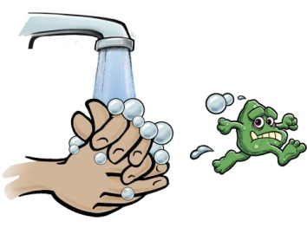
How has the situation affected staff and the way they are working?
How have you been coping with the need for constant hand washing and do you have your own hand washing song?
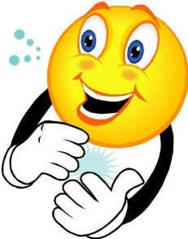
Has the ward been getting involved in Thank You Thursdays and doing any artwork for this such as painting rainbows, which have suddenly become iconic symbols across the country?

Staying in Touch:
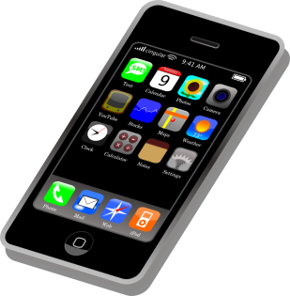
Are you managing to keep in touch with family and friends?
How has this been?
What would you like to say to them that you may not have been able to?

Following the News:
Have you been following progress of the pandemic on the news?
How has the reporting made you feel?
Have you been limiting your access to the news so that it doesn’t overwhelm you?
Collect any particular news reports or headlines that interest you

Staying Fit and Active:
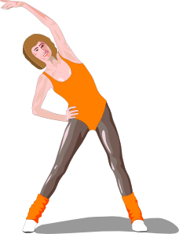
Although it’s not easy, how have you been keeping fit?
Have you been getting outside?
Have you found any exercise or dance videos to get involved with?
What have the difficulties been?

Getting Involved:
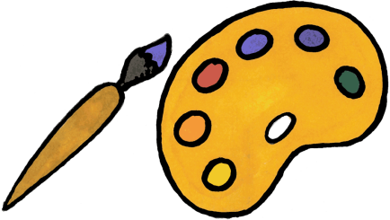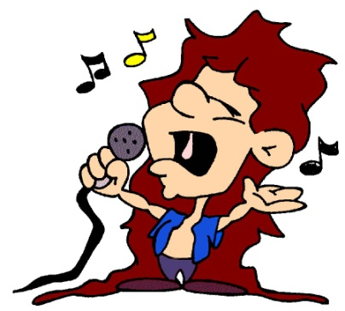
How have you been spending your time?
Many well known people have been making recordings from home and reaching out on TV, YouTube and Social Media, to everyone who is not able to go out.
Has there been anything which has interested you and got you involved?
Have you been learning anything new or developed any new hobbies or interests?

Coping with how you are feeling:
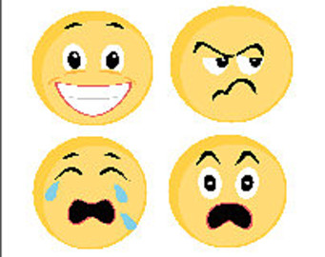
How have you been feeling at this time?
How have you been managing your feelings, what strategies have you been using.
Talking
Relaxation
Mindfulness
Reading
Music
Singing
TV / Radio
Writing
Art
Self-Soothing
Puzzles and Games

Reflecting on these times:
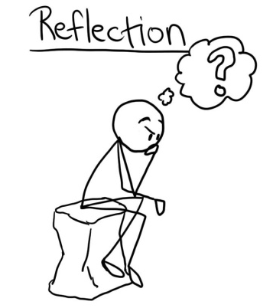
Is there anything you have learned from living through this experience during the pandemic?
Have you found your views about things altering in any way?
What has annoyed or irritated you the most in respect of the Covid 19 situation?
Have there been things you have been thankful for?
What have you been most thankful for?

Good Times and Good News:
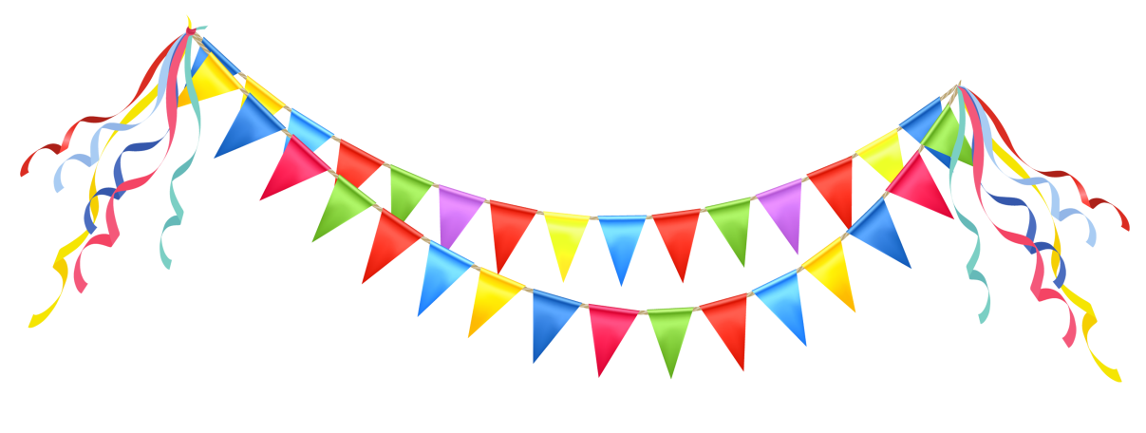
Despite not being able to go out and about, have there been any special occasions you have still managed to be involved in and make the most of in some way, - Easter for example.
What happened, how were these occasions marked?
Have there been any times when people have been kind and helped one another?

Looking Forward:
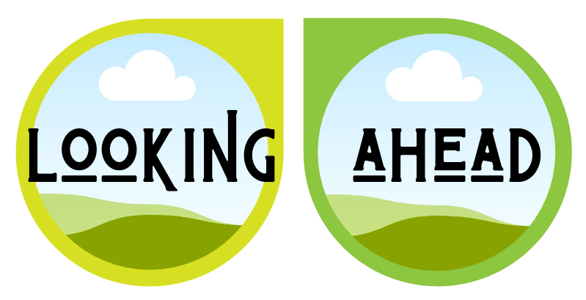
What do you plan to do when things eventually and slowly begin to return to a sense of more normal?
How do you think this will feel?

