Supporting your
wellbeing pack

Name

………………………….

Taking care of your wellbeing
We have developed this pack to help you manage your wellbeing. It includes strategies and techniques which you might find helpful at this time.
It is normal to feel unsettled when big changes happen. You might be feeling worried about coronavirus and how it could affect you. You might be feeling frustrated or scared because of the changes being made and the impact this is having on all our lives. These are all natural reactions.
This pack should be an addition to support from staff. If you need more help or you want to talk to someone, please speak to a member of staff.

Contents
Taking positive steps to wellbeing 4
Coping calendar 5
Activity planner 6
Positive affirmations 8
Managing worry 9
Mindfulness practice 11
Mindful breathing 12
The body scan 13
Mindful walking 14
Compassion focused imagery 15
Letting go of difficult emotions through Mindfulness 16
5-4-3-2-1…Grounding 17
Self-Soothe 18
Apps for mental health and wellbeing 19
Free guided mindfulness scripts 21
Pulling it all together – What works for you? 22
Further help and acknowledgements 23
Taking positive steps to wellbeing
It is important to find ways to keep yourself busy with activities that help you feel good about yourself. Focus on what you can do and plan in activities for each day. Have a look a list below for ideas.
Be kind to yourself  We all have bad days.  Encourage rather than criticise. Treat yourself the way you would treat a friend. | Exercise regularly  Being active helps lift our mood, reduces stress and anxiety, improves physical health, and gives us more energy.
Take up a hobby or learn a new skill  Increase your confidence and interest | Have some fun or be creative  Draw a picture, colour in or make a scrapbook. Enjoy yourself!
Help others  Get involved with a project, or simply help out someone you know. | Relax  Make time for yourself. Allow yourself to chill out and relax. Find something that suits you.
Eat healthily  Eat regularly, eat breakfast, eat fruit and vegetables, drink water. | Balance sleep  Get into a healthy sleep routine – including going to bed and getting up at the same time each day.
Connect with others  Stay in touch with family and friends. | Music  Listen to music you like. Sing a song or learn to play an instrument.
Try something new  Try a new food, listen to new music or read a new book. Be curious. | Write  Write a letter, a ‘thank you’ card or a journal

What other activities could you plan in each day?
………………………………………………………………………………………………………………………………………………………………………………………………………………………………………………………………………
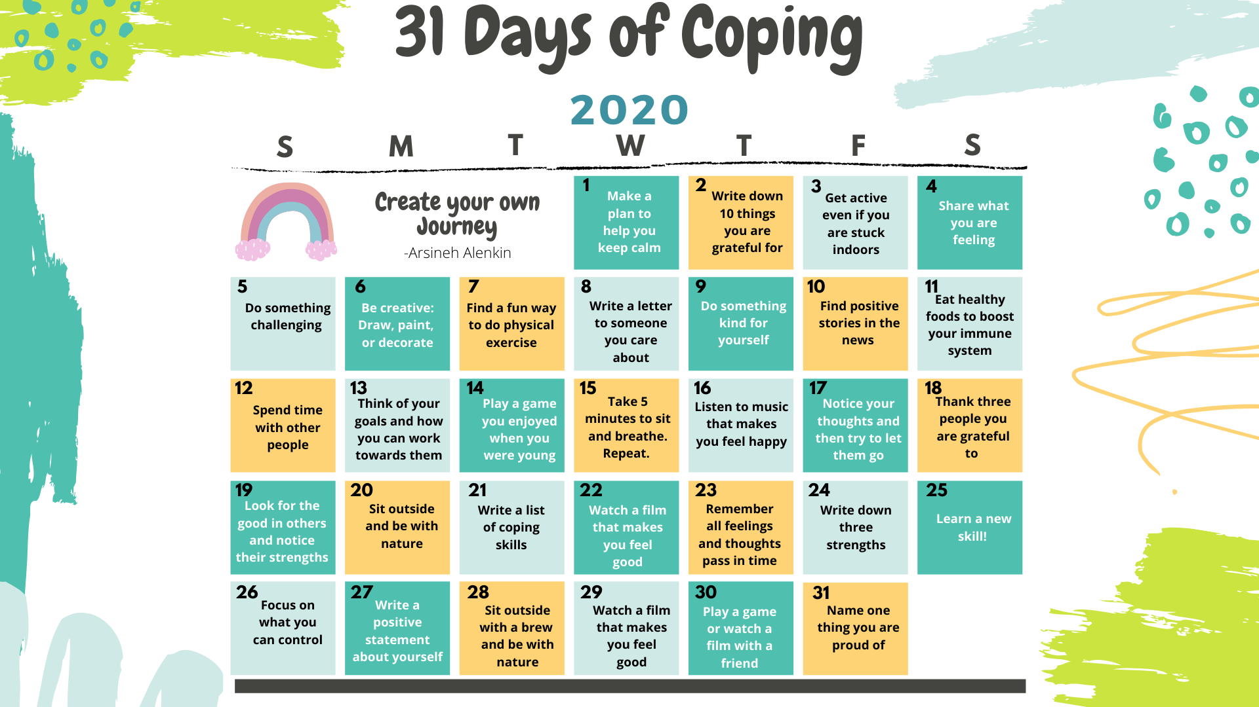
Activity planning
Now that you have thought of a few ideas to keep busy, try to make a plan for the week ahead. Try to plan activities throughout the day and break tasks down into smaller chunks.
 | Morning | Afternoon | Evening
Monday
Tuesday
Wednesday
 | Morning | Afternoon | Evening
Thursday
Friday
Saturday
Sunday

Keeping a routine is really important and can help to give us a sense of purpose and achievement and can help to feel more settled.

Positive affirmations
Sometimes we can get into unhelpful thinking patterns and think negatively about ourselves and the situation we are in. Positive affirmations can help us to think and feel better about ourselves. Use a statement that starts with I, for example:

- I am a good person
- I care about others
- I have a lot to be proud of
- I am in control of my choices
- I can get through this
- I am strong and resilient

Try to create a statement about yourself and practice using it whenever you have a negative thought.

I am…………………………………………………………

These questions might also help you to notice something positive from the day:
Describe something that made you laugh?
How has another person shown they care about you?
What has made you smile today?

What was something nice you said this week?
What challenge have you overcome this week?
Describe something you are thankful for?
Describe a moment when you felt calm or content?
What personal strength have you used today?
Managing worry
There are lots of changes at the moment. It would be hard not to worry about what it all means for yourself and others, but sometimes we can get sucked into worrying, thinking about it over and over. This type of worry can be exhausting and can make us feel worse.
Try to:
- Notice when you are worrying
- Remind yourself lots of worrying does not help
- Focus on the present moment (there are lots of mindfulness activities in this pack to help practice this)

Building resilience
Think about specific challenges you have got through in the past:
- How did you get through it?
- What did you do?
- What did you say to yourself?
- Who was supportive or helpful at this time?
- What resources did you use?
- What useful advice did you get from others?
- What did you learn about how to cope with challenges?

When thinking about ways you have coped with challenges in the past.

What did you notice about yourself?
………………………………………………………………………………………………………………………………………………………………………………………………………………………………………………………………………………………………………………………………………………………………………………………………………………………………………………………

Are there any skills which could be helpful again?
………………………………………………………………………………………………………………………………………………………………………………………………………………………………………………………………………………………………………………………………………………………………………………………………………………………………………………………

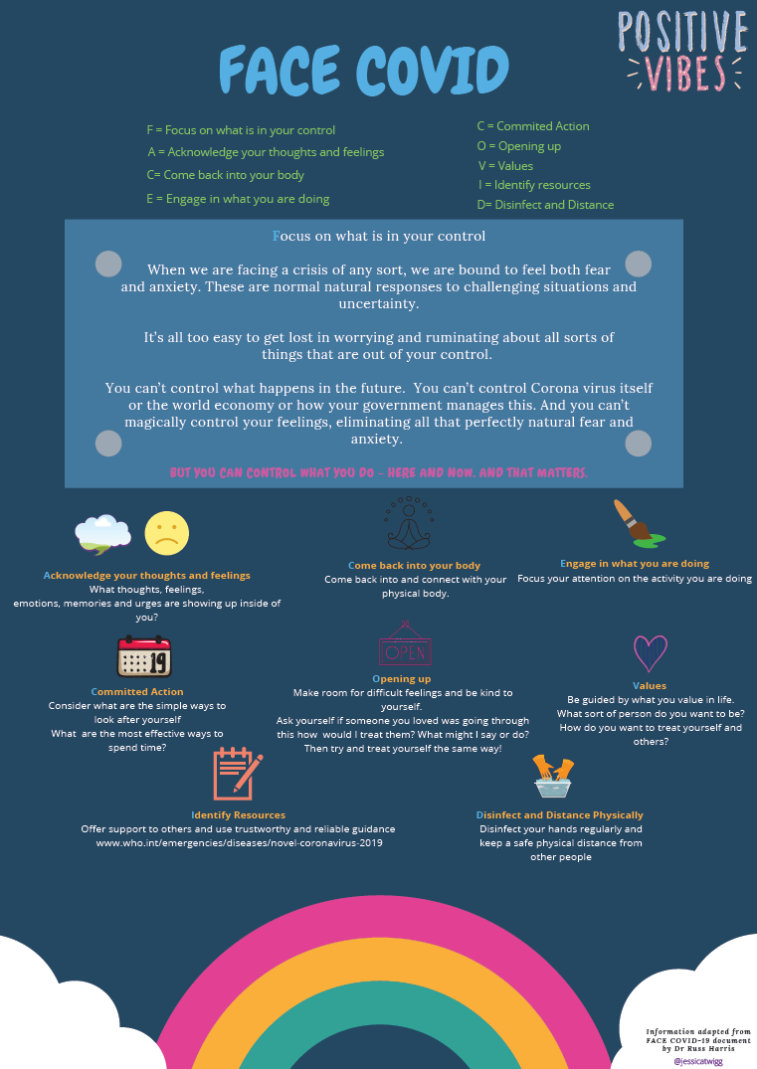
Mindfulness practice
Mindfulness can be described as paying attention to what we are experiencing in this moment, and doing so with a particular attitude: One of curiosity, openness, acceptance and warmth.
Simply observing what we are experiencing, right now, and bringing a warm curiosity to whatever arises. Allowing thoughts and feelings to come and go without getting caught up in them and without a need to change what you observe. This is your experience
Mindfulness is something that we can bring to any aspect of our day to day life. It can help to create feelings of calmness, warmth and self-compassion.
Take a moment to feel your breath and ask yourself: How is my mind right now? Is it busy or calm?
………………………………………………………………………………………………………………………………………………………………………………………………………………………………………………………………………

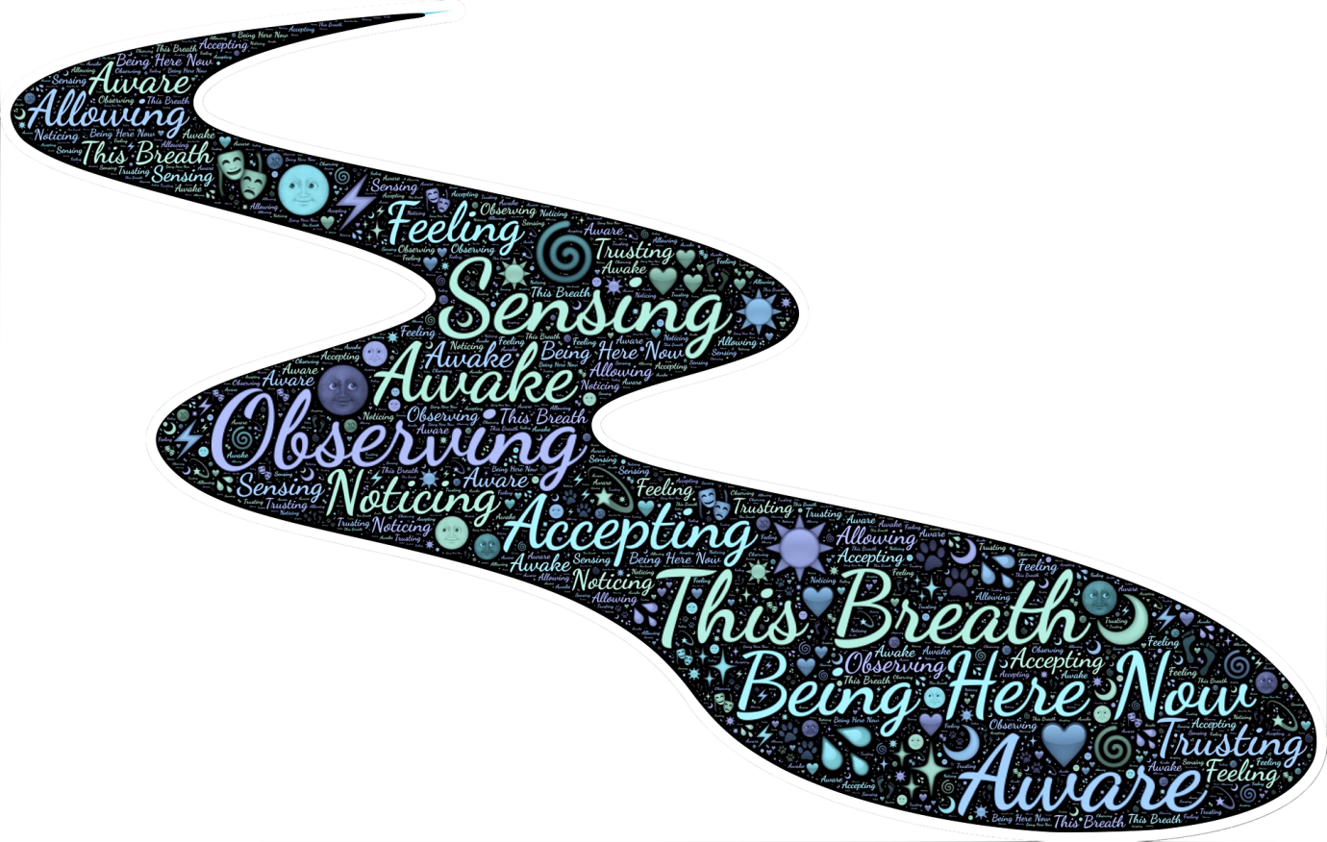
Mindfulness practice - Mindful breathing
- Sit in an upright position on a chair. Place both feet on the floor and put your hands in a comfortable position, perhaps resting on your lap, or on the arms of your chair.

- If you feel able to do so close your eyes.

- Focus on your breathing, pay close attention to each in breath and each out breath. You could pay attention to the temperature of your breath or the depth of your breath.

- Thoughts will come into your mind, and that’s okay, because that’s just what the human mind does. Simply notice those thoughts, then bring your attention back to your breathing.

- Likewise, you can notice sounds, physical feelings, and emotions, and again, just bring your attention back to your breathing.

- Keep paying attention to your breathing for a few minutes.

- With practice you could try this for about five minutes before bringing your attention back to your surroundings.

Mindfulness practice – The body scan
- Sit in an upright position on a chair. Place both feet on the floor and put your hands in a comfortable position, perhaps resting on your lap, or on the arms of your chair.

- If you feel able to do so close your eyes.

- Focus on your breathing, pay close attention to each in breath and each out breath.

- Now bring your attention to your head, notice any physical sensations in this part of your body.

- Next scan your neck and the top of your shoulders and see if you are aware of any sensations in this part of your body.

- Bring your attention down your back and notice how the top, middle and bottom of your back feel.

- Now bring your attention to your legs, notice how the top of your legs feel, then bring your attention to the bottom of your legs, finally focusing on your ankles, feet and toes.

- Now direct your attention to your hands, noticing how your fingers and thumbs feel.

- Scan your wrists, lower arms, elbows, and top of your arms and pay attention to any sensations in this part of your body.

- Bring your attention to your tummy area and notice how this part of your body feels.

- Finally pay attention to your chest. Can you notice your heart beating?

- Now take three deep breaths in and out and open your eyes, returning your attention to the room and your surroundings.

Mindfulness practice - Mindful walking
- First, set your intention to walk mindfully. Take a few deep breaths, and just acknowledge that during your walk you will try to be aware of your environment and your internal state (i.e., thoughts, feelings, sensations). There are no set rules for this walk, and it can be done anywhere.

- As you begin to walk, notice the sensation of your feet hitting the ground. Notice the process of moving your legs. What muscles tense or relax as you move? Notice where you are stepping, the quality of each step (i.e., are you stepping hard or lightly onto the ground), and the feel of the ground beneath your feet or shoes.

- Expand your awareness to notice your surroundings. As you walk, what do you see, smell, hear, taste, and feel? How does the air feel on your skin? What do you notice around you?

- Expand your awareness so that you also become aware of your internal experiences, such as your thoughts and emotions. What thoughts cross your mind as you walk? What emotion or emotions are there right now? Are they intense, or mild? Are these internal experiences pulling you in or can you observe them with a little bit of distance? No need to judge these internal experiences as good or bad, practice just noticing them for what they are.

- As you complete your walk, congratulate yourself for your intention to practice mindful walking, no matter how many times your mind was pulled away from the walk, or how "well" you thought your practice went today. Just notice that the intention to be mindful is the key to practice, and pat yourself on the back

- If at any point during your walk you notice your mind wandering to the past or the future, or being pulled away from the walk, just gently acknowledge that your mind has wandered and bring yourself back to the present moment and the walk.
Compassion focused imagery
The aim of this activity is to develop more feelings of compassion and kindness. Don’t worry if you struggle with the imagery to start with. Sometimes we need to practice to get used to it. The important thing is to be curious and see what works for you.
Creating a safe place
- Start by sitting comfortably and finding a soothing breathing rhythm.
- Allow your mind to focus on and create a place that seems as if it could give you the feeling of safeness and calmness.
- Sometimes these feelings may be difficult to generate. The act of trying, and the sense of it being the sort of place you would like it to is the important thing.
- Your place may be a beautiful wood where you can feel the wind gently on your face; it may be a beach with a crystal clear blue sea and soft white sand, or a cabin with a log fire.
- Wherever you imagine it should bring a sense of pleasure to you and a feeling of safeness.
- At your imagined place, bring your attention to each of your senses; what you can imagine seeing, feeling, hearing, tasting and smelling.
- When you bring you safe place to mind allow your body to relax.
- Imagine this as your own unique safe place, created by you. The place itself can take joy and happiness in you being there.
- When you imagine this place, allow yourself to feel soothed.

Compassion colour
- Imagine a colour you associate with compassion or kindness.
- Now imagine your compassionate colour surrounding you. Then slowly imagine this entering your heart area, through your body.
- As this happens try to focus on the colour as having wisdom, strength and warmth.
- Try to create a facial expression of kindness on your own face as you do this.
Letting go of difficult emotions through Mindfulness

5-4-3-2-1…Grounding
Grounding exercises can be helpful in managing overwhelming feelings by helping us to regain our focus and stay in the present moment. Here is a simple exercise you can do to help you feel grounded:
Look around you. What can you see?

Describe 5 things in detail

Name 1 thing you can a taste
Describe the flavour, e.g. sweet, salty, bitter, sour?
OR
Take 1 deep breath
What can you smell?
Describe 2 scents

Stop and listen. What can you hear?
Describe 3 sounds
Touch 4 things. How do they feel?
e.g. Hard or soft? Rough or smooth? Hot or cold?

Self-soothing

What is self-soothing?
Self-soothing is another way to manage difficult emotions using your
five senses
When should I use this skill?
Soothe one or more of your senses for a couple of minutes each day. Plan practice time into your day. For example, try this skill when you are not distressed. Practice using the skill when you need to cope with a lot of distress.

Developing your Self-soothing kit
Pick a box or bag that you like. Collect five or more items to go into it. Try to pick items to soothe all five senses. The ideas below might help you.
Apps for mental health and wellbeing
You might find the following apps helpful. Please note, some of the apps listed below allow you to use some of the practices for free, however, sometimes you have to pay. If you don’t want to pay for an app, go to the end of this pack, where there is a list of free YouTube links you can access.

Mindfulness
Headspace
Stop, Breathe & Think
Mindfulness Based Living

Sleep Meditation and Sleep Stories

Calm
Slumber

Breathing practices
Breathe2Relax
Breathing Zone
Mental Health
My Possible Self
(Anxiety, stress and unhelpful thinking)
Stress and Anxiety Companion
(Stress and anxiety)
Woebot
(Anxiety and depression)
What’s up?
(Depression, Anxiety, Anger, Stress)

Other NHS approved apps can be discovered here:
https://www.nhs.uk/apps-library/category/mental-health/
Online self-help booklets and NHS approved audio guides covering a range of issues, from anxiety to low mood and difficulties sleeping can be found here:
http://www.selfhelpguides.ntw.nhs.uk/penninecare/
https://www.nhs.uk/conditions/stress-anxiety-depression/moodzone-mental-wellbeing-audio-guides/

Free guided mindfulness scripts
The free Mindfulness project website: http://www.freemindfulness.org/home
Leaves on a stream:
https://www.youtube.com/watch?v=yIlZHoiOb0s 7 minutes 57 seconds
5 minute breathing:
https://www.youtube.com/watch?v=nmFUDkj1Aq0 5 minutes 22 seconds
Body scan:
https://www.youtube.com/watch?v=QS2yDmWk0vs 8 minutes, 38 seconds
Self-soothing:
https://www.youtube.com/watch?v=Xl_B45DpMLU 10 minutes 7 seconds
Being present:
https://www.youtube.com/watch?v=ZToicYcHIOU 10 minutes 30 seconds
Visuals - Calm breathing bubble:
https://www.youtube.com/watch?v=iaQed_Xdyvw 50 seconds
Octagon breathing:
https://www.youtube.com/watch?v=Wdbbtgf05Ek 5 minutes
Sleep - Time for rest:
https://www.youtube.com/watch?v=RsrYKy5aYKg 5 minutes

Pulling it all together – What works for you?
This pack contains lots of ideas for strategies you might find helpful, to look after your wellbeing.
Spend time trying different techniques. Use the box below to write down your experience during each practice. We all find different activities helpful.
You can use this information, to learn more about what works for you.
What did you try? | Day/time | How did it feel?
Mindful breathing | Monday morning | Relaxing, but took me a while to get the hang of it.

Further help
We hope you will find the exercises suggested in this pack helpful. If you feel that you are experiencing difficulties or you would like some other ideas of techniques to use then please speak to a member of the team.

Acknowledgments
This pack was developed by the RHSD Psychology team. It draws on the following psychological approaches and resources:
- Dialectical Behavioural Therapy (DBT); Marsha Linehan
- Acceptance and Commitment Therapy (ACT); Dr Russ Harris
- Compassion Focused Therapy (CFT); Paul Gilbert
- Mindfulness; The Free Mindfulness Project http://www.freemindfulness.org/home
- https://www.getselfhelp.co.uk/
- https://www.psychologytools.com/

