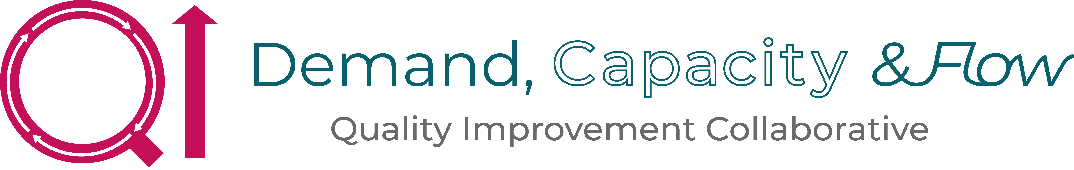
PDSA Worksheet Template

The Plan-Do-Study-Act (PDSA) cycle is a useful tool for documenting a test of change. Running a PDSA cycle is a way to test change ideas — you develop a plan to test the change (Plan), carry out the test (Do), observe, analyse, and learn from the test (Study), and determine what modifications, if any, to make for the next cycle (Act).

In most improvement projects, teams will test several different changes, and each change may go through several PDSA cycles as you continue to learn. Keep a file of all PDSA cycles for all the changes your team tests. Fill out one PDSA worksheet for each change you test.

Instructions

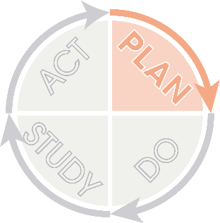 | - Plan: Plan the test, including a plan for collecting data  - State the question you want to answer and make a prediction about what you think will happen  - Develop a plan to test the change. (Who? What? When? Where?)  - Identify what data you will need to collect and how you will collect it
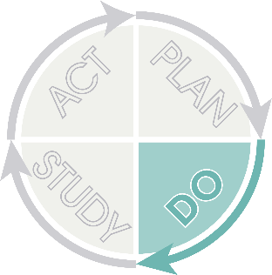 | - Do: Run the test on a small scale.  - Carry out the test.  - Document problems and unexpected observations.  - Collect and begin to analyse the data.
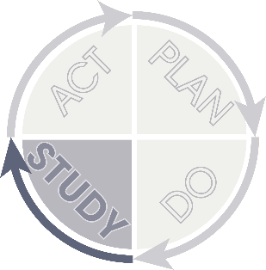 | - Study: Analyse the results and compare them to your predictions.  - Complete, as a team, your analysis of the data.  - Compare the data to your prediction.  - Summarise and reflect on what you learned.
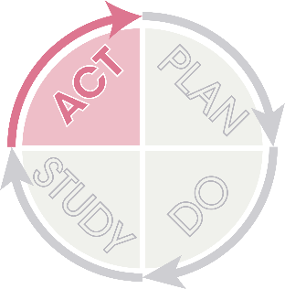 | - Act: Based on what you learned from the test, make a plan for your next step  - Adapt (make modifications and run another test), adopt (test the change on a larger scale), or abandon (don’t do another test on this change idea).  - Prepare a plan for the next PDSA

PDSA Worksheet Template
Objective:
A description of the idea and aim

- Plan: Plan the test, including a plan for collecting data

Questions and Predictions:
What do we want to know? What can this idea help improve?
What do we think will happen? (This can include the positives but also the challenges/barriers)

Who, what, where, when:
Who will lead and take actions forward to make it happen?
What are we going to do?
When will you start?
How often will you do this?

Plan for collecting data:
What will you measure? (Based on your prediction)
How often will you measure this? (Who, what, when, where?)

- Do: Run the test on a small scale

Describe what happened. What data did you collect? What observations did you make?
What data did you collect?
What observations did you make?

- Study: Analyse the results and compare them to your predictions

Summarise and reflect on what you learned:

- Act: Based on what you learnt from the test, make a plan for your next step:

Determine what modifications you should make – adapt, adopt or abandon:

