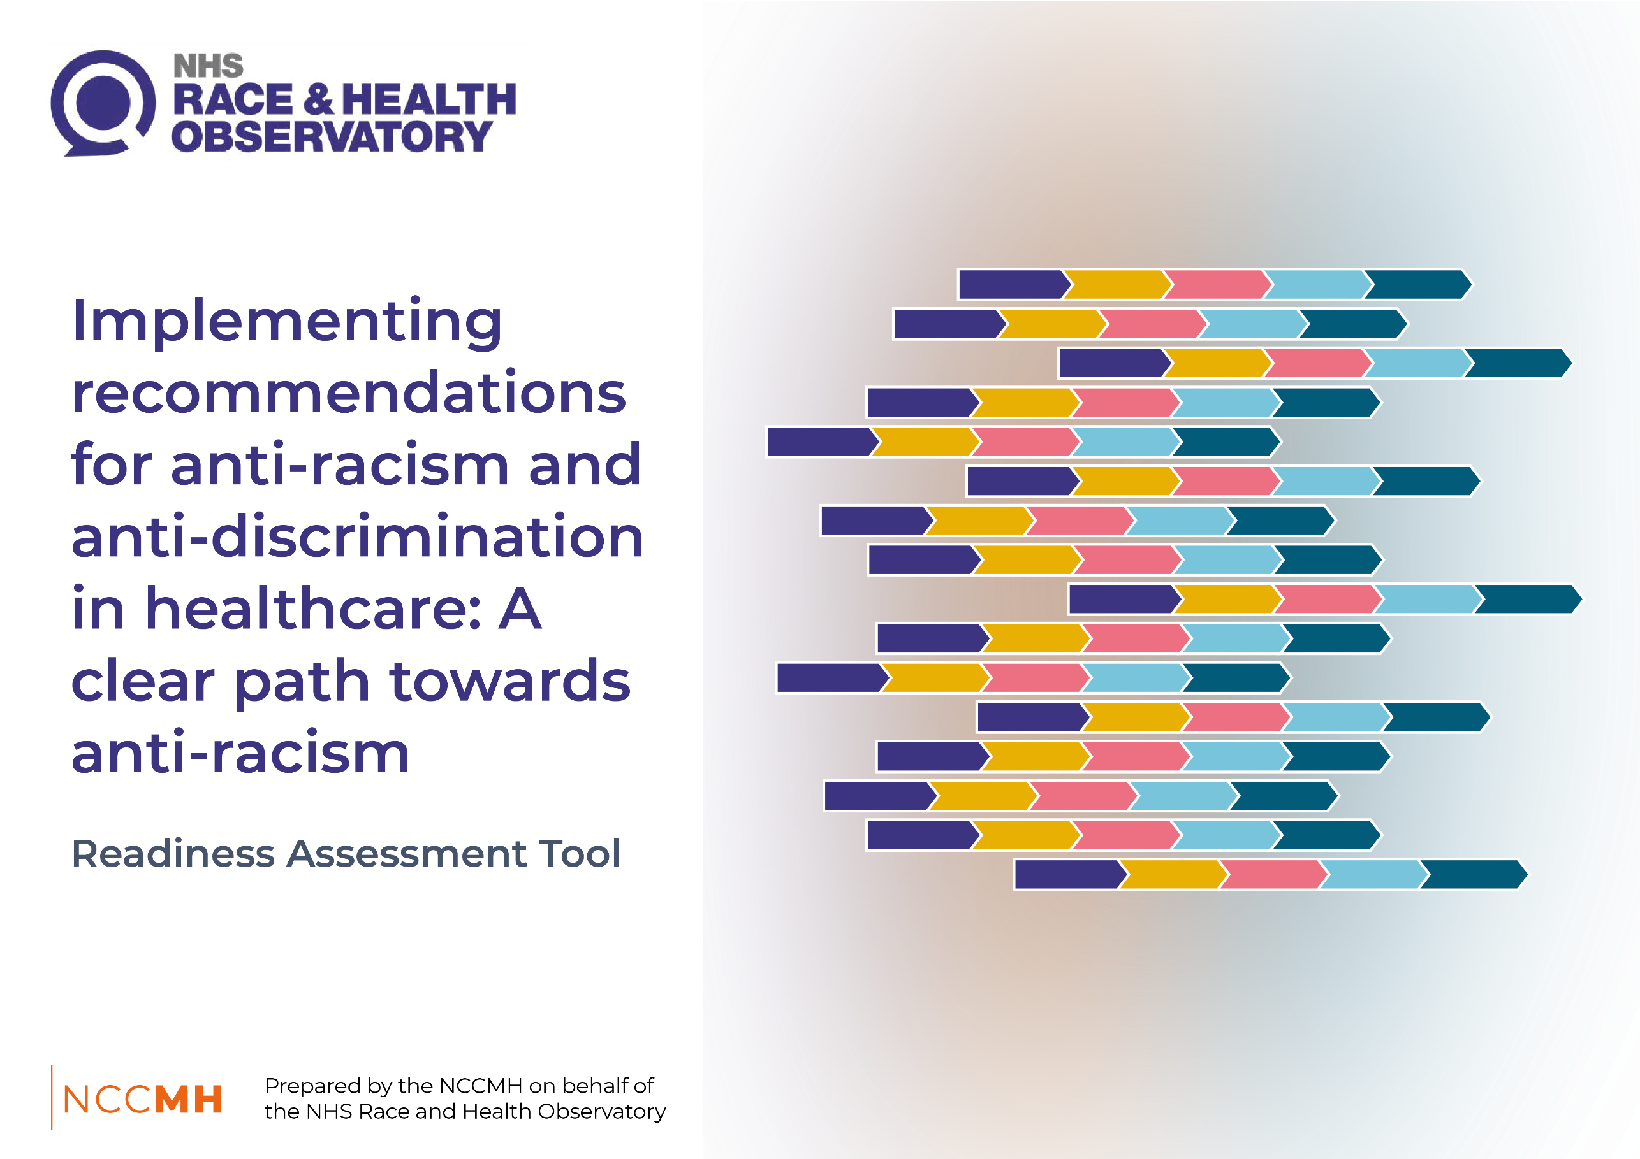
Readiness Assessment Tool
When developing draft recommendations and assigning them to stakeholders/organisations, it may be helpful for the stakeholders/organisation to complete a readiness assessment tool. This can determine the organisational buy-in and capacity and identify what might need to happen for the recommendation to have the best chance of being successfully implemented.
This Readiness Assessment Tool is recommended for use with the following Toolkit:
National Collaborating Centre for Mental Health. Implementing recommendations for anti-racism and anti-discrimination in healthcare: A clear path towards anti-racism. Toolkit. London: National Collaborating Centre for Mental Health; 2025; updated 2026.
This tool has been adapted from the following tool:
Capacity Building Center for States. Change and implementation readiness assessment tool. Washington, DC: Children’s Bureau, Administration for Children and Families, US Department of Health and Human Services; 2019.
There are three parts to the readiness assessment:
- Part 1: Assessing motivation for the intervention
- Part 2: Assessing capacity for the intervention
- Part 3: Summary of findings and areas to address
For Part 1 and Part 2, rate each item in the readiness items table using the following rating scale:

SA = Strongly agree (fully ready to go) PA = Partially agree (somewhat ready)
DA = Disagree (not yet ready) NS = Not sure (need more information)

Part 1: Motivation
Item | Rating (SA/PA/ DA/NS) | Notes/evidence
The intervention aligns with the stakeholder’s mission, values, and guiding principles
The intervention supports existing programs and initiatives and fits with how the agency does things
The intervention is compatible with the values of individuals who will deliver it
The intervention is compatible with the values of the intervention’s target population (e.g. communities)
Leadership, staff, and stakeholders clearly understand the intervention
The intervention is viewed as ‘doable’
There are buy-in and support for the intervention
The intervention is embraced as a priority
The intervention is perceived as being better than other alternatives to address the problem and current practice
The expected outcomes of the intervention are apparent to leadership, staff, and stakeholders
The intervention can be tested in small ways prior to a full rollout

Part 2: Capacity
Readiness factor | Capacity dimension | Item | Rating (SA/PA/ DA/NS) | Notes/evidence
Implementation supports | Infrastructure | The stakeholder has policies and procedures in place to support the intervention
Knowledge, skills, & abilities | Knowledge & skills | Managers and staff have knowledge, skills, and abilities to deliver the intervention
Knowledge, skills, & abilities | Knowledge & skills | Managers and staff have knowledge, skills, and abilities for monitoring the intervention
Leadership buy-in & support | Culture & climate | There is leadership and organisational support for the selected intervention
Leadership buy-in & support | Culture & climate | Stakeholder leaders, staff, and wider stakeholders have a shared vision of the plans and desired outcomes for the intervention
Relationships & networks | Engagement & partnership | Communities and people with lived experience are engaged and involved in the planning or implementation of the intervention
Relationships & networks | Engagement & partnership | Key partners in the wider system are engaged in the planning or implementation of the intervention
Relationships & networks | Engagement & partnership | Staff from different parts of the organisation know what they need to do to help carry out the intervention

Part 3: Summary of findings and areas to address
Component | Strengths | Areas to develop and challenges | Possible strategies and next steps
Motivation
Capacity

