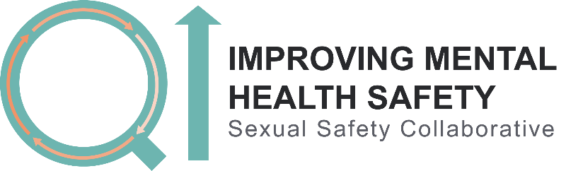

Replace with Trust logo

Ward charter
Sexual safety
If you feel too frightened or upset to speak to a member of staff, you can get independent advice or support by calling {insert organisation name} on {contact details}.
Everyone has the right to feel safe from sexual harm. On this ward, we do not want you to feel uncomfortable, frightened or intimidated in a sexual way by service users or staff. We will work to promote everyone’s sexual safety. Everyone should behave in a way that meets the following standards.
Expected standards of behaviour on [insert ward name}
I respect myself
I treat others with respect and dignity
I understand that sexual activity with another person should be for mutual pleasure and never used for punishment or through coercion
I do not try to talk to someone else into engaging in sexual activity or harass another person sexually
I try to be aware of how my behaviour makes others feel, and will change my behaviour if someone tells me it makes them uncomfortable, or I will ask for help with this if I need to
I respect the rights of others to space and privacy to fulfil their sexual needs through masturbation
I understand that fulfilling my own sexual needs through masturbation must be conducted privately and discreetly
I will speak up if I have been hurt, harassed or assaulted physically or sexually
I speak up if I see or hear about someone else being hurt, harassed or assaulted either physically or sexually

Overleaf you will find an example of the type of ‘Ward Charter’ we would like each ward on the Sexual Safety Collaborative to produce together with service users. The example standards of behaviour have been taken from those developed in Australia. You can find more examples and further detail using the following links:

https://www.cnwl.nhs.uk/wp-content/uploads/Sexual-safety-leaflet.pdf

https://www.mentalhealthcarersnsw.org/wp-content/uploads/2017/07/GL2013_012Sexual-Safety-of-Mental-Health-Consumers-Guidelines.pdf - Appendix A, page 58

Each ward charter should include the following:
- Introductory few sentences about what sexual safety is, a person’s right to feel safe from sexual harm and a statement of intent to promote sexual safety on the ward
- Standards of expected behaviour for everyone on the ward
- A sentence that provides clear contact details for where independent support or advocacy can be obtained.

Please feel free to develop your own ward charter or use this example template provided.
Please also contact your QI coach with any questions you have. You can also send the necessary text to them to put into this template for you, if you wish to use it.

You will need to have completed this task, and visually displayed the ward charter and/or provided a copy to all staff and service users, by the 1st November 2019. This is so that you are ready to begin your data collection plan on the 4th November, which references the ward charter.

