Paternal postnatal depression
Titilopemi Oladosu
King’s College London
titilope.oladosu@kcl.ac.uk
Word count: 4900

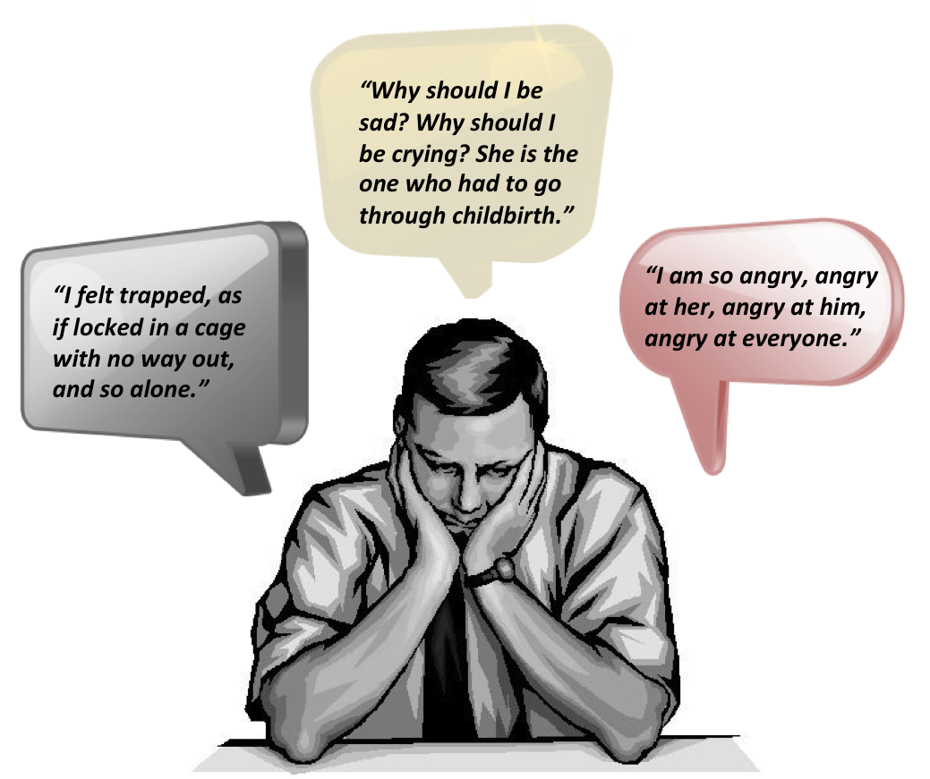
Diagram 1: Sentences formulated from descriptions of men’s feelings and responses to paternal postnatal depression (PPD), source Post and Ante Natal Depression Association ¹

Abstract

Introduction
Postnatal depression affects 1 in 10 fathers worldwide. However, academic literature on the condition is sparse, while in the media the existence of paternal postnatal depression (PPD) is debated.

Methods
A literature review was conducted between September and December 2012. Pubmed and ISI Web of Knowledge searches were used to access academic literature; grey literature was accessed through Google.

Findings
The paucity of literature regarding PPD is due to a combination of high attrition rates of men in studies, low levels of health seeking behaviour in men, the atypical presentation of depression in men, and a neglect of paternal health in child development research.

Paternal postnatal depression has severe negative impacts on current family health, parent-child interactions, and future child health - particularly for male children. Several bio-psycho-social risk factors such as hormonal changes during the perinatal period, previous psychiatric illness, maternal depression, and income status contribute to the development of PPD.

Conclusion
Preventions, screening, and effective management are possible. In Britain however, diagnosis and clinician awareness can be improved through incorporation in the main diagnostic manuals DSM-IV and ICD-10. Also, there is a need for increased screening and better inclusion of fathers in antenatal care programmes.

Contents
1: Introduction: What is paternal postnatal depression?
 |  |  |  |  |  |  |  | page
1 | Introduction: What is paternal postnatal depression? |  |  |  |  |  |  | 4
 | 1.1 | Aim |  |  |  |  |  | 4
 | 1.2 | Objectives |  |  |  |  |  | 4
2 | Methodology |  |  |  |  |  |  | 5
3 | Research on paternal postnatal depression |  |  |  |  |  |  | 6
4 | Impact of paternal postnatal depression |  |  |  |  |  |  | 7
 | 4.1 | Effects on maternal outcome |  |  |  |  |  | 7
 | 4.2 | Effects on early interactions and parenting |  |  |  |  |  | 7
 | 4.3 | Effects on child outcomes |  |  |  |  |  | 8
 | 4.4 | Healthcare costs |  |  |  |  |  | 8
5 | Risk factors for paternal postnatal depression |  |  |  |  |  |  | 9
 | 5.1 | Maternal depression |  |  |  |  |  | 9
 | 5.2 | Previous psychiatric disorders |  |  |  |  |  | 9
 | 5.3 | Income status |  |  |  |  |  | 10
 | 5.4 | Unintended pregnancies |  |  |  |  |  | 10
 | 5.5 | Marital relationship |  |  |  |  |  | 10
 | 5.6 | Social network |  |  |  |  |  | 11
 | 5.7 | Information and education level |  |  |  |  |  | 11
 | 5.8 | Hormonal changes |  |  |  |  |  | 11
6 | Postnatal paternal depression in healthcare |  |  |  |  |  |  | 13
 | 6.1 | Screening for PPD |  |  |  |  |  | 13
 |  | 6.1.1 | The Edinburgh Postnatal Depression Scale (EPDS) |  |  |  |  | 13
 |  | 6.1.2 | The Postnatal Depression Screening Scale (PDSS) |  |  |  |  | 13
 |  | 6.1.3 | The Gotland male depression scale |  |  |  |  | 13
 | 6.2 | Prevention |  |  |  |  |  | 14
 | 6.3 | Diagnosis |  |  |  |  |  | 14
 | 6.4 | Management |  |  |  |  |  | 14
7 | Recommendation |  |  |  |  |  |  | 17
8 | Conclusion |  |  |  |  |  |  | 19
 | Appendix 1 |  |  |  |  |  |  | 20
 | Appendix 2 |  |  |  |  |  |  | 21
 | Appendix 3 |  |  |  |  |  |  | 23
 | References |  |  |  |  |  |  | 24

There are no specific definitions for postnatal depression.² Currently the diagnostic criterion for clinical depressive disorder is used (see appendix 1)³. The diagnosis is then further qualified as postnatal if the illness occurs afterbirth, with no other explanation for the cause.⁴ For DSM IV the timeframe is 4 weeks after birth and for ICD-10 it is 6 weeks.⁴

Maternal postnatal depression (MPD) is well recognised in clinical medicine and the media.⁵ In some countries screening programmes for MPD is integrated into antenatal care delivery, paternal postnatal depression in comparison less well researched and rarely screened for.^{5–7} Only recently has research focused on paternal perinatal psychiatric disorders and media recognition has been slow to follow.^{7,8}

1.1: Aim
To review the available literature on paternal postnatal depression (PPD) and provide recommendations for clinical management and further research

1.2: Objectives
-To investigate the research position on PPD
-To summarise the impact of PPD
-To explore the risk factors for PPD
-To evaluate current screening, diagnosis, and management of PPD in the United Kingdom
-To provide recommendations for healthcare services and further research

2: Methodology

The literature search took place between September and December 2012. The aim was to gather sufficient literature regarding paternal postnatal depression, analyse the reliability, draw conclusions, and highlight gaps in the literature.

I searched for the terms paternal, postnatal, and depression within titles and abstracts in different combinations. In order to use the most current studies but also collect sufficient literature on the topic, I placed the time-span limit at 2000.

Then I read the titles and abstracts of all the studies and downloaded the ones I deemed suitable. Relevant citation within the downloaded articles were, assessed, and added if suitable. All articles were read, annotated, and referenced using Mendeley Desktop software.

Studies written in foreign languages were excluded except one article in Spanish, which was translated. I also performed a search in Google to access grey literature.

Sources searched: | Date of search | Search strategy used
Pubmed | September  2012 | paternal[Title/Abstract] AND postnatal[Title/Abstract] AND depression[Title/Abstract] AND ("2000"[Date - Publication] : "3000"[Date - Publication])
ISI Web of Knowledge | October 2011 | Topic=(paternal) AND Topic=(depression)  Topic=(paternal) AND Topic=(postnatal)  Timespan=2000-2012  Search language=English Lemmatization=On
Google | December 2011 | Paternal postnatal depression  Fathers depressed  Treatment maternal postnatal depression
Table 1: Search strategy
3: Research on paternal postnatal depression

Recognition of maternal depression has been encouraged by research findings showing the negative effects on the mother’s health, the impact of postnatal depression on the parent-child relationship, and the influence on children’s future emotional, cognitive, and physical development.^{9,10} The fact that both screening and treatment are possible has helped to integrate management into the existing healthcare systems.¹¹

Research involving men in the perinatal period is scarce. The task of including men in health research is challenging for several reasons:
(1) There is a tendency for high attrition rates, which may compromise the results of studies in particular statistical testing of findings.¹²
(2) Men often display less health seeking behaviours, with a tendency to avoid presentation and to self-manage instead. This can be due to societal gender norms, which encourage men to be self reliant and stigmatise help (health)-seeking behaviour.¹³ This in turn leads to an underestimation of prevalence and population needs.
(3) More related to postnatal depression, unlike for mothers who are automatically recognised. There has been an underestimation of the impact of fathers in child development.^{12,14} This maybe also be due to societal gender roles which places the mother in the childrearing seat and so prioritises her well being for healthy child development.⁸

As the role of fathers in childrearing shifts from silent observer to active aide, there is need for an equal shift in child development research to recognise the challenges faced by fathers.
4: Impact of paternal postnatal depression

Worldwide 10% of new fathers suffer from postnatal depression, the prevalence of unipolar depression in men in the UK is 2.4%.^{15,16} PPD usually occurs within the first year, a time when the structure and identity of the family is changing.^{17,18} Apart from the detrimental effects it can have on fathers’ health, there are numerous potential effects on mother and child, and costs to healthcare.

4.1: Effects on maternal outcome
About half of all fathers with PPD have partners with postnatal depression.¹⁹ Partners rely predominantly on their other halves for emotional support, when a partner is depressed, this support mechanism maybe lost.²⁰ Increasing the risk of depression in the otherwise well partner. This may be further compounded by the symptoms of the male depressive syndrome - aggression/violence, alcohol, and drug abuse.^{6,21,22} The combination of stressful life event, loss of emotional support, and aggression may in extreme cases lead to intimate partner violence.²³

4.2: Effects on early interactions and parenting
On observation depressed fathers have been found to display less positive behaviours such as “warmth, sensitivity and responsiveness”, and an increase in negative behaviours such as “hostility and disengagement” towards their children.²⁴ The difference in parental behaviours may be directly related to the psychological symptoms of depression. For example, fatigue and anhedonia may lead to irresponsiveness, while irritability may cause increased hostility.²⁴ The same study found that ‘parental intrusion’ classed as a negative parental behaviour was reduced in depressed fathers. However, it is unclear if this was a real decrease in a negative attribute (and an increase in ensuring child autonomy), or simply a lack interest in the child - an expression of somatic depressive symptoms.

4.3: Effects on child outcomes
There is evidence that children, in particular sons, of depressed men, have increased mood and temperament disorders.^{14,25} In general children in such homes are twice as likely to develop a psychiatric disorder compared to controls, with significant numbers developing conduct, anxiety, and hyperactivity disorders.¹² However, as there has been little research in this field and it is difficult to draw firm conclusions.

4.4: Healthcare costs
A recent study based in the United Kingdom found that fathers without depression have lower healthcare costs, than those at risk of depressions, and depressed fathers had the highest community service cost of all.²⁶ Hospital inpatient, outpatients, and day-patient cost also showed a similar trend, however, the findings of this study were not statistically significant. Recall bias, missing data, and low response rates, limited the sample size and may have resulted in the lack of a statistically significant sample.²⁶

5: Risk factors for paternal postnatal depression

Many factors have been identified as contributing to PPD.^{6,27} Some of these risk factors are mentioned in diagram 2, while the key ones are discussed below.

5.1: Maternal depression
Maternal depression is the most significant correlate to paternal depression.^{6,15,19,28} There is good evidence that PPD often follows maternal depression, and half the fathers suffering from PPD have partners with maternal postnatal depression.^{19,29–32} Partners who are not clinically depressed have been found to score highly on screening tests throughout the duration of their partner’s illness.¹⁹ The mechanism for this is unclear; however, one theory suggests that as the mother is usually the provider of emotional support for the father after the birth of the child, her postnatal depression may prevent him from being able to rely on her, “impairing his psychological adjustment” and increasing his risk of depression.¹⁹ Also, “living with a depressive person may have a depressive effect”; alternatively the couple could be exposed to similar depressive risk factors.¹⁹

5.2: Previous psychiatric disorders
A study of Japanese fathers show that a history of clinical psychiatric treatment is strongly linked to the development of PPD.³³ This has been supported by other studies which show that previous depressive disorders pose the most significant risk to development of PPD compared to other disorder.⁶ This may be due to predisposing genetic factors and/or enduring environmental factors, with the perinatal period acts as a stressful life event which triggers remission.

5.3: Income status
Unemployment, an unstable source of income, or lower income levels have been associated with PPD.^{6,33,34} It can be particularly difficult for men in homes where there are strict gender roles placing the man in the breadwinner position.⁸ The addition of another mouth to feed can increase the father’s anxiety and feelings of failure, while an increase in work commitments may reduce his involvement in parenting.⁸

5.4: Unintended pregnancies
Lack of choice and preparation inherent in the unintended nature of some pregnancies increases the risk of PPD.³³ There is a greater risk for men who did not want the pregnancy but whose partners intended to become pregnant.³⁵ These men may find the changes in the relationship dynamics, the perceived/true loss of freedom, and the responsibility associated with childrearing more stressful.⁶

5.5: Marital relationship
Traditional marital relationships have reduced rates of PPD and men living in stepfamilies are at an increased risk of depressive symptoms.^{6,27,28} The reasons for this are presently unclear. However, poor marital relationships also correlate with an increased risk of PPD, and the causality direction is unclear.^{16,27} The added strain on each partner during the transition to parenthood may lead the relationship to deteriorate and increase the risk of depression in fathers.³⁶ Additionally, depression has frequently been associated with an increase in marital discord.³⁷

5.6: Social network
Support from family and friends reduces the risk of PPD.^{28,30} Participants who report lower levels of perceived social support tend to have more depressive symptoms.^{6,8} Social support through the availability of confidantes, practical assistance in childminding, and advice regarding childrearing, help to alleviate anxiety and depression in mothers and may help fathers too.⁹

5.7: Information and education level
Lack of information about pregnancy or childbirth is an important risk factor for PPD particularly in first-time fathers.^{6,12,36} This may be linked with the lower levels of education that is also associated with PPD.³⁶ These factors may be related in that less educated fathers may find it more difficult to seek and access information and services regarding pregnancy and childbirth. This in turn may mean these men are less informed and less prepared for the changes that a newborn brings.

5.8: Hormonal changes
Men also experience hormonal changes during pregnancy and the postnatal period. It has been suggested that changes in the hormones testosterone, oestrogen, cortisol, vasopressin, and prolactin may mediate the risk of PPD.⁸ Mammalian studies show a decrease in paternal testosterone levels around the perinatal period. Furthermore, men who have lower testosterone (and higher prolactin) levels were more likely to respond to infant stimuli, such as babies cries.^{38,39} Meanwhile, studies of depressed older men have shown an association with decreased testosterone and depression.⁴⁰ Perhaps dysregulation of these biologically controlled responses mediates PPD.

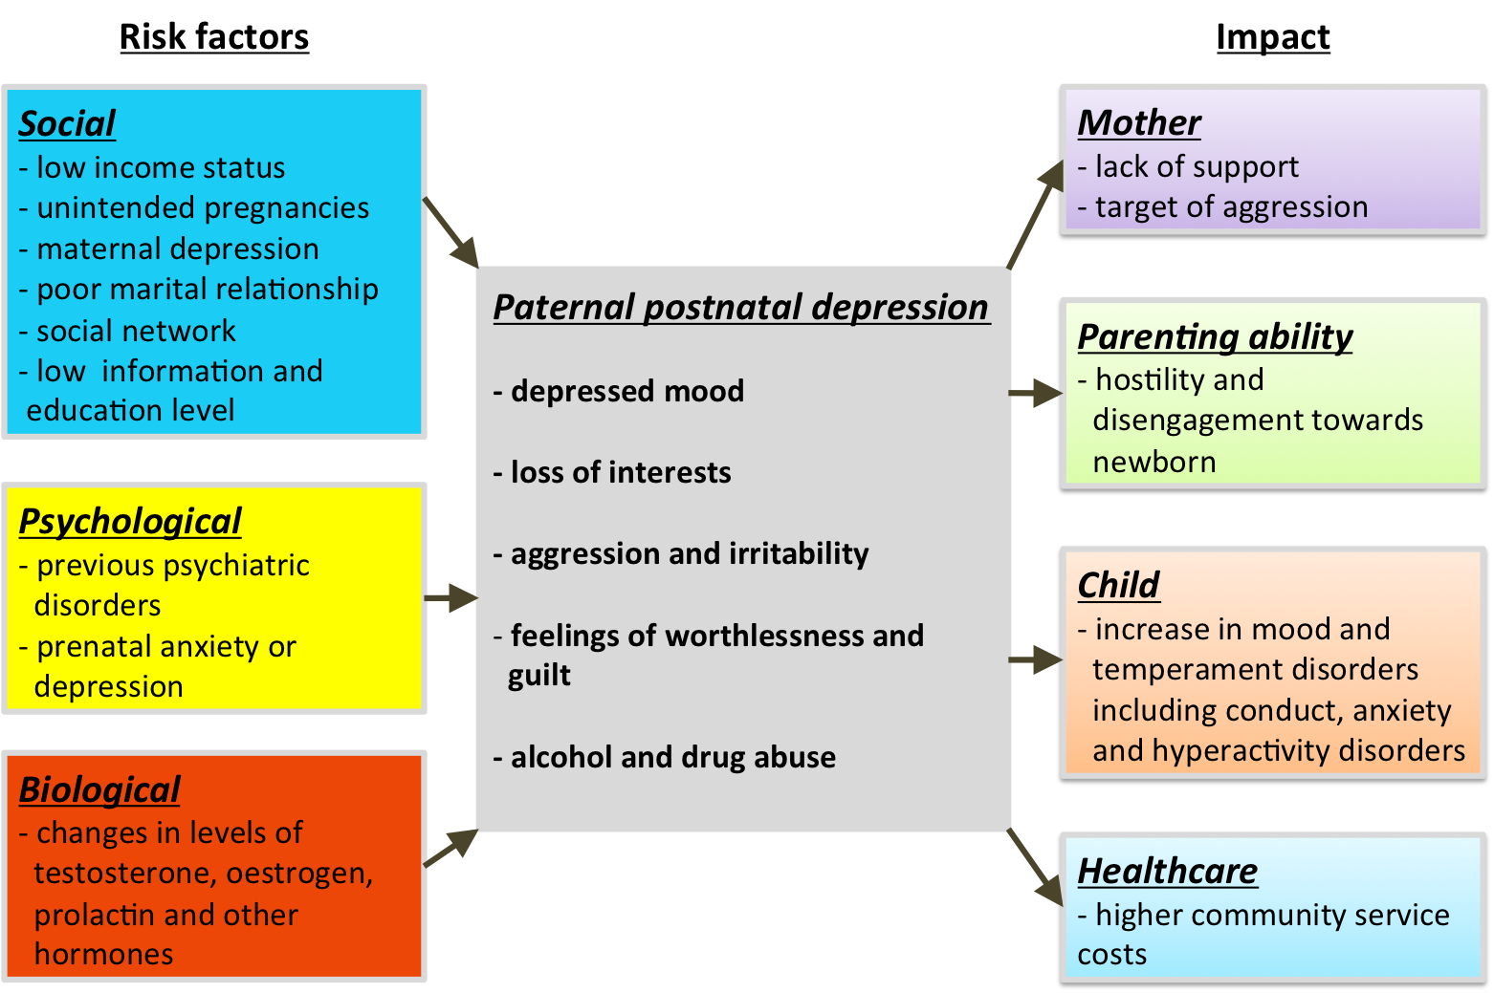
Diagram 2: Summary diagram of the risks and impacts of paternal postnatal depression^{6,12,29}
6: Postnatal paternal depression in healthcare

6.1: Screening for PPD
There is little evidence that risk assessment or screening for PPD occurs in the UK. Several studies have highlighted the importance of screening for PPD, particularly in household where maternal depression exists.¹⁹

6.1.1: The Edinburgh Postnatal Depression Scale (EPDS)
The EPDS was developed as a screening questionnaire for maternal postnatal depression, however, it has been widely used for PPD screening.^{41,42} It has been shown to have high sensitivity (91%) and specificity (78-97%) when used in men.^{13,43} Some studies have highlighted the need for a lower cut-off point at about 6/7 for the EPDS when screening for fathers, rather the usual point of 12/13 for maternal postnatal depression to increase its sensitivity.⁴⁴

6.1.2: The Postnatal Depression Screening Scale (PDSS)
The PDSS has significantly more sensitivity and specificity than the EPDS in studies with female participants.^{45,46} However, the PDSS is not as widely used and the difference in depressive symptoms in male compared to females, may mean these findings are not generalisable to men.

6.1.3: The Gotland Male Depression Scale (GMDS)
The Gotland Male Depression scale may be a better screening tool for paternal postnatal depression. It takes into account the difference in depressive symptoms presented by men compared to women and incorporates questions to elicit this.⁴⁷ It shows more sensitivity than the PDSS with male participants.⁴⁸ However, a more specific scale, which incorporates the male depressive symptoms in the context of postnatal depression, is needed for men.

6.2:Prevention
Preventative management has been used for women who are deemed at risk of postnatal depression. These range from frequent monitoring and assistance with household tasks, to informal advice.⁸ Informal advice such as the one shown in diagram 3, may be useful preventatively and could be particularly beneficial for fathers whose depression is compounded by anxiety and who are lacking in social support.^{8,49}

6.3: Diagnosis
The maximum period allowed by the most widely used handbooks for diagnosis of a postnatal disorder is 4-6 weeks post birth.^{3,4} The evidence shows that postnatal depression often occurs later in fathers, with one research paper showing a 5.4% incidence at 3-6 months postnatal.^{15,31} There is a need for revision of these handbooks to reflect the evidence and better clinical guidelines to prevent some depressed fathers being missed or misdiagnosed.

6.4: Management
Research is sparse regarding the best method for management of PPD. However, psychological therapies such as cognitive behavioural therapies, informal counselling, and family and marital group therapy, has also been shown to reduce scores on the EPDS for mothers.^{49,50}

Maternal postnatal depression is often responsive to pharmacological therapies used for unipolar depression; this has also been used for fathers. However, research with depressed mothers has shown little to no improvement in the mother-child relationship at 18 months and 5 years, even when reductions in the severity of symptoms have been achieved.²⁵ These findings have led to the recommendation that therapies should also address how to improve the parent-child relationship rather than focusing solely on reducing maternal symptoms.²⁵
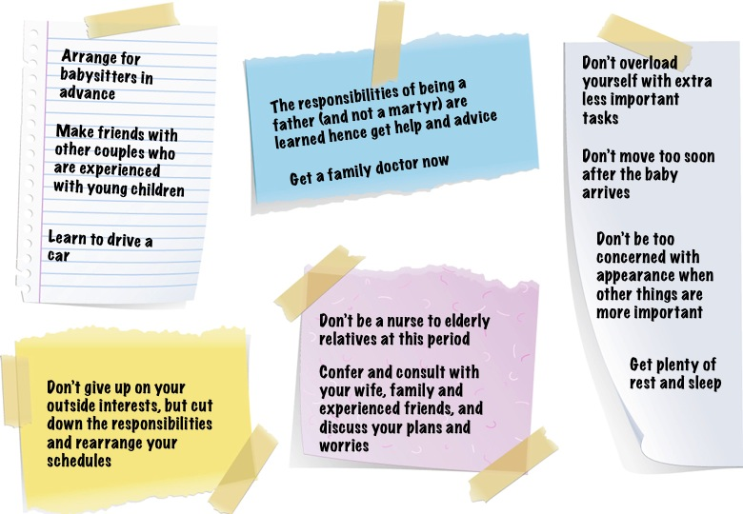
Diagram 3: Diagrammatical adaptation for fathers of some informal preventative advice given to mothers⁴⁹
7: Recommendations

Many cases of postnatal depression are picked up through screening in the hospital and the community. However, adequate training of healthcare workers, proper follow up, and support with clinical diagnosis are crucial to management.⁴⁹ There is a good case for screening and treatment to improve the father’s individual health, reduce the impact on the family, and reduce the cost to healthcare. Also a longer timeframe for onset, about 3 months, and a specific diagnostic criteria which includes minor depressive episodes should be developed.⁴

Screening male partners of diagnosed women is advisable, due to the high prevalence of untreated co-morbidity. Likewise diagnosed males should not be viewed in isolation and their partners should be screened. This would reduce the incidence of untreated co-morbidity, and may improve parenting outcomes. All healthcare professionals who are in contact with the family at this crucial period should be able to offer screening, this includes midwives, general practitioners, and paediatrians.⁵⁰

Increased clinician awareness and media coverage can improve detection rate.⁵¹ Clinical staff can provide appropriate treatment and support for the family to reduce the adverse effects on partner and parent-child relationships. In addition, media awareness may improve the incidence of recognition and self-presentation, and reduce the stigma associated with the condition. More literature such as ‘Sad Dads’, and ‘Fact Sheet 9 - Men and Postnatal depression’ by the Post-Ante Natal Depression Association is needed for the clinician and the layman.^{1,8}

Father specific information and sessions as part of routine antenatal care is also desirable.⁵² This may help alleviate the anxiety and exclusion experienced by some men during the perinatal period. It may also encourage paternal involvement in childrearing, as well as discussion and support between partners.

The changing roles of fathers should be better reflected in research, there is a need for more research to examine the impact of paternal illness on child development.¹² The literature is also lacking in biological theories and pathways for PPD; more work in this area may guide therapy or help identify at risk fathers.

8: Conclusion

PPD has only recently been recognised and research is sparse on the topic, when compared to maternal postnatal depression. PPD has several adverse effects on both partner and father-child relationships, this is particularly important for boys as it is a risk factor for behavioural disorders in adolescence.

There are several, bio-psycho-social risk factors for PPD, the most important risk factor however, are maternal postnatal depression, previous psychiatric disorders, and income status. There are no policies for screen for PPD in the UK at present and there is a need for revaluation of the diagnostic criteria to include PPD. More research and theories are needed to address the mechanism for PPD and to identify effective and appropriate management.

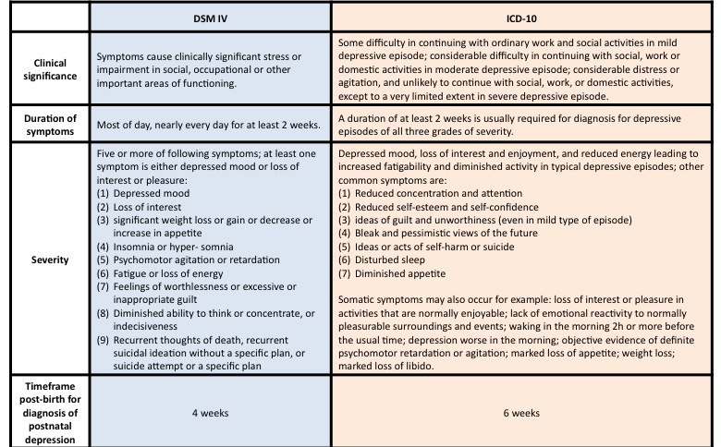
Appendix 1: Table of ICD 10 and DSM criteria for depression (adapted from Gruenberg et al.)³
Appendix 2: Edinburgh Postnatal Depression scale from source⁴²
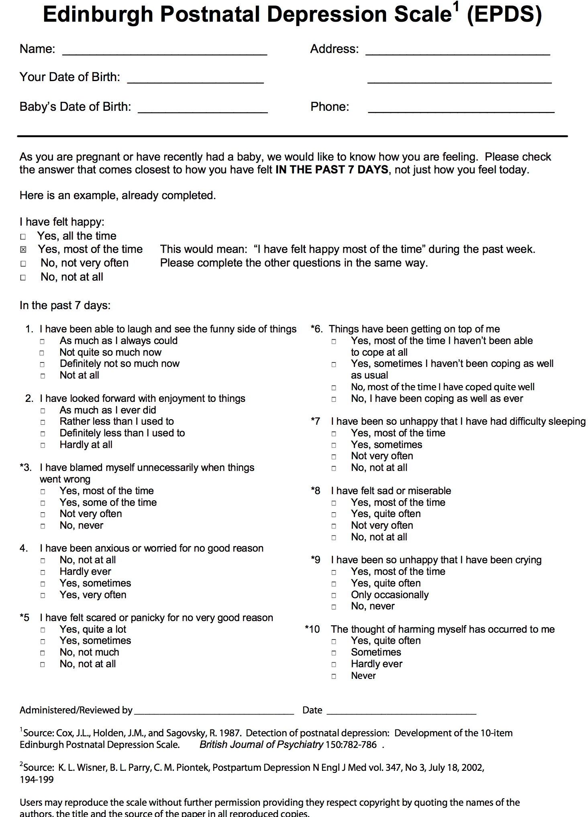
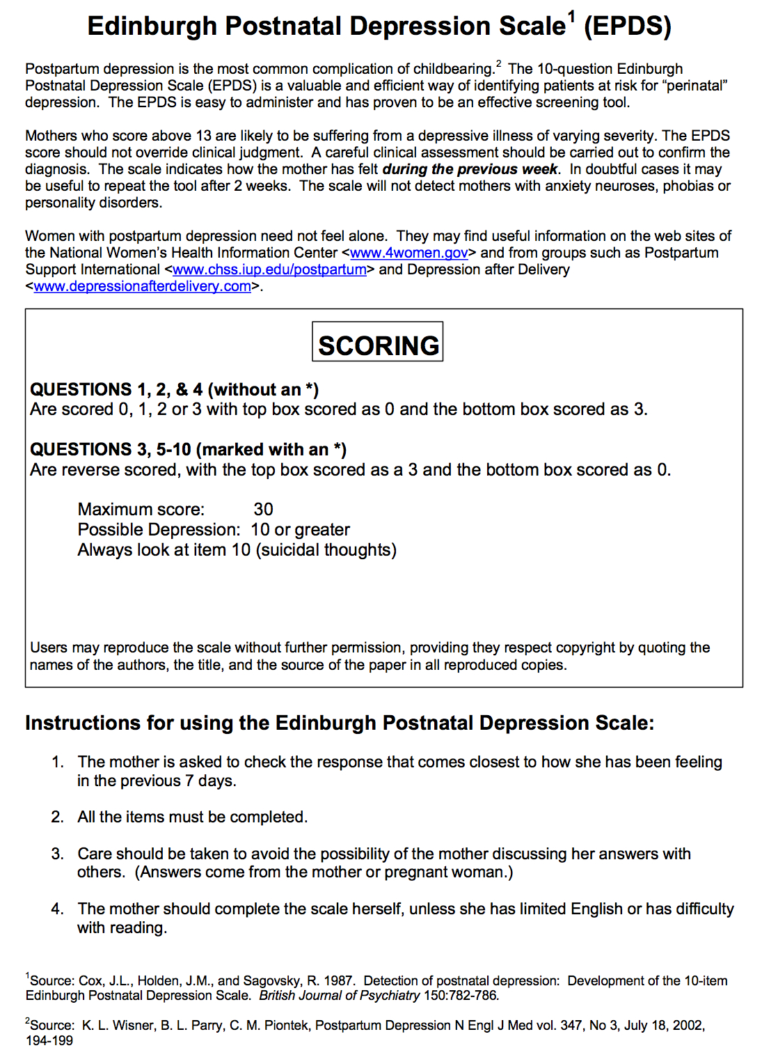
Appendix 3: The Gotland Scale for assessing male depression from source⁴⁷

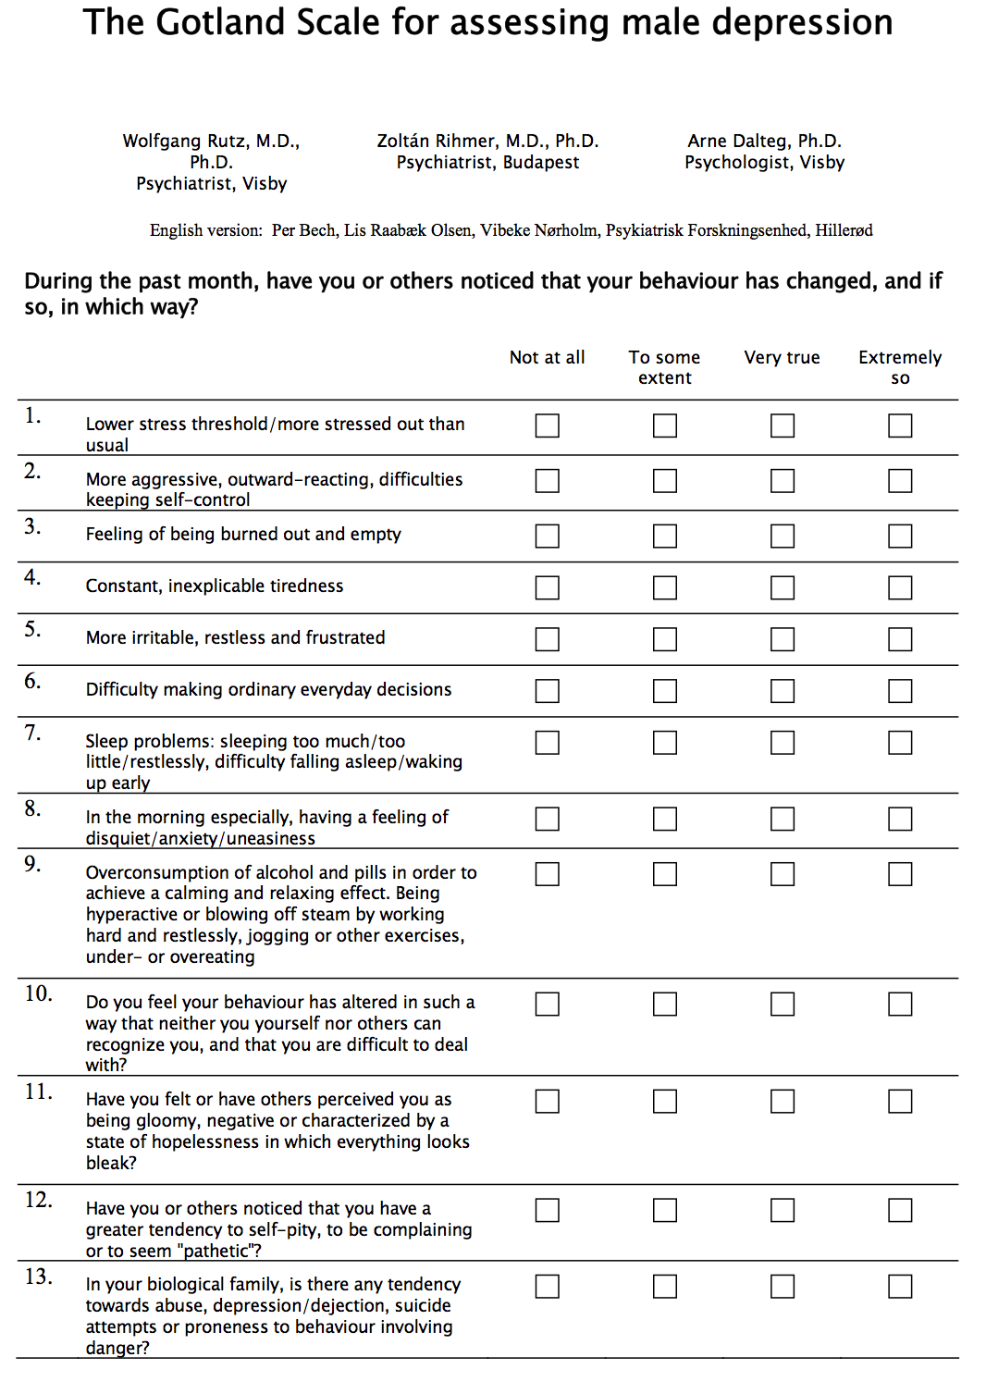
Reference:
1. Post and Ante Natal Depression Association. Fact Sheet 9 - Men and Postnatal depression [Internet]. 2006 [cited 2012 Nov 4]. Available from: http://www.gidgetfoundation.com.au/export/download/gidget/9_Men_and_postnatal_depression.pdf
2. Stewart DE, Robertson E, Dennis C, Grace SL, Wallington T. Postpartum depression: literature review of risk factors and interventions [Internet]. 2003 [cited 2012 Nov 4]. page 1–289. Available from: http://www.who.int/mental_health/prevention/suicide/lit_review_postpartum_depression.pdf
3. Gruenberg AM, Goldstein RD, Pincus HA. Classification of Depression : Research and Diagnostic Criteria : DSM-IV and ICD-10. Biology of Depression: From Novel Insights to Therapeutic Strategies [Internet]. 2008 [cited 2012 Nov 4]. page 1–12. Available from: http://onlinelibrary.wiley.com/doi/10.1002/9783527619672.ch1/summary
4. Cox J. Postnatal mental disorder: towards ICD-11. World psychiatry : official journal of the World Psychiatric Association (WPA) [Internet]. 2004 Jun [cited 2012 Nov 4];3(2):96–7. Available from: http://www.pubmedcentral.nih.gov/articlerender.fcgi?artid=1414676&tool=pmcentrez&rendertype=abstract
5. Matthey S. The Edinburgh Postnatal Depression Scale * Authors’ reply. The British Journal of Psychiatry [Internet]. 2003 Apr 1 [cited 2012 Nov 4];182(4):368–368. Available from: http://bjp.rcpsych.org/cgi/doi/10.1192/bjp.182.4.368
6. Wee KY, Skouteris H, Pier C, Richardson B, Milgrom J. Correlates of ante- and postnatal depression in fathers: a systematic review. Journal of affective disorders [Internet]. 2011 May [cited 2012 Nov 4];130(3):358–77. Available from: http://www.ncbi.nlm.nih.gov/pubmed/20599275
7. Condon J. What about dad? Psychosocial and Mental issues for new fathers. Australian Family Physician [Internet]. 2006 [cited 2012 Nov 4];35(9):690–2. Available from: http://www.ncbi.nlm.nih.gov/pubmed/16969437
8. KIM P, SWAIN JE. Sad Dads: Paternal Postpartum Depression. Psychiatry [Internet]. 2007 [cited 2012 Nov 4];4(2):35–47. Available from: http://www.ncbi.nlm.nih.gov/pmc/articles/PMC2922346/
9. Murray L, Stein A. The effects of postnatal depression on the infant. Baillière’s clinical obstetrics and gynaecology [Internet]. 1989 Dec [cited 2012 Nov 4];3(4):921–33. Available from: http://www.pubmedcentral.nih.gov/articlerender.fcgi?artid=3161178&tool=pmcentrez&rendertype=abstract
10. Goodman SH, Brogan D, Lynch ME, Fielding B. Social and Emotional Competence in Children of Depressed Mothers. Child Development [Internet]. 1993 [cited 2012 Nov 4];64(2):516–31. Available from: http://www.ncbi.nlm.nih.gov/pubmed/8477632
11. Dietrich AJ, Bertram S, Graham D, Madison S, Pace WD. TRIPPD: A Practice-Based Network Effectiveness Study of Postpartum Depression Screening and Management. Annals of family medicine [Internet]. 2012 [cited 2012 Nov 4];10(4):320–9. Available from: http://www.ncbi.nlm.nih.gov/pubmed/22778120
12. Ramchandani PG, Stein A, O’Connor TG, Heron J, Murray L, Evans J. Depression in men in the postnatal period and later child psychopathology: a population cohort study. Journal of the American Academy of Child and Adolescent Psychiatry [Internet]. The American Academy of Child and Adolescent Psychiatry; 2008 Apr [cited 2012 Nov 4];47(4):390–8. Available from: http://www.pubmedcentral.nih.gov/articlerender.fcgi?artid=2650418&tool=pmcentrez&rendertype=abstract
13. Lai BPY, Tang AKL, Lee DTS, Yip ASK, Chung TKH. Detecting postnatal depression in Chinese men: a comparison of three instruments. Psychiatry research [Internet]. Elsevier Ltd; 2010 Dec 30 [cited 2012 Nov 4];180(2-3):80–5. Available from: http://www.ncbi.nlm.nih.gov/pubmed/20493548
14. Ramchandani PG, O’Connor TG, Evans J, Heron J, Murray L, Stein A. The effects of pre- and postnatal depression in fathers: a natural experiment comparing the effects of exposure to depression on offspring. Journal of child psychology and psychiatry, and allied disciplines [Internet]. 2008 Oct [cited 2012 Nov 4];49(10):1069–78. Available from: http://www.pubmedcentral.nih.gov/articlerender.fcgi?artid=2737608&tool=pmcentrez&rendertype=abstract
15. Paulson JF, Bazemore SD. Prenatal and Postpartum Depression in Fathers and its association with Maternal Depression A meta-analysis. The Journal of the American Medical Association [Internet]. 2010 [cited 2012 Nov 4];303(19):1961–9. Available from: http://www.ncbi.nlm.nih.gov/pubmed/20483973
16. Singleton N, Bumpstead R, O’Brien M, Lee A, Meltzer H, Office of National Statistics, London U. Psychiatric morbidity among adults living in private households , 2000 London : The Stationery Office [Internet]. 2000 page 1–164. Available from: http://informahealthcare.com/doi/pdf/10.1080/0954026021000045967
17. Soliday E, McCluskey-Fawcett K, O’Brien M. Postpartum affect and depressive symptoms in mothers and fathers. The American journal of orthopsychiatry [Internet]. 1999 Jan [cited 2012 Nov 4];69(1):30–8. Available from: http://www.ncbi.nlm.nih.gov/pubmed/9990434
18. Davé S, Petersen I, Sherr L, Nazareth I. Incidence of maternal and paternal depression in primary care: a cohort study using a primary care database. Archives of pediatrics & adolescent medicine [Internet]. 2010 Nov [cited 2012 Nov 4];164(11):1038–44. Available from: http://www.ncbi.nlm.nih.gov/pubmed/20819960
19. Goodman JH. Paternal postpartum depression, its relationship to maternal postpartum depression, and implications for family health. Journal of advanced nursing [Internet]. 2004 Jan [cited 2012 Nov 4];45(1):26–35. Available from: http://www.ncbi.nlm.nih.gov/pubmed/14675298
20. Holopainen D. The experience of seeking help for postnatal depression. The Australian journal of advanced nursing : a quarterly publication of the Royal Australian Nursing Federation [Internet]. 2002 [cited 2012 Nov 4];19(3):39–44. Available from: http://www.ncbi.nlm.nih.gov/pubmed/12002628
21. Magovcevic M, Addis ME. The Masculine Depression Scale: Development and psychometric evaluation. Psychology of Men & Masculinity [Internet]. 2008 [cited 2012 Nov 4];9(3):117–32. Available from: http://doi.apa.org/getdoi.cfm?doi=10.1037/1524-9220.9.3.117
22. Winkler D, Pjrek E, Kasper S. Anger attacks in depression--evidence for a male depressive syndrome. Psychotherapy and psychosomatics [Internet]. 2005 Jan [cited 2012 Nov 4];74(5):303–7. Available from: http://www.ncbi.nlm.nih.gov/pubmed/16088268
23. Lundberg KS, Mccollum EE, Rosen KH, Coleman JU. A comparison of depressed and nondepressed male perpetrators of partner violence [Internet]. 2000 [cited 2012 Nov 4]. Available from: http://scholar.lib.vt.edu/theses/available/etd-07072000-13570015/unrestricted/THESISetd.PDF
24. Wilson S, Durbin CE. Effects of paternal depression on fathers’ parenting behaviors: a meta-analytic review. Clinical psychology review [Internet]. Elsevier Ltd; 2010 Mar [cited 2012 Nov 4];30(2):167–80. Available from: http://www.ncbi.nlm.nih.gov/pubmed/19926376
25. Hanington L, Ramchandani P, Stein A. Parental depression and child temperament: assessing child to parent effects in a longitudinal population study. Infant behavior & development [Internet]. 2010 Feb [cited 2012 Nov 4];33(1):88–95. Available from: http://www.pubmedcentral.nih.gov/articlerender.fcgi?artid=2875886&tool=pmcentrez&rendertype=abstract
26. Edoka IP, Petrou S, Ramchandani PG. Healthcare costs of paternal depression in the postnatal period. Journal of affective disorders [Internet]. Elsevier B.V.; 2011 Sep [cited 2012 Nov 4];133(1-2):356–60. Available from: http://www.pubmedcentral.nih.gov/articlerender.fcgi?artid=3161179&tool=pmcentrez&rendertype=abstract
27. Schumacher M, Zubaran C, White G. Bringing birth-related paternal depression to the fore. Women and birth : journal of the Australian College of Midwives [Internet]. 2008 Jun [cited 2012 Nov 4];21(2):65–70. Available from: http://www.ncbi.nlm.nih.gov/pubmed/18479990
28. Deater-deckard K, Pickering K, Dunn JF, Golding J, Team CS. Family Structure and Depressive Symptoms in Men Preceding and Following the Birth of a Child. American Journal of Psychiatry [Internet]. 1998 [cited 2012 Nov 4];155(6):818–23. Available from: http://www.ncbi.nlm.nih.gov/pubmed/9619156
29. Zelkowitz P, Milet TH. The Course of Postpartum Psychiatric Disorders in Women and their partners. The Journal of Nervous and Mental disease [Internet]. 2001;189(9):575–82. Available from: http://www.ncbi.nlm.nih.gov/pubmed/11580000
30. Areias ME, Kumar R, Barros H, Figueiredo E. Correlates of postnatal depression in mothers and fathers. The British Journal of Psychiatry [Internet]. 1996 Jul 1 [cited 2012 Nov 4];169(1):36–41. Available from: http://bjp.rcpsych.org/cgi/doi/10.1192/bjp.169.1.36
31. Ballard CG, Davis R, Cullen PC, Mohan RN, Dean C. Prevalence of postnatal psychiatric morbidity in mothers and fathers. The British Journal of Psychiatry [Internet]. 1994 Jun 1 [cited 2012 Nov 4];164(6):782–8. Available from: http://bjp.rcpsych.org/cgi/doi/10.1192/bjp.164.6.782
32. Matthey S, Barnett B, Ungerer J, Waters B. Paternal and maternal depressed mood during the transition to parenthood. Journal of affective disorders [Internet]. 2000 Nov [cited 2012 Nov 4];60(2):75–85. Available from: http://www.ncbi.nlm.nih.gov/pubmed/10967366
33. Nishimura A, Ohashi K. Risk factors of paternal depression in the early postnatal period in Japan. Nursing & health sciences [Internet]. 2010 Jun [cited 2012 Nov 4];12(2):170–6. Available from: http://www.ncbi.nlm.nih.gov/pubmed/20602688
34. Bronte-Tinkew J, Moore K a., Matthews G, Carrano J. Symptoms of Major Depression in a Sample of Fathers of Infants: Sociodemographic Correlates and Links to Father Involvement. Journal of Family Issues [Internet]. 2007 Jan 1 [cited 2012 Nov 4];28(1):61–99. Available from: http://jfi.sagepub.com/cgi/doi/10.1177/0192513X06293609
35. Leathers SJ, Kelley M a. Unintended pregnancy and depressive symptoms among first-time mothers and fathers. The American journal of orthopsychiatry [Internet]. 2000 Oct [cited 2012 Nov 4];70(4):523–31. Available from: http://www.ncbi.nlm.nih.gov/pubmed/11086530
36. Boyce P, Condon J, Barton J, Corkindale C. First-Time Fathers’ Study: psychological distress in expectant fathers during pregnancy. The Australian and New Zealand journal of psychiatry [Internet]. 2007 Sep [cited 2012 Nov 4];41(9):718–25. Available from: http://www.ncbi.nlm.nih.gov/pubmed/17687657
37. Ramchandani PG, Psychogiou L, Vlachos H, Iles J, Sethna V, Netsi E, et al. Paternal depression: an examination of its links with father, child and family functioning in the postnatal period. Depression and anxiety [Internet]. 2011 Jun [cited 2012 Nov 4];28(6):471–7. Available from: http://www.pubmedcentral.nih.gov/articlerender.fcgi?artid=3128925&tool=pmcentrez&rendertype=abstract
38. Wynne-Edwards KE. Hormonal changes in mammalian fathers. Hormones and behavior [Internet]. 2001 Sep [cited 2012 Nov 4];40(2):139–45. Available from: http://www.ncbi.nlm.nih.gov/pubmed/11534974
39. Fleming AS, Corter C, Stallings J, Steiner M. Testosterone and Prolactin Are Associated with Emotional Responses to Infant Cries in New Fathers. Hormones and Behavior [Internet]. 2002 Dec [cited 2012 Nov 4];42(4):399–413. Available from: http://linkinghub.elsevier.com/retrieve/pii/S0018506X02918404
40. Seidman SN, Walsh BT. Testosterone and depression in aging men. The American journal of geriatric psychiatry : official journal of the American Association for Geriatric Psychiatry [Internet]. 1999 Jan [cited 2012 Nov 4];7(1):18–33. Available from: http://www.ncbi.nlm.nih.gov/pubmed/9919317
41. Cox JL, Holden JM, Sagovsky R. Detection of postnatal depression. Development of the 10-item Edinburgh Postnatal Depression Scale. The British Journal of Psychiatry [Internet]. 1987 Jun 1 [cited 2012 Nov 4];150(6):782–6. Available from: http://bjp.rcpsych.org/cgi/doi/10.1192/bjp.150.6.782
42. Fresno Medical Education and Research. Edinburgh Postnatal Depression Scale [Internet]. 2002 [cited 2012 Nov 4]. page 1–2. Available from: http://www.fresno.ucsf.edu/pediatrics/downloads/edinburghscale.pdf
43. Edmondson OJH, Psychogiou L, Vlachos H, Netsi E, Ramchandani PG. Depression in fathers in the postnatal period: assessment of the Edinburgh Postnatal Depression Scale as a screening measure. Journal of affective disorders [Internet]. Elsevier B.V.; 2010 Sep [cited 2012 Nov 4];125(1-3):365–8. Available from: http://www.pubmedcentral.nih.gov/articlerender.fcgi?artid=2927780&tool=pmcentrez&rendertype=abstract
44. Matthey S, Barnett B, Kavanagh DJ, Howie P. Validation of the Edinburgh Postnatal Depression Scale for men, and comparison of item endorsement with their partners. Journal of affective disorders [Internet]. 2001 May [cited 2012 Nov 4];64(2-3):175–84. Available from: http://www.ncbi.nlm.nih.gov/pubmed/11313084
45. Beck CT, Gable RK. Postpartum Depression Screening Scale. Nursing research [Internet]. 2003 [cited 2012 Nov 4];52(5):296–306. Available from: http://www.ncbi.nlm.nih.gov/pubmed/14501544
46. Beck CT, Gable RK. Comparative Analysis of the Performance of With Two Other Depression Instruments. Nursing research [Internet]. 2001 [cited 2012 Nov 4];50(4):242–50. Available from: http://www.ncbi.nlm.nih.gov/pubmed/11480533
47. Rutz W, Rihmer Z, Dalteg A. The Gotland Scale for assessing male depression [Internet]. 1999 [cited 2012 Nov 4]. page 1–2. Available from: http://www.cure4you.dk/960/Gotland Scale for Male Depression - English.pdf
48. Madsen SA, Juhl T. Paternal depression in the postnatal period assessed with traditional and male depression scales. The Journal of Men’s Health & Gender [Internet]. 2007 Mar [cited 2012 Nov 4];4(1):26–31. Available from: http://linkinghub.elsevier.com/retrieve/pii/S1571891307000088
49. Elliott S a. Psychological strategies in the prevention and treatment of postnatal depression. Baillière’s clinical obstetrics and gynaecology [Internet]. 1989 Dec [cited 2012 Nov 4];3(4):879–903. Available from: http://www.ncbi.nlm.nih.gov/pubmed/2700148
50. Munoz C, Agruss J, Haeger A, Sivertsen L. Postpartum Depression: Detection and Treatment in the Primary Care Setting. The Journal for Nurse Practitioners [Internet]. 2006 Apr [cited 2012 Nov 4];2(4):247–53. Available from: http://linkinghub.elsevier.com/retrieve/pii/S1555415506001565
51. Ramchandani P, Psychogiou L. Paternal psychiatric disorders and children’s psychosocial development. Lancet [Internet]. Elsevier Ltd; 2009 Aug 22 [cited 2012 Nov 4];374(9690):646–53. Available from: http://www.ncbi.nlm.nih.gov/pubmed/19411102
52. Fletcher RJ, Matthey S, Marley CG. Addressing depression and anxiety among new fathers. The Medical Journal of Australia [Internet]. 2006 [cited 2012 Nov 4];185(8):461–3. Available from: https://www.mja.com.au/journal/2006/185/8/addressing-depression-and-anxiety-among-new-fathers

