Royal College of Psychiatrists in Scotland
Addictions Faculty Conference
Thursday and Friday, 14-15th March 2019
Dunkeld House Hotel, Dunkeld
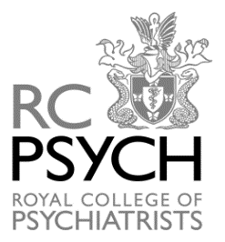
PROGRAMME

Thursday, 14 March 2019

19:00-20.00 Introduction
Dr Donna Mullen, Vice-chair of the Royal College of Psychiatrists in Scotland Addictions Faculty

20.00 Dinner

Friday, 15 March 2019

9:15 – 9.45 Arrival & Registration

9.45- 10.30 Cocaine, Psychopharmacology, Clinical Issues, Treatment for those on ORT
Dr Anna Fletcher, SPR Lothian

10:30 – 11.15 Drug Related Presentations in A&E Glasgow
Dr Richard Stevenson, Consultant in Emergency Medicine, Glasgow Royal Infirmary
11.15 – 11.30 Tea /Coffee

11.30 – 12.00 Substance Misuse and Substance Misuse Services for Young People
Dr Deborah Judge, Consultant in Child and Adolescent Psychiatry

12.00 – 12.30 Current trends in Young People Misuse
Lisa Mellen, Operational Manager, Youthinc

12.30 – 13.45 Lunch

13.15 – 13.45 Business Meeting

13.45 – 14.30 Cocaine; Cultural and Historical Aspects
Dr Douglas Small, Wellcome Trust Research Fellow

14.30 – 15.15 Cocaine/ Stimulants from a Police Perspective
DC Kenny Foy, Detective Constable, Statement of Opinion Unit
(STOP), Specialist Crime Division, Police Scotland

15.15 – 15.30 Tea/Coffee

15.30 – 16.15 Chemsex, STIs and the role of stimulants and other drugs
Dr Manik Kohli, Trainee, London

16.15 - 16.30 Closing Remarks
Dr Donna Mullen

This meeting qualifies for 5 CPD points subject to approval by the individual member’s Peer Group.

