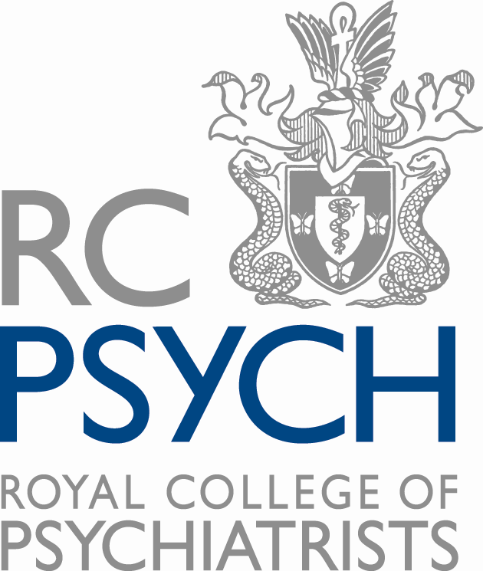

Briefing note on Royal College of Psychiatrists members’ survey

Date: 17/04/2020

Background
- The Royal College of Psychiatrists is the professional medical body responsible for supporting psychiatrists throughout their careers, from training through to retirement, and in setting and raising standards of psychiatry in the United Kingdom.
- The College aims to improve the outcomes of people with mental illness, and the mental health of individuals, their families and communities. In order to achieve this, the College sets standards and promotes excellence in psychiatry; leads, represents and supports psychiatrists; improves the scientific understanding of mental illness; works with and advocates for patients, carers and their organisations. Nationally and internationally, the College has a vital role in representing the expertise of the psychiatric profession to governments and other agencies.
- Following the outbreak of the Coronavirus, there has been significant changes to the day to day work of clinicians, including psychiatrists. This includes the equipment they need to safely treat patients, the need for tests to confirm whether patients or the clinicians themselves have the virus and changes to practices such as detention orders.
- Further changes may also be necessary as contained within the legislation introduced in response to the crisis. These include those which were introduced immediately as well as those which may be introduced on a temporary basis.
- With these factors in mind, the latest survey of members by the Royal College of Psychiatrists sought to capture the views of our members on these and other key issues. This is to inform our work in engaging and supporting their efforts.

Overview
- The survey took place from Tuesday 14 April to Friday 17 April 2020.
- Of the 1,360 members of the Royal College of Psychiatrists in Scotland, 180 responded (13.2%).
- It is expected there will be further such surveys in the coming weeks in order to offer comparative data.

Key results
The key results are as follows:

Can you currently access the correct level of PPE that you need?
- 103 (equating to 57.2%) said that they were receiving sufficient PPE, with 52 (28.9% saying no and 25 (19.9%) not sure.
- This was a smaller proportion than in England (61%) but compared favourably to Northern Ireland (55.3%) and Wales (47.3%)

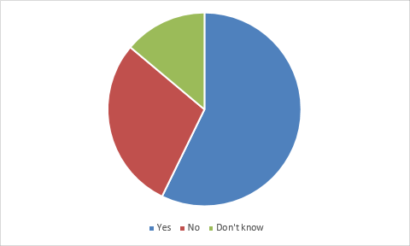

Are you currently able to access the COVID-19 testing that you need?
- Members were asked to consider the availability of testing for three groups: patients; members of their household with symptoms; and themselves.
- For patients, 70.9% of members said they were able to test those that showed symptoms compared to 8.9% who said no. This was the highest proportion in the UK.
- 53.6% of members said those family members who showed symptoms were able to access tests. In England, 25.9% of members said they were able to access tests for family members, and in Wales and Northern Ireland it was at 25.% and 66% respectively.
- For clinicians themselves, 59.6% said there were able to access a test if they started showing symptoms. This was higher than England (48.2%) and Wales (54.1%) but less than Northern Ireland (89.4%).

The clinicians only result by percentage:

Have you witnessed delays in patients being assessed under the Mental Health (Care and Treatment) (Scotland) Act 2003 in the past three weeks?
- 15.6% of respondents suggested they had experienced delays, compared to 57.2% who hadn’t.

Do you think the provisions in the Coronavirus (Scotland) Act to amend section 13ZA of the Social Work (Scotland) Act 1968 in relation to incapable adults being moved from hospitals to the community should be enacted?
- The question had 179 respondents.
- Within those, nearly 40% either agreed or strongly agreed that these powers should be enacted, with 11.27% disagreeing. 49.16% didn’t agree or disagree.

