Royal College of Psychiatrists in Scotland  Old Age Faculty Spring Conference  17 May 2019  DoubleTree by Hilton Treetops, Aberdeen | 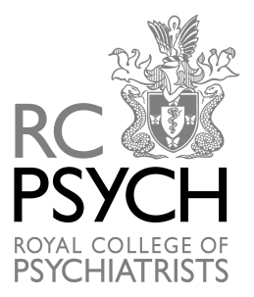

Programme

09.15 – 09.45 Registration/ Tea & Coffee

09.45 – 10.45 NICE guidelines on Dementia
Prof John O'Brien, University of Cambridge School of Clinical Medicine

10.45 – 11.00 Tea & Coffee break

11.00 – 12.00 Functional Cognitive Disorder
Prof Alan Carson, Neuropsychiatrist, Royal Edinburgh Hospital

12.00 – 13.00 Young Onset Dementia (YOD)
Dr Graham McKay, Consultant Neurologist, Aberdeen Royal Infirmary and;
Dr Tom MacEwan, Consultant in Old Age Psychiatry, Aberdeen

13.00 –14.00 Lunch

14.00 – 14.15 Faculty Business Meeting

14.15 – 15.00 SIGN guidelines on Delirium
Dr Ajay Macharouthu. Consultant in Liaison Psychiatry for Elderly, NHS
Ayrshire & Arran

15.00 – 15.45 Dementia Research
Dr Alasdair Lawrie, Consultant in Old Age Psychiatry, Royal Cornhill Hospital

15.45 – 16.00 Tea & Coffee

​16.00 – 16.45 Title TBC
Dr Vaishnavi, Psychiatrist, Chennai, India

16.45 Close

