Royal College of Psychiatrists in Scotland  Old Age Faculty Autumn Meeting 2019  Friday 22 November 2019  The Hilton Carlton, Edinburgh | 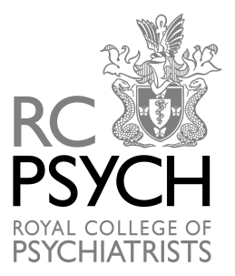

Programme

8.30 – 9.00 Registration/ Tea &Coffee

9.00 – 9.10 Welcome
Dr Ian McClung, Consultant Psychiatrist for Older Adults, NHS Lothian

9.10 – 10.10 Practical and useful imaging in dementia and emerging methods
Professor Joanna Wardlaw, Chair of Applied Neuroimaging and Head of Neuroimaging Sciences and Edinburgh Imaging, The University of Edinburgh

10.10 – 10.30 Tea & Coffee Break

10.30 – 11.30 An update from the European Prevention of Alzheimer’s Dementia Consortium (EPAD) and the PREVENT dementia programme.
Professor Craig Ritchie, Professor of the Psychiatry of Ageing
Centre for Clinical Brain Sciences, University of Edinburgh

11.30 – 12.00 The Edinburgh Consensus: Preparing for the advent of disease modifying therapies for Alzheimer’s Disease
Dr Tom Russ, Consultant Psychiatrist & Honorary Clinical Senior Lecturer, NHS Lothian and The University of Edinburgh. Co-director, Alzheimer Scotland Dementia Research Centre

12.00 – 12.30 National progress in regards to setting up Brain Health Clinics.
Dr Catherine Pennington, Senior Clinical Research Fellow, Centre for Clinical Brain Sciences, University of Edinburgh and Honorary Consultant Neurologist, NHS Lothian.

12.30 – 13.30 Lunch

13.30 – 13.45 Faculty Business Meeting

13.45 – 14.45 Case presentations from an early onset cognitive disorders clinic
Dr Suvankar Pal, Senior Clinical Lecturer in Neurology& Honorary Consultant Neurologist, The Anne Rowling Regenerative Neurology Clinic, NHS Lothian

14.45 – 15.45 Rapid Response Team – An Alternative to Psychiatric Hospital Admission
Mrs Karen Ritchie, Senior Charge Nurse, RRT, Royal Edinburgh Hospital, NHS Lothian

15.45 – 16.00 Tea & Coffee

16.00 – 17.00 Scottish Mental Health Law Reform: Where next and why?
Dr Arun Chopra, Consultant Psychiatrist in General Adult Psychiatry, NHS Lothian

