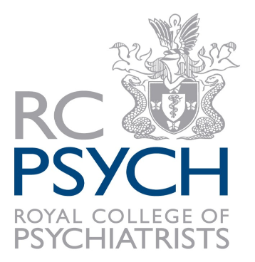
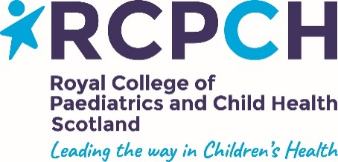

‘LEARNING FROM EACH OTHER’

A JOINT MEETING BETWEEN THE ROYAL COLLEGE OF PAEDIATRICS AND CHILD HEATH, SCOTTISH PAEDIATRIC SOCIETY AND THE ROYAL COLLEGE OF PSYCHIATRISTS IN SCOTLAND

Friday 1st March 2019 – 9.30-16.30

Royal College of Physicians and Surgeons of Glasgow
232-242 St Vincent Street, Glasgow, G2 5RJ

Draft AGENDA
Registrations will open at 9am
09.30 | Welcome – purpose of the day | Prof Steve Turner, RCPCH  Dr Elaine Lockhart, RCPsych  Dr Helen Mactier, SPS
09.40 | Dr Dame Denise Coia
10.10 | 5 x 15 min Audit/research papers presentations
11.25 |  | Break
11.45 | Dr Virginia Davies | Medically unexplained symptoms: aiming for business as usual
12.20 |  | MindEd presentation
12.40 |  | Lunch
13.40 | 5 x 15 min case presentations
14.55 |  | Break
15.15 | Dr Patricia Jackson – Dr Justin Williams | FASD
16.15 | Presentation of prizes Summary of the day
16.30 | Close

Book your place here for further information contact Claire.burnett@rcpch.ac.uk 0131 247 3644

