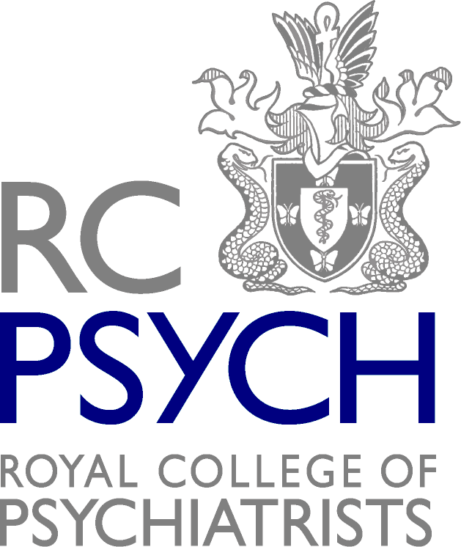
Report on the Royal College of Psychiatrists in Scotland Personality Disorder Campaign
Why did the College choose Personality Disorder as a campaign?
The Royal College of Psychiatrists in Scotland Executive Committee identified personality disorder as a priority at the Strategy Day held in 2016. It was felt this group of patients is generally not well served by mental health and other services, despite a number of UK and Scottish documents over the past 15 years which have highlighted the challenges in providing good care for this patient group, as well as describing good practice. It is striking that the 2003 National Institute of Mental Health (NIMHE) document “Personality Disorder, no longer a diagnosis of exclusion” considered it necessary to specify as one of its aims that PD patients should be seen as being part of the legitimate business of mental health services. Despite progress in refining psychotherapy treatments, and improved understanding of the development of PD and good principles of care, it is not clear that this aim has been achieved.
What are the main aims of the campaign?
- Challenge misconceptions and reduce stigma around personality disorders
- Advocate for adequate funding and equal service provision for personality disorders across Scotland
- Promote best practice in service delivery across both primary and secondary care

Background Information
Personality Disorder Working Group
RCPsych in Scotland Executive Committee identified personality disorder as a priority at the Strategy Day held in 2016. A short-life working group was established, with representatives from faculties within the College who identified themselves as having an interest in improving care for individuals with this condition. We also invited others from various professional backgrounds (Nursing, Psychology, Allied Health Professions, Police, Criminal Justice, Social Work, and Art Therapy), the chair of the Scottish Personality Disorder Network and people with lived experience of the diagnosis. The working group has met on eight occasions and has utilised a conference hosted by the Scottish Personality Disorder Network (SPDN) to gather wider stakeholder views from across Scotland.
The working group also conducted a survey of current provision of services for people with personality disorder in Scotland and a survey of training models utilised across Scotland. The group has reviewed existing documents, including National Institute for Health and Care Excellence (NICE) guidelines on borderline and antisocial PD, NHS England good practice guidance.

Report Launch
The Personality Disorder in Scotland report was launched on 17th August 2018 and received media coverage in the Herald and positive coverage on social media. A formal report launch was held on the 9th October at RICS Edinburgh.
Initial Letters
In August, letters were sent out by the College, in the name of Professor John Crichton and Dr Andrea Williams, promoting the report, recommendations and campaign. These letters were sent to Health Boards, Associate Medical Directors and Health and Social Care Partnerships. We received four responses from Health Boards and Health and Social Care Partnerships.
Presenting to the world
Dr Andrea Williams, chair of the PD Working Group, presented the College’s report at two conference; the national British and Irish Group for the study of Personality Disorder Conference (April 2019); and the International European Society for the study of Personality Disorder Conference (September 2018).
Meeting with Scottish Government
Following the launch of the report, we met with Scottish Government to discuss the campaign’s recommendations and the Government’s views on their implementation. The minutes from this meeting are attached here. The Campaign was also highlighted to the then new Minister for Mental Health, Clare Haughey, in an introductory meeting between her and the College.
Influencing the College
In May 2019, a cross-Faculty Personality Disorder working group led by the Medical Psychotherapy Faculty in England and Wales were in the final stages of producing a position statement on Personality Disorder. After reviewing the draft, the Scotland PD working group made several suggestions to ensure the position statement was in line with the Scotland report. Our recommendations were accepted, with the position statement now recognising the Scotland report and the differences in services compared to the rest of the UK.
Letters to Health Boards asking for an update
In June 2019, the College wrote to the respective Chief Executives of each NHS Scotland Health Board, asking them to provide an update on their work to incorporate our recommendations into their services. Out of the fourteen health boards, six boards have responded in some capacity to our letters so far (Borders, D&G, Grampian, Lanarkshire, Lothian and Orkney).
Proposal for a Managed Network
The College has submitted a proposal for a Managed Network for Personality Disorder structure and funding.
The proposal is currently being reviewed by Scottish Government regarding its suitability for the Programme for Government. The College will meet with the Government to discuss the proposal. Should it be accepted and implemented, this will have a positive impact on recommendations 2, 3, 5, 6, 7 and 8.
Current progress on recommendations:
National
1. Personality disorder should be a priority for the Scottish Government, with inclusion of specific actions in the Mental Health Strategy relevant to improving experiences of care and outcomes.
Meetings in November and December 2018 with Scottish Government and the Minister for Mental Health, Claire Haughey discussed this recommendation. There was an initial indication of some support for a college initiative, for example a well targeted MCN proposal. However, there was little enthusiasm from Scottish Government for introducing new actions specific to PD in the Mental Health Strategy.

5. A managed clinical network for Personality Disorder (PD) should be established to co-ordinate development of equitable service provision across Scotland.
The College’s proposal for a Managed Network is currently being reviewed and we await the outcome.

8. There should be a personality disorder lead for each health board – to advocate for appropriate services and promote a consistent and evidence-based approach and continue the work which was commenced in developing Integrated Care Pathways (ICPs) within each health board.
Several Health Boards have indicated that they have a PD lead in place (GGC, Borders, Lanarkshire, D&G) or were in the process of recruiting (Lothian and Grampian). Proposal success for managed network will influence progress.

9. Continue funding of the Scottish Personality Disorder Network, which has successfully acted as a broad-based learning network where good practice and innovation can be shared across Scotland.
While progressing, it is unclear if funding would come from Joint Board budgets or from the new Mental Health money that the Government had announced in the 2019/20 budget.

Regional
6. Health boards should include personality disorders in plans for mental health services.
This was a recommendation that is being worked on already in some Health board areas (example - Borders, Highland and GGC confirmed). Proposal success for managed network will influence progress.
7. People with personality disorder should expect equal access to and quality of service across geographical areas.
The Mental Health Strategy Delivery Board have discussed what the standard of quality should be, and this would need to be seen before the recommendation is progressed. Proposal success for managed network will influence progress.
Service level
2. Crisis plans for patients with personality disorder should be developed and shared between relevant service providers.
Proposal success for managed network will influence progress.

3. Adequate training, supervision and opportunity for reflective practice should be provided for all staff working with people with personality disorder, as appropriate to their role.
Proposal success for managed network will influence progress.

4. All staff should strive to demonstrate the principles of compassion, curiosity and empathy when working with people with personality disorder and challenge stigma by promoting good attitudes towards people with personality disorder.
Difficult to demonstrate this being done.

Given the current situation in NHS Tayside, it was unlikely that we will receive a response from this Health Board

