Summary of relevant questions for Disclosure Scotland Consultation

Section 3
This section is about reforming the eligibility policy underpinning the PVG scheme.
- Proposals are provided on how a mandatory PVG scheme can be established.
- PVG scheme membership will become time-limited (anywhere between 1 — 5 years depending on consultation outcome).
- ‘Regulated work’ as a concept will be discontinued. Instead, the Scottish Government will establish and regularly updated a schedule of ‘protected roles’ (p.28).
- It will become a criminal offence to do work in any ‘protected roles’ whilst not a member of the PVG scheme.
- ‘Protected adults’ will be defined relative to an adult’s use of health services, registered care services, community care services and welfare services.
- Volunteers at charitable organisations will now potentially have to pay a small fee for PVG membership, or if they satisfy the relevant criteria this fee may be waived.

Section 4
This section is about removing people from working with ‘protected groups’.
- The age threshold for the shorter prescribed period (i.e. how long a person is on the list for) may be raised from the age of 18 to 25, as evidence shows most young people who offend do not continue to do so in adulthood.
- For volunteers, it would be an offence for non-members of the PVG scheme to be employed in work for which PVG Scheme membership is mandatory. Similarly, it would be an offence for an organisation to offer work to a non-member of the scheme.
- The capacity for court referral procedures to be used will be removed.
- People included in the barred lists will be able to apply for removal from the lists.
- The Automatic Listing Procedure, where the most dangerous criminals are prevented from entering the PVG Scheme, is intended to remain in place. This procedure would mean individuals who cannot contextualise or explain their previous actions may be put on a list of adults prohibited on the PVG Scheme at the discretion of Scottish Ministers.
- Proposal to give police new referral powers which can be used to make a referral where they have charged someone with the offence of working in a protected role whilst not a scheme member, or where a referral has not been made by a relevant organisation.
- Proposals to provide Disclosure Scotland with the power to impose standard conditions, on time limited basis, whilst a person is under consideration for listing.
- Overseas work which would be considered to be a protected role if carried out in Scotland is now intended to become a specified protected role. It would be a criminal offence for any Scottish based organisation to knowingly offer a barred individual work overseas that would be a protected role were it in Scotland.

Section 5
This section is about changing the time frames under which persons convicted of offences must disclose their prior convictions.
- Anticipating the passing of the Management of Offenders (Scotland) Bill, which changed the length of rehabilitation periods in respect of custodial sentences, Disclosure Scotland suggested reducing the timescales for retention of criminal conviction information.
- The Management of Offenders (Scotland) Bill will reduce the period of disclosure for custodial sentences up to and including 48 months. The length of time within which prior convictions must be disclosed following a custodial sentence would adapt to below:
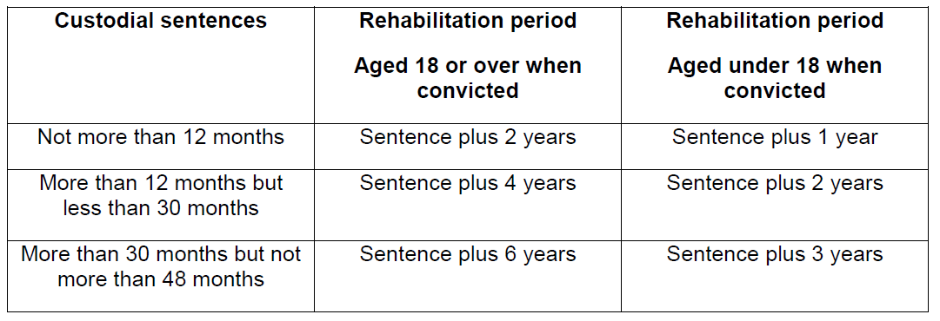
- Instead of continuing to rely on a sheriff to decide on the potential removal of convictions from disclosure, three alternative mechanisms for adjudication are suggested including; an administrative process stage prior to application to a sheriff; introducing an independent reviewer; or using the Scottish Tribunals.
- Provisions established to reduce the possibility of disclosure of criminal convictions accrued by young people 12 years or older on all types of disclosure. As the document states: ‘An individual may consider that even a serious conviction should not be disclosed because of their youth at the time of the offence and because they consider that the circumstances are exceptional enough to justify non-disclosure.’
- Three options to change disclosure demands for young people are highlighted — make no changes; ensure no possibility of disclosing automatically a conviction accrued between 12 and upper age limit is possible; or disclose any conviction except where the conviction is for schedule 8A/8B offence.
- Disclosure Scotland wants to place a lower age limit on applicants for criminal record checks, a practice which would be commensurate with the rest of the UK.

Section 4
Question 20: Do you agree with the proposal to replace the “regulated work” definition with a list of roles/jobs?
Yes ☐ No ☐

Question 21: Do you foresee any challenges for organisations from this proposed approach?
Yes ☐ No ☐

Question 22: Are there any roles/jobs not within the list in Annex B that you think should be subject to mandatory PVG scheme membership?
Yes ☐ No ☐

Question 23: To avoid inappropriate membership, what criteria to you think should be used to decide if an individual is in a protected role?

Question 26: Are there any services that should be added, or are there any services that should be removed?
Yes ☐ No ☐

Questions 30: There are also certain exclusions that apply to work in such establishments. A person whose normal duties involve working in such a place will only be doing regulated work if doing something permitted by their position gives them unsupervised access to adults, and where that contact with the adults is not incidental.
Do you think this approach is clear and helpful?

Question 32: How long should scheme membership last in a mandatory scheme?
a) 5 years ☐
b) 3 years ☐
c) 1 year ☐
Question 41: Should volunteers continue to receive free membership?
Yes ☐ No ☐

Question 41a: If no, should they be subject to a reduced fee?
Yes ☐ No ☐

Question 42: Do you agree that voluntary organisations seeking to benefit from a reduced fee or the fee waiver should be subject to a public interest test?
Yes ☐ No ☐

Question 42a: If so, how should that test be defined?

Section 4
Question 46: Do you agree with our proposals to dispense with the current court
referral procedure under section 7 of the 2007 Act?
Yes ☐ No ☐

Question 47: Are there offences missing from the Automatic Listing Order that you
think should be included? You can access the order here
Yes ☐ No ☐

Question 48: Do you agree with proposals to create new referral powers for the
Police?
Yes ☐ No ☐

Question 49: Do you agree these powers should be limited to when police have
charged a person with unlawfully doing a Protected Role whilst not a scheme member
or where a referral has not been made by a relevant organisation?
Yes ☐ No ☐
Question 50 [in reference to giving Health and Social Care Partnerships the power to make referrals to the police on behalf of children/vulnerable adults] Do you think this proposal closes the safeguarding gap in terms of self-directed support?

Question 53: Do you agree with the proposal to provide Disclosure Scotland with
powers to impose standard conditions?
Yes ☐ No ☐

Question 54: If yes, how long should the conditions last before lapsing?
a) 3 months ☐
b) 6 months ☐

Question 55: Under what circumstances do you think Disclosure Scotland should be
able to impose standard conditions and why?

Question 56: Do you agree that it should be a criminal offence if an individual and
employer/voluntary body failed to comply with standard conditions?
Yes ☐ No ☐
Question 59: Do you think it’s appropriate that organisations, irrespective of where
the regulated work is to be carried out, should be informed of a listed individual’s
barred status?
Yes ☐ No ☐
Question 60: Do you agree with our approach for PVG Scheme Members in a
protected role overseas or organisations employing PVG members to do a protected
role, such as providing aid services?
Yes ☐ No ☐
Section 5
Question 66: Do you believe the rules for disclosure in the current form of 15 years
and 7.5 years provide appropriate safeguarding and privacy protections?
Yes ☐ No ☐

Question 67: Do you agree that a reduction in the disclosure periods from 15 & 7.5
years is appropriate considering the changing policy on rehabilitation of offenders?
Yes ☐ No ☐

Question 68: What period between 11 and 15 years do you think is appropriate for
disclosure?
11 ☐ 12 ☐ 13 ☐ 14 ☐ 15 ☐
Question 69: Do you think the application process to seek removal of a spent
conviction should be reviewed?
Yes ☐ No ☐

Question 70: At present, an individual has three months from the date of notification
of an intention to appeal to make an application to a Sheriff. Do you think this time
period is:
Too long ☐ Too short ☐ Correct ☐

Question 70a: If you indicated that the time period is too long or too short, what do
you think the time period should be?
Section 6
Question 75: Should there be specific provisions reducing the possibility of the state
disclosure of criminal convictions accrued by young people 12 years or older on all
types of disclosure?
Yes ☐ No ☐
Questions 76: Should there be a presumption against the disclosure of all convictions
accrued between 12 and a specified upper age, with the only possibility being police
disclosure as ORI after ratification by the Independent Reviewer on the Level 2 and
PVG Level disclosures?
Yes ☐ No ☐
or
Question 77: Should there be no state disclosure of any conviction between the age
of 12 and the specified upper limit, except where the conviction is for an offence listed
in schedule 8A or 8B?
Yes ☐ No ☐
Question 81: Do you agree with the proposal to place a lower age limit on applicants
for criminal record checks?
Yes ☐ No ☐

Question 82: In what circumstances should a criminal record check for a child under
16 be permitted?
Question 90: Please tell us about any potential impacts, either positive or negative;
you feel the proposals in this consultation document may have on any particular
groups of people?
Question 94: Please tell us about any potential impacts, either positive or negative;
you feel the proposals in this consultation document may have on children?

