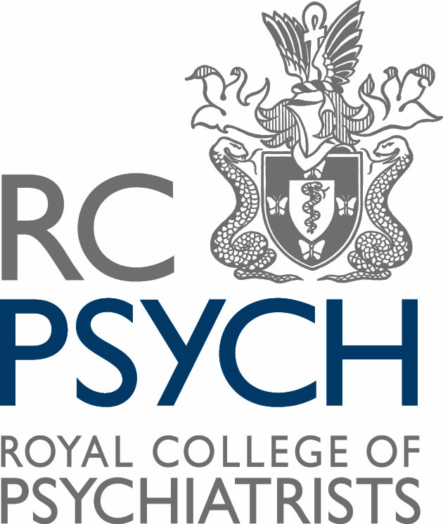

The Royal College of Psychiatrists Wales, and
Welsh Government
Joint conference

‘A Whole School Approach’

Monday 11 November, All Nations Centre, Cardiff, CF14 3NY

Delegate Name :
Organisation :
Email Contact :
Telephone Contact :
Dietary Requirements :

Please return this application form by email to Louis.Mertens@rcpsych.ac.uk
Or by post to :
Louis Mertens, The Royal College of Psychiatrists Wales, Baltic House, Mount Stuart Square, Cardiff. CF10 5FH.

We will confirm receipt and event registration.

The conference will begin at 11:15, however it’s preceded by the Young People’s Mental Health Debate. Conference delegates are welcome to observe the debate which begins at 9.45.

Would you be interested in observing the morning debate? Y / N

The conference is free to attend, but we do require delegates to register. Importantly, we require 48 hours notice prior to the start of the event, should you wish to cancel your booking. Also we would look to impose the day delegate rate of £29, if you fail to confirm cancellation.

