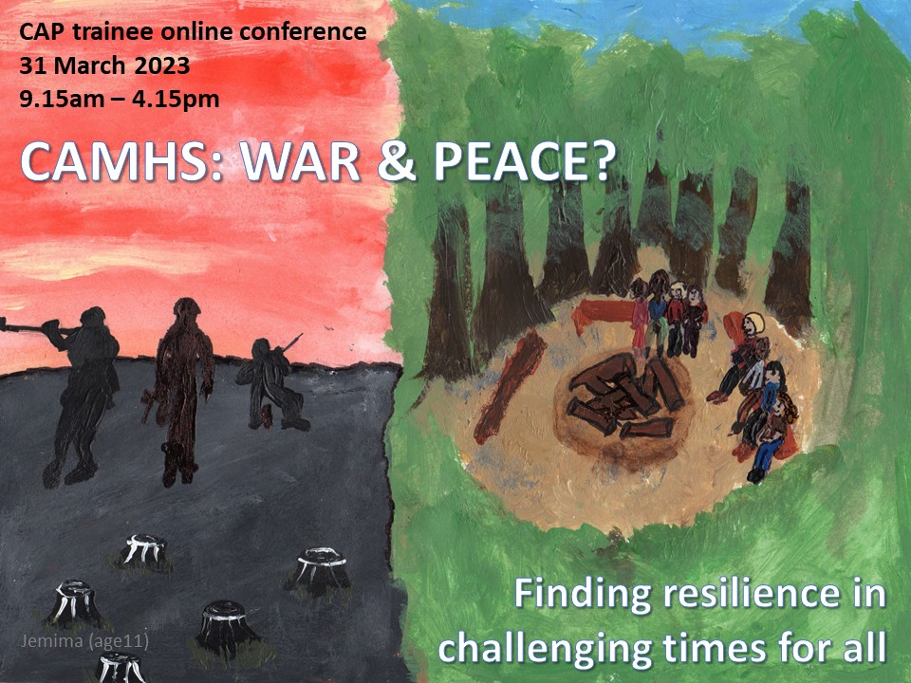
RCPSYCH CAP Trainee Conference 2023
CAMHS: WAR AND PEACE? Finding resilience in challenging times for all

Friday 31st March 2023, 9am-5pm, Online

You are warmly invited to join us for the 2023 CAP Trainee conference. This event is organised by and for CAP trainees. Sign up now using the Eventbrite link: https://www.eventbrite.co.uk/e/camhswar-and-peace-finding-resilience-in-challenging-times-for-all-tickets-514126535307

T﻿he 2023 CAP trainee conference will have sessions on:
-﻿RCPSYCH Faculty updates (what you need to know about the faculty and what is does for you and some curriculum updates)
-﻿CAMHS and Trauma informed practice and supporting the mental health of children and young people affected by war and displacement
-﻿EcoCAMHS and how to be sustainable psychiatrist
-﻿How to start and stay well as a trainee including a reflective forum on trainee issues, updates from the psychiatric trainee committee and some interactive activities to promote your physical and mental wellbeing
-﻿Portfolio careers and acting up experiences from recent trainees
-W﻿e will also be exhibiting poster submissions online with prizes. See below details on how to submit your poster abstract.
Call for posters: RCPSYCH CAP Trainee Conference 2023

The RCPSYCH CAP Trainees are inviting poster submissions for our 2023 CAP Trainee conference on 31st March 2023. All submissions will be reviewed ahead of the conference and successful authors will then be invited to present their work as an online poster.

Regulations:
1. Abstracts must be in English. Abbreviations may be used only if they are defined (spelled out in full text at first mention) followed by abbreviation in brackets.
2. The abstract must not exceed 300 words including sub titles (see No 4) and formulas.
3. The abstract must not contain bibliographical references, tables, diagrams or appendices. If accepted for presentation at the conference these can be added at a later date.
4. Abstracts must be presented in five headed paragraphs in the following order:
Aims and hypothesis, Background, Methods, Results, and Conclusions.
5. Abstracts could present either novel findings or new interpretations of existing data; Quality Improvement
projects; Education and Training projects or other types of service evaluation, audit or case reports. They should include brief details of the rationale for the research and the methods used, including, if appropriate, the statistical approach. The major findings should be stated; it will not be acceptable, for example, to state merely that the "results will be discussed"
6. The title of the abstract must be clearly coherent with the data included in the abstract and the conclusions must be warranted by information included in the results section. Submissions are accepted on the understanding that the work has been performed with the permission of any relevant ethical or legislative body. The authors should therefore ensure the work was conducted with appropriate ethical and governance safeguards.
7. Authors are encouraged to state their hypotheses and frame their conclusions accordingly.
8. For studies of service users, patients or populations, the number of people studied should be explicitly stated in the methods section.
9. Submissions are accepted on the understanding that the work has been performed with the permission of any relevant ethical or legislative body. The authors should therefore ensure the work was conducted with appropriate ethical and governance safeguards.
10. All sources of financial sponsorship of the study should be stated at the end of the abstract.

Please submit you abstract using this link: https://forms.gle/GLq95dNKrPqaReSo7
The details you enter cannot be saved, to avoid losing your work please copy your abstract to the form from another document.

The submission closing date is 5pm on Tuesday 28th February 2023.

