Assessment, Diagnosis and Management of Delirium during COVD-19 Pandemic
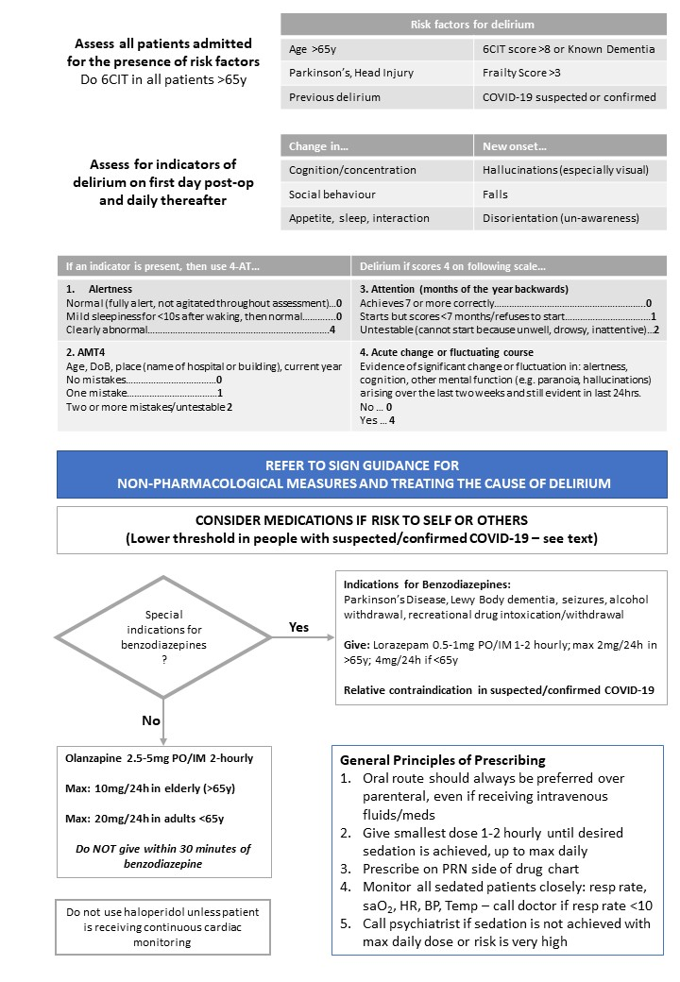
This guidance should be read in parallel with the Trust’s policy on the Assessment, Prevention and Management of Delirium; however, please note this guidance supersedes it whilst the Trust operates under a Major Incident Protocol.

British Geriatric Society Recommendations for management of delirium in people with suspected or confirmed COVID-19 infection
Delirium, the clinical expression of encephalopathy, is important in the context of COVID-19, because (a) delirium may be a symptom at presentation and/or during management, and (b) the behavioural changes commonly seen in delirium, particularly agitation, may make management including delivery of care and reducing the risk of cross-infection more challenging.
Delirium as a feature of COVID-19
Older people are at the greatest risk from COVID-19. If infected they may present with or develop a delirium. However, delirium is not exclusive to older people and may well be seen in any patient with severe infection, adult respiratory distress syndrome, and those requiring invasive ventilation on ICU units.
Delirium and the management of COVID-19
Delirium, especially its hyperactive motor form, will present significant additional challenges in the context of the COVID-19 crisis. Standard non-pharmacological measures to treat or prevent delirium may well not be possible in isolation environments, and these environments may themselves worsen delirium.
Recommendations
The following recommendations follow two key themes. First, good general care including prevention, early detection, and non-pharmacological management should be provided as systems allow. Second, because of the ease of transmission of COVID-19, the risk of harm to others may exceed risk of harm to the individual and this may necessitate earlier use of pharmacological treatments for potentially risky behaviour. However even in complex situations where a patient has a delirium in the context of COVID-19, with added risks of transmission to others and possibly limited human resource, the same basic principles of risk assessment and the Mental Capacity Act apply.
- Enhanced implementation of screening for delirium in at risk groups and also regular assessment for delirium using a recommended tool (e.g. the 4AT). This may be increasingly constrained by staff and time limitations.
- Reduce the risk of delirium by avoiding or reducing known precipitants. Actions include: regular orientation, avoiding constipation, treating pain, identification and treatment of superadded infections early, maintaining oxygenation, avoiding urinary retention and medication review. See the SIGN delirium guidance below.
- With respect to behavioural disturbance, always look for and treat direct causes including pain, urinary retention, constipation, etc. Where these interventions are ineffective or more rapid control is required to reduce the risk of harm to the patient and others, it may be necessary to move to pharmacological management earlier than would normally be considered.
- If patients are given sedating mechanisms, especially if given parenterally, please monitor for side effects, vital signs, hydration level and consciousness at least every hour until there are no further concerns about the person’s physical health. Be mindful of use of benzodiazepine with respiratory depression.
- Note the usual guidance of caution with use of medication in older people, and especially certain medications in people with Parkinson’s disease or dementia with Lewy bodies (eg antipsychotic medication)
Delirium may cause considerable distress amongst both staff and families in addition to the patient. Provision of information around delirium is important using locally available resources. Booklets are available through the SIGN website.

SIGN Recommendations: Risk Reduction and Management of Delirium
The World Health Organization states older adults, especially in isolation and those with cognitive decline/dementia, may become more anxious, angry, stressed, agitated, and withdrawn during the outbreak/while in quarantine. Provide practical and emotional support through informal networks (families) and health professionals.
Share simple facts about what is going on and give clear information about how to reduce risk of infection in words older people with/without cognitive impairment can understand. Repeat the information whenever necessary. Instructions need to be communicated in a clear, concise, respectful and patient way. It may also be helpful for information to be displayed in writing or pictures. Engage their family and other support networks in providing information and helping them practice prevention measures (e.g. handwashing etc.)
Follow these basic principles:
