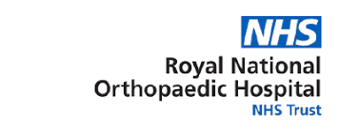
Mood/Anxiety Screen
In patients who present with mood changes or heightened anxiety, ask the patient to complete the Hospital Anxiety and Depression Screen (HADS) – see overleaf.

Scoring the HADS
The HADS consists of 14 questions that can be scored from 0 to 3.
7 questions relate to anxiety (indicated by an ‘A’) and 7 questions relate to depression (as shown by a ‘D’).

Each subscale: Anxiety (A) and Depression (D) are scored separately. Therefore the maximum score (maximum anxiety and depression) is 21 for each subscale.

Interpreting the Score
Any patient scoring above 11 on either subscale, or answering ‘A lot of the time’ or ‘A great deal of the time’ to the statement ‘Worrying thoughts go through my mind’, (irrespective of final score) should have a Suicide Risk Assessment – Refer to separate resource on Suicide Risk Assessment.
Where the patient has no or low suicidal risk, the score on the HADS should be interpreted in the following manner:
Score* | Meaning | Triage Code** | Response
0-7 | Normal | G | Reassurance
8-10 | Elevated distress | F/G | Watchful Waiting
11-14 | Abnormal | F | Primary care mental health response
15-21 | Severe distress | E+ | Specialist mental health input required
* for each subscale
** refer to separate document on Mental Health Triage

HOSPITAL ANXIETY AND DEPRESSION SCALE (HADS)
Please tick the box beside the reply that is closest to how you have been feeling IN THE PAST WEEK.
Don’t take too long over your answers: your first thought is usually the most accurate.
