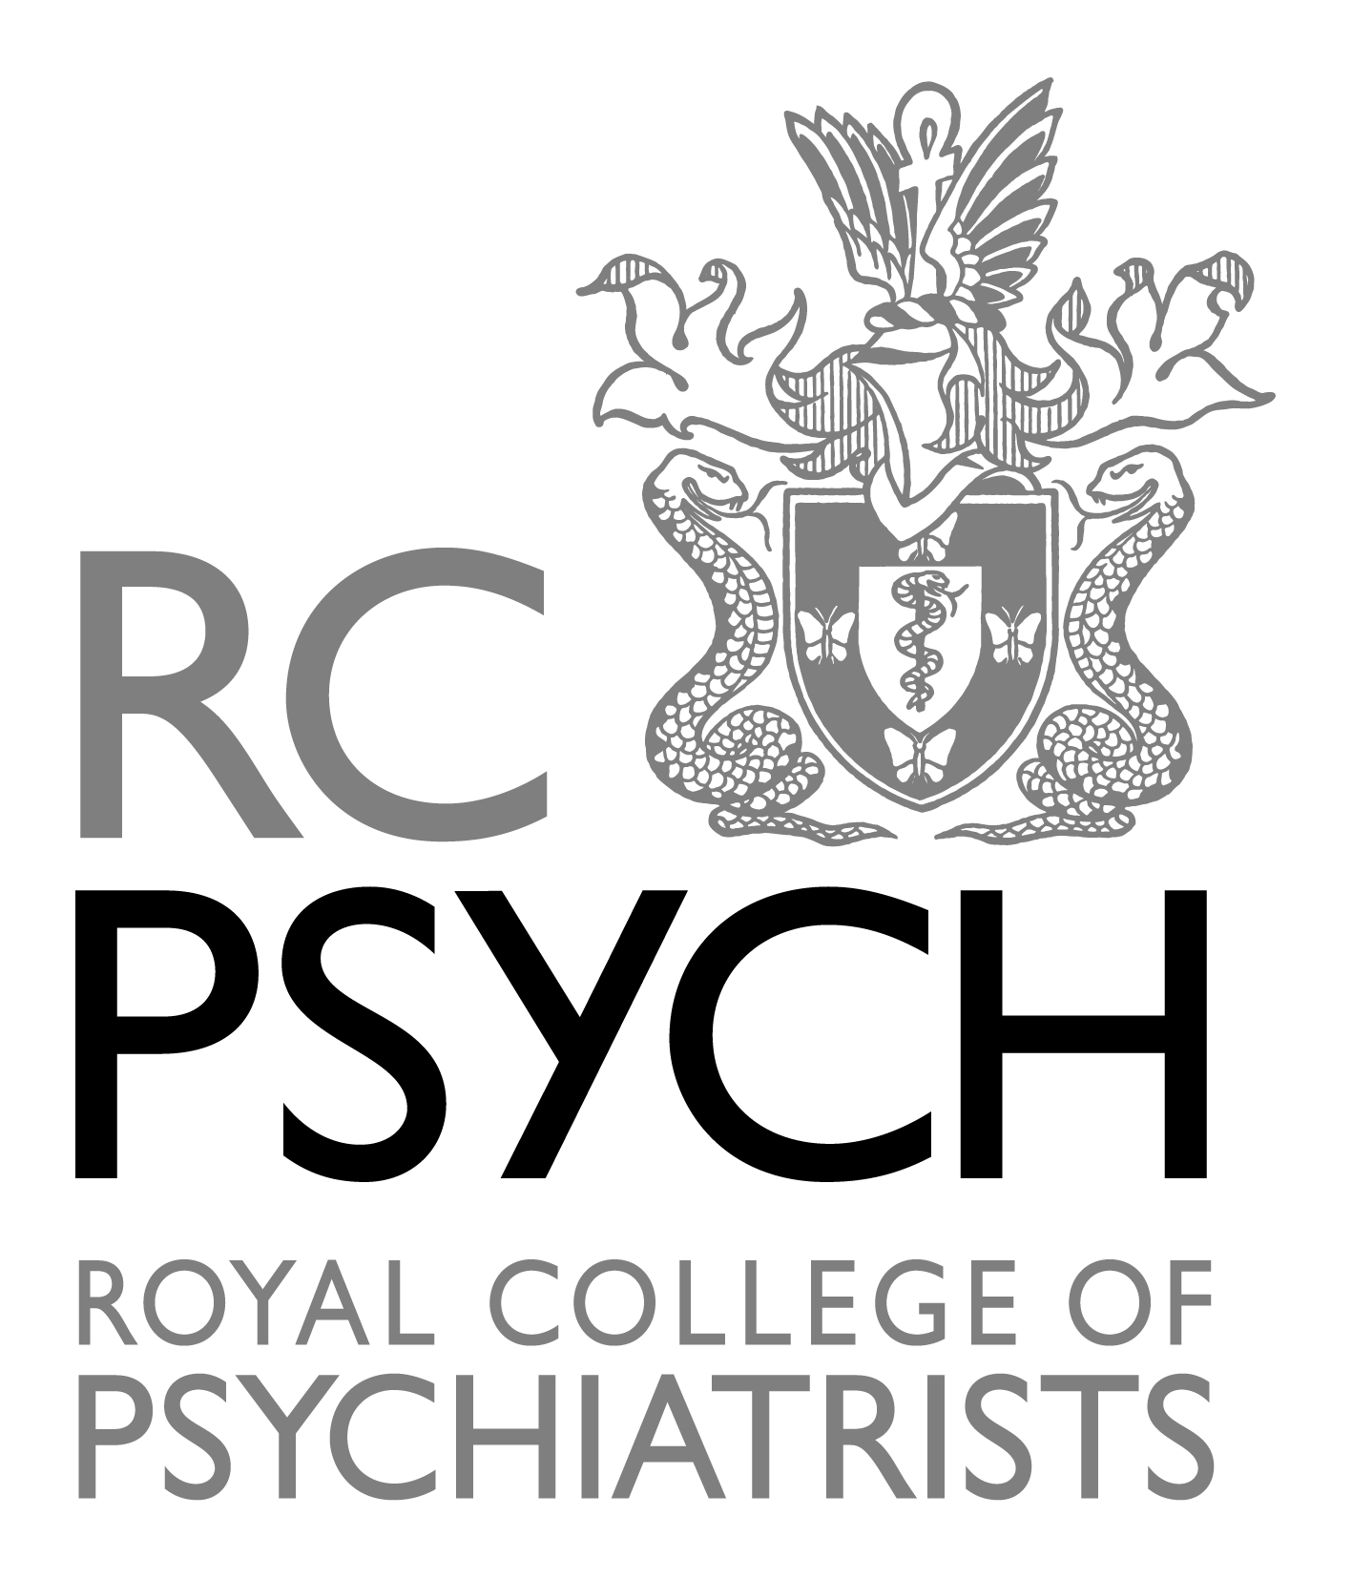

To: All Chief Executives
All Medical Directors, Mental Health Trusts
All Regional Advisors and Deputy Regional Advisors
All Regional Representatives, Old Age Faculty

17th January, 2013

Dear Colleague

Development of ageless mental health services

We are writing to you to request your help in securing a pause in the re-provision to “ageless” (also known as age-inclusive or age-blind) services for older people with all forms of mental illness as a replacement for the comprehensive models of care provided by old age psychiatry services over more than thirty years.

Age is an important personal characteristic enshrined in law. The main tenet of Parity of Esteem is that all people are entitled to the best care available, whatever their diagnosis or personal characteristics (such as age or gender). Older people with mental disorders should have their care and treatment managed by professionals who have specific expertise in that area. This principle is supported by NICE, the Department of Health, the Royal College of Psychiatrists and the British Psychological Society. The National Mental Health Strategy expects services to be age appropriate and non-discriminatory.

The expertise of older peoples mental health services lies in the care and treatment of people with complex mixtures of psychological, cognitive, functional, behavioural, physical and social problems usually relating to ageing. Although not restricted to older people, the presence of an increasing number of these domains in an individual is characteristic of the mixture of problems associated with the aging process. Current evidence suggests specialist old age services are best equipped to diagnose and treat mental illness in our ageing population.

Old age services should not be seen as managing only dementia; a recent survey of old age psychiatrists (with responses from over 90% of Trusts across the UK) found that up to 40% of patients in older adults services have functional (i.e other than dementia) illnesses and a dual diagnosis of co-existent functional illness and dementia is common. The same survey found that around 10% of respondents had already undergone significant merger into ageless adult services and a similar number reported this was imminent. We believe the specialism of old age psychiatry, with a specifically trained, skilled workforce for older people with functional illness or dementia, should be the vehicle for the provision of age-appropriate non-discriminatory services to our older population.

We are working hard to develop appropriate needs-led criteria for old age services. Once these are finalised we need a wide-ranging debate on how Old Age psychiatry services will develop moving forward. Until that point we encourage you to support our call.

Kind regards

 | Sue Bailey (President, RCPsych)
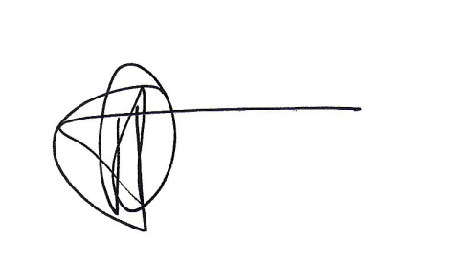 | James Warner (Chair, Old Age Psychiatry Faculty, RCPsych)
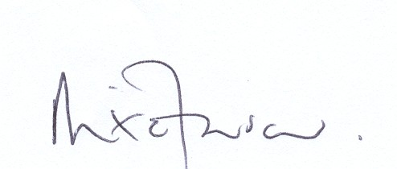 | Mike Farrar (Chief Executive, NHS Confederation)
 | Stephen Dalton (Chief Executive, NHS Confederation’s Mental Health Network)
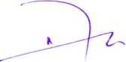 | Dave Anderson (past Chair- Faculty of Old Age Psychiatry, RCPsych)
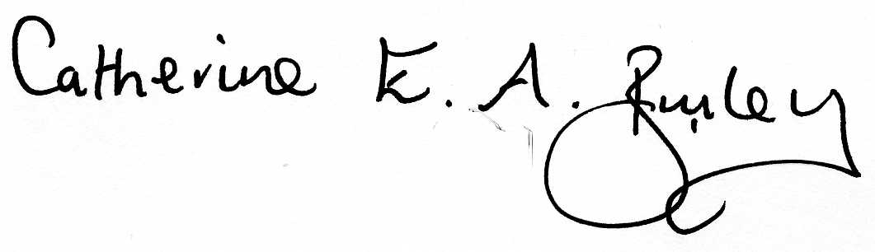 | Catherine Burley (Chair, Old Age Faculty, British Psychological Society)
 | Peter Carter (Chief Executive, RC of Nursing)
 | Peter Connelly (Immediate past chair- Faculty of Old Age Psychiatry, RCPsych)
 | Nori Graham (Vice President of the Alzheimer's Society)
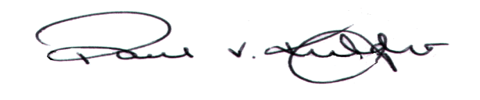 | Paul Knight (President, British Geriatrics Society)
 | Nick Kosky, (Chair, General Adult Faculty, RCPsych)

