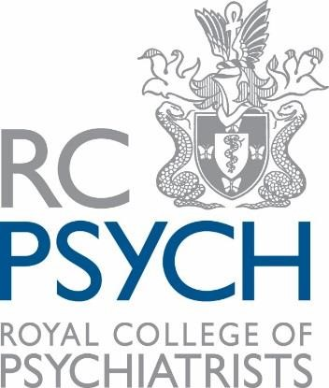
Royal College of Psychiatrists
Art Special Interest Group
Annual Conference
8th February 2019
RCPsych, London

PROGRAMME

Chair: Dr Stephen Ginn, consultant psychiatrist

09:00-09:25 | Registration and refreshments
09:25-09:30 | Welcome by Dr Stephen Ginn and Dr Peter MacRae
09:30-10:15 | Daniel Hack Tuke and his son, the artist Henry Scott Tuke  Nicolas Tromans
10:15-11:00 | The Dizziness of Freedom, a poetry anthology on mental health  Amy Acre
11:00-11:30 | Refreshments
11:30-12:15 | tbc
12:15-13:15 | Parallel workshop sessions (choose one of):  - SYNCHRONY Group Song writing  - Disappointman Drawing with visual artist Chris Sav  - Theatre-devising for clinical practice (ELFTarts, East London NHS Foundation Trust)
13:15-14:00 | Lunch and Short Film Screening
14:00-14:45 | The Girl Who Would Be God: Sylvia Plath’s Omnipotent Self-Creation  Sally Bayley
14:45-15:30 | Big Brother  Louis Quail
15:30-15:45 | Refreshments
15:45-16:30 | Madlove  the vacuum cleaner
16:30 | Conference Close

