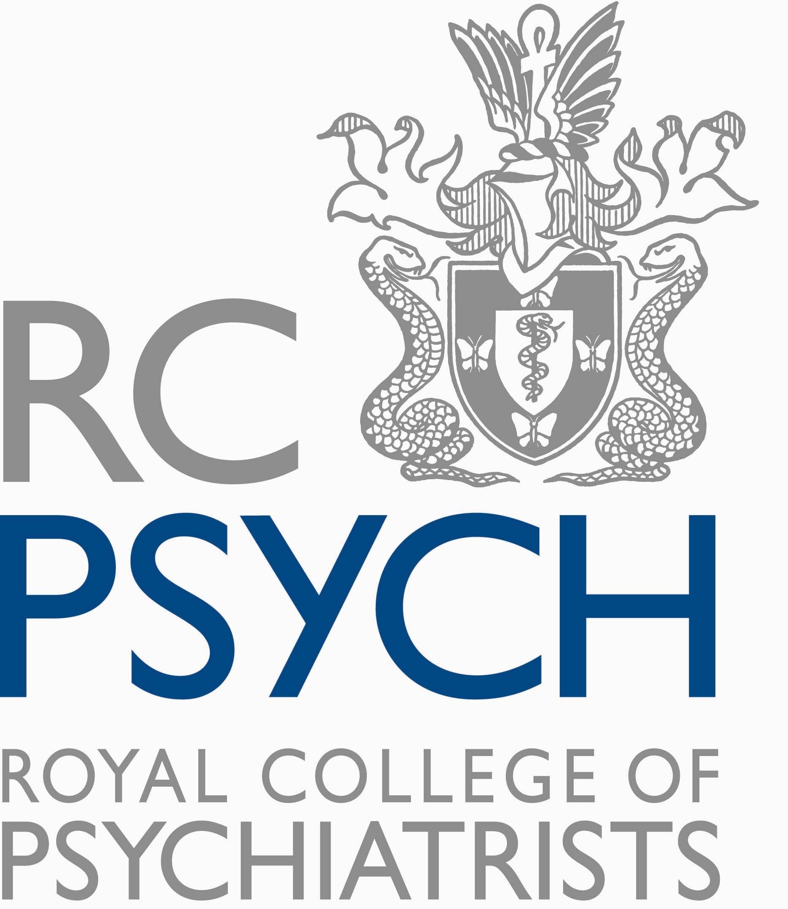
HISTORY OF PSYCHIATRY
SPECIAL INTEREST GROUP

Medical students’ history showcase afternoon
Wednesday 16th March 2016

Biographical notes and Abstracts

Learning about the History of Psychiatry; a new Student Selected Component (SSC)
Aileen O'Brien and Paul Lomax
Aileen O'Brien: Biography
- A George's graduate myself, I did an intercalated BSc in sociology and philosophy. I have combined clinical and academic work since training as a clinical lecturer at St George's.
- I am now a Reader in Psychiatry and Education. I am joint Consultant for the Psychiatric Intensive Care Unit and section 136 suite at South West London and St. George's Mental Health NHS Trust.
- My academic commitments include being the psychiatry undergraduate teaching lead at St George's, one of the personal tutor leads and the Athena Swan Lead.
- I am also the education and training lead for the National Association of Psychiatric Intensive Care Units (NAPICU) and I am one of the debate and analysis editors of the British Journal of Psychiatry.
Paul Lomax: Biography
I am a ST5 dual trainee in General Adult and Old Age Psychiatry working at South West London and St George’s NHS Mental Health Trust. I am currently working in an Old Age Psychiatry Community Team in Richmond, London.
I have long had an interest in the History of Psychiatry and more recently have become involved in the SSC course at St Georges, University of London. I run sessions on ‘Shellshock’ and ‘The dancing plague: 1518’ as well as marking student assignments.
Abstract
In 2014 St. George's University of London broadened the scope of SSCs offered, to include more that were related to humanities. The aim of the course is to fulfil the requirement to broaden the curriculum to involve more medical humanities whilst increasing the exposure of undergraduates to a career in psychiatry.
This presented an opportunity to introduce a SSC in the history of psychiatry; as this was an interest of several of the clinicians in the Trust.
We will describe how we developed the course and will discuss the range of assignments the students have done.
Feedback gathered from the undergraduates was positive and reinforced the view that exposure to psychiatry in undergraduate settings can increase interest in a future career in psychiatry.
Suggested reading
Matthew Langley, Benjamin Lomas, Zena Schofield, Gillian Doody, ‘A guide to a new short course to promote interest and engagement in psychiatry in medical students’ Psychiatric Bulletin 2015; 39: 200-204
Jane Macnaughton, ‘The humanities in medical education: context, outcomes and structures’ J Med Ethics: Medical Humanities 2000; 26: 23–30

History of Addictions
Anna Eaton
Biography
I’m a final year undergraduate medical student at St George’s. I chose the history of psychiatry SSC as I felt it would be something completely different from the medical school curriculum and offered a different perspective of a field I’m already interested in. I had a very limited knowledge about this area to start, but this only made it more interesting to explore. Because of the breadth of the topic it allowed me to delve into different areas of psychiatry and history I wasn’t familiar with, which generated curiosity along the way and gave rise to reading and research purely based on genuine desire and inquisitiveness. The placement gave me an insight into the role and development of psychiatry as a profession whilst the lectures and visits gave an opportunity for abstract thinking, sometimes on very obscure and niche matters, and learning for enjoyment rather than to meet a deadline or prepare for an exam, which was quite liberating!
I focused on substance misuse after being inspired by the history of the phenomenon, although I didn’t particularly enjoy the addiction psychiatry attachment during my psychiatry placement. Having explored the history of the problem and appreciating the difficulties in management on both an individual and population basis, it’s an area I’m much more interested in and a topic I’m much more receptive too and passionate about where I’d never given it much thought previously.
Abstract
Currently, over two million people in the UK are estimated to be suffering from a form of addiction. The ‘No Quick Fix’ report (2013) from the Centre for Social Justice, described the UK as the addiction capital of Europe with the highest rates of illicit drug abuse and alcoholism.
However, substances which are now prohibited were easily sourced throughout history. Notably, over the past two centuries: the original John Pemberton’s Coca-Cola and the popular Vin-Mariani wine both contained cocaine; opium houses were commonplace; morphine and syringes were available to order via catalogue; and patent medicine trade concoctions incorporated drugs from cannabis confectionary for menstrual cramps to cocaine pep-pills, and laudanum for cough medicine and syrup to soothe teething babies. Addictive substances were popular with various prominent historical figures, Alexander the Great, Queen Victoria and Sigmund Freud, to name a few, succumbed to chemical indiscretions.
But with alcohol being a legal intoxicant and most illicit drugs having only been outlawed over the past century, how has the use, misuse and our understanding of dependency to these substances changed over time, and can the past shed light on how and why addiction comes about?
The first written warnings of addiction came about in 1000AD but patterns of substance misuse were described throughout antiquity. Aristotle noted the effects of alcohol withdrawal, and Roman physician Celsus described alcohol dependency as a disease.
Society has dealt with substance misusers in a number of ways over the years by imprisonment, banishment, flogging, asylum incarceration, religious conversion and finally ‘treating’ addicts in the modern era. The ancient Turks reportedly poured molten lead down the throats of drunkards, and ancient Egyptians would remove the lips of those smoking tobacco or cannabis. The ancient Greeks believed that the properties of the amethyst crystal would protect them from alcohol dependency and cravings and thus would wear the gems, adorn their glasses with it and even add the powder to wine. Over a third of the population of China was addicted to opium by the time of the opium wars, and the epidemic wasn’t controlled until post-World War II when the communist government began public executions as a deterrent. Around the same time, America used the media and propaganda to perpetuate ‘horror stories’ to generate fear to control and limit drug use, as banning substances went against the Constitution.
Historically, prohibition has not been a deterrent and this alludes to a disease like desperation and dependency stronger than just a moral failing or lack of willpower. The scale of the problem throughout time supports a medical model of addiction – in which the addict is 'at risk’ rather than ’at fault’. Risks might include social circumstances, genetics, environment or emotional vulnerability, and the choice to experiment with a drug, but choice is soon replaced with physiological dependence and psychological compulsion. This contrasts with moral and learning models, ‘poor moral faculty’ or simple conditioning. Fear of this misanthropic and iniquitous conduct prompted the introduction of drugs laws, and arguably the same fear sustains them despite being ineffective in curbing addiction. Perhaps alternative, if not idealistic ways, to tackle the problem of addiction in society is to focus on the initial risk factors and equip people with coping strategies, make alternative and accessible ways for them to seek help for adverse events, and treat it as an illness without stigma when people do succumb.

Colonial Psychiatry
Ivan Shanley
Biography
I am a final year medical student at St George’s, University of London. I have a long standing interest in psychiatry and the SSC of my final year gave me an opportunity to explore this further. I have always enjoyed history and this study block allowed me to combine the two interests. I chose Colonial Psychiatry as the modern European empires had such a profound effect on today’s international, social and political landscape that they would undoubtedly have influenced healthcare. I now have a greater understanding of the role the imperial powers had in determining psychiatric care in the developing world, and have learning points that can be used in today’s multicultural societies.

Abstract
The international social and political landscape in the 19th and early 20th centuries was shaped by the great European empires. Psychiatry as a specialism was in many ways still underdeveloped in Europe yet the prevailing ideas of the time were to have a profound effect on the indigenous populations of the colonies. The process of formation of a formal system of mental health care in the modern empires can perhaps enable a greater understanding of today’s services offered worldwide.
Psychiatric care was not a priority on initial invasion of a new territory, whereas controlling malaria, dysentery and typhoid was crucial in making life in the new land an attractive proposition for European people (1). For example, in the Gold Coast colonial administrators’ annual report, psychiatric services were on several occasions omitted entirely. Such was the limited nature of the services, the British psychiatrists were often isolated, unable to discuss their treatment approaches with any colleagues.
Ethnopsychiatry, a hybrid of psychiatry and anthropology, became the broad term for the study of the psychology and behaviour of African people (1). As a concept it only existed from approximately 1900 to 1960, after which time the colonial framework on which it stood was systematically dismantled. In essence, it was initially based on the assumption that the white European is superior to the African. Perhaps this theory was seen as some sort of moral justification for the actions of the imperial powers abroad, as the increased work on the topic appears to mirror the expansion of the empires.
In terms of legislation, some significant steps forward were made under colonial rule, particularly by the British. The Indian Lunacy Asylum Act 1858 was used widely throughout the British Empire and formalised the detention of the insane, with strict criteria for how the process should be undertaken (1). By 1912, a new Lunacy Act took an even more modern approach. Voluntary admissions were accommodated for the first time outside England and the Governor-General of Madras, more than 20 years before the English parliament, suggested the need to cater for these patients (2). This shows that in some respects the colonies took a leading role in the improvement of care for mentally ill people.
Psychiatry as a specialty seems to have been manipulated by the governing bodies of the time to meet their own goals, and we may learn from this the importance of maintaining a certain distance between the medical and political worlds. The work of the psychiatrists in the colonies provided a platform for developing a greater understanding of the effects of alternative cultures on mental health, and will hopefully allow a more nuanced approach to psychiatric care globally.
References
1. McCulloch J, Colonial Psychiatry and the African Mind, Cambridge: Cambridge University Press, 1995
2. Bhugra D, The Colonized Psyche: British Influence on Indian Psychiatry, Oxford: Oxford University Press, 2001
Suggested reading
Keller RC, Colonial Madness – Psychiatry in French North Africa, Chicago: University of Chicago Press, 2007.
McCulloch J, The Theory and Practice of European Psychiatry in Colonial Africa, Oxford: Oxford University Press, 2001.

History of the use of electroconvulsive therapy
Nikita Hyare
Biography
I am a 4th year medical student at St George’s Medical School, currently undertaking the Global Health intercalated BSc at Imperial College London.
I participated in the History of psychiatry SSC during my third year at medical school. Mental health is my passion, and I saw it as a great opportunity to learn how the specialty has changed over time.
Abstract
Electroconvulsive therapy (ECT) is a treatment given for a small minority of mental illnesses. Over time its use has steadily declined. This is due to many reasons, partially because of the availability of more effective and less invasive therapies, and due to the ongoing controversy that has surrounded ECT in the years since its development. In this presentation the history behind ECT will be discussed and the reasons behind the changes in attitude towards it over time.
Suggested reading
The Guardian. What is having ECT like? 2012. Available from: http://www.theguardian.com/society/2012/may/13/what-is-having-ect-like
Garry Walter M, Andrew Mcdonald M. About To Have ECT? Fine, but don't watch it in the movies: The sorry portrayal of ECT in film. Psychiatric Times. 2016. Available from: http://www.psychiatrictimes.com/about-have-ect-fine-dont-watch-it-movies-sorry-portrayal-ect-film
Lauber C, Nordt C, Falcato L, Rössler W. Can a seizure help? The public's attitude toward electroconvulsive therapy. Psychiatry Research. 2005; 134: 205-209.

History of functional disorders
Jayo de Murga
Biography
34-year-old fourth year medical student, Oxford graduate, former teacher and SENCo with an interest in mental health and psychiatry.
I chose the module as I have a deep interest in psychiatry and wish to train and practice as a psychiatrist once I qualify – it is the reason I went to medical school. There is such an interplay between the physical and psychological that to study psychology alone was not enough.
I found researching the history of psychiatry fascinating, learning about the past and how things have changed, drawing parallels with issues that still exist today.
The clinical relevance of the history of psychiatry is many and varied; to learn from the mistakes of the past so that they are not repeated, to gather evidence of what has worked and what has not with the benefit of hindsight, and to inform future choices, treatments and research to improve care for patients.
Abstract
- A review of functional disorders through the ages, including what the phrase encompasses and overlapping terms.
- A brief overview of historical disorders thought of as functional such hysteria, dancing mania, shell shock and railway spine and modern examples such as chronic fatigue syndrome (CSF), fibromyalgia, functional gastrointestinal disorders (FGIDs) such as irritable bowel syndrome (IBS), tension headaches, psychogenic non-epileptic seizures and functional neurological symptoms such as functional weakness.
- A brief discussion touching on the subject of dualism and holism in medicine
Suggested reading
Ader R, Cohen N. Behaviorally conditioned immunosuppression. Psychosomatic Medicine. 1975; 37: 333-340.
Bartholomew R. Little Green Men, Meowing Nuns, and Head-hunting Panics. Jefferson, NC: McFarland; 2001.
Beard G. Neurasthenia, or nervous exhaustion. Boston Medical and Surgical Journal. 1869; 80(13):217-221.
Burton C. Beyond somatisation: a review of the understanding and treatment of medically unexplained physical symptoms (MUPS). Br J Gen Pract. 2003; 53: 231–239.
Buskila D, Cohen H. Comorbidity of fibromyalgia and psychiatric disorders. Current Pain and Headache Reports. 2007;11: 333-338.
Crimlisk H, Bhatia K, Cope H, David A, Marsden C, Ron M. Slater revisited: 6 year follow up study of patients with medically unexplained motor symptoms. BMJ. 1998; 316: 582-586.
Damasio A. Descartes’ Error: Emotion, Reason and the Human Brain. London: Vintage Books; 2006. 251
Hochschild A. To end all Wars. Boston: Mariner Books/Houghton Mifflin Harcourt; 2012. xv, 242, 348.
Kanaan R, Lepine J, Wessely S. The association or otherwise of the functional somatic syndromes. Psychosomatic Medicine. 2007; 69: 855-859.
Maines R. The Technology of Orgasm. Baltimore: Johns Hopkins University Press; 2001.
Mellers J. The approach to patients with "non-epileptic seizures". Postgraduate Medical Journal. 2005;81(958):498-504.
Natelson B. Facing and fighting fatigue. New Haven: Yale University Press; 1998. 33.
Richardson R, Engel C. Evaluation and management of medically unexplained physical symptoms. Neurologist. 2004; 10: 18-30.
Schweinhardt P, Sauro K, Bushnell M. Fibromyalgia: A disorder of the brain? Neuroscientist. 2007;14: 415-421.
Sharpe M. “Unexplained” somatic symptoms, functional syndromes, and somatization: Do we need a paradigm shift? Annals of Internal Medicine. 2001;134 (9_Part_2):926.
Slater E, Glithero E. A follow-up of patients diagnosed as suffering from “hysteria”. Journal of Psychosomatic Research. 1965;9: 9-13.
Shorter E. From Paralysis to Fatigue. New York: Free Press; 1992.
Stone J. Functional symptoms in neurology: management. Journal of Neurology, Neurosurgery and Psychiatry. 2005;76(suppl_1):i13-i21.
Veith I. Hysteria. Northvale, NJ: Jason Aronson; 1993.
Weir E. Mass sociogenic illness. Canadian Medical Association Journal. 2005; 172: 36-36.
Watkins A, Lewith A. Putting mind-body care into practice. In: Watkins A. (ed.) Mind-body Medicine. New York: Churchill Livingstone; 1997.
Whitehead W, Palsson O, Jones K. Systematic review of the comorbidity of irritable bowel syndrome with other disorders: What are the causes and implications? Gastroenterology. 2002; 122: 1140-1156.

How childhood matters
Alana Ahmet
Biography
I am currently undertaking the first year of the foundation program in the North of England after completing my MBBS degree at St. George’s University of London. I have an avid interest in psychiatry, more specifically child psychiatry.
In most branches of medicine, positive advances have been so rapid that historical aspects have had relatively little application in modern practice. However, psychiatry is polar to this trend: obtaining a historical sense has always been key. The History of Psychiatry module gave me the opportunity to research and understand different aspects of psychiatry, past and present. I found completing the History of Psychiatry module a very positive experience. Not only did it afford me the luxury of time to explore my thoughts, feelings and discuss these, but it gave me the opportunity to discover a specialty not so extensively coved in the medical syllabus. It provided a platform for me during medical school for career exploration and an opportunity to develop many transferable skills: information gathering, planning, organisational skills, all very helpful during the foundation program.
Abstract
How childhood matters explores the birth and development of child and adolescent psychiatry from the medieval to the modern world, using available literature.
Child and adolescent psychiatry in Britain is now a well-established specialty. As specialties increasingly compete for a place on the therapeutic spectrum and at a time when funding and the cost of health care is a crucial political issue, the challenge is to develop more effective ways of using the skills of the child psychiatrist. One must have a perception of the past to unlock the path of the present.
Suggested reading
Siegel DJ, The Developing Mind: How Relationships and the Brain Interact to Shape Who We Are. New York: Guilford Press, 2012. ISBN 978-1-4625-0390.
Stein G, Early Child Psychiatry. BJP [Serial Online].2010,197:105. Available from URL: http://dx.doi.org/10.1192/bjp.197.2.10
Walk A, The pre-history of child psychiatry. BJP [Serial Online]. 1964; 110:754-767. Available from URL: http://dx.doi.org/10.1192/bjp.110.469.754
Orme N, Childhood in Medieval England, c.500-1500 [Web Page Online]. Exeter: University of Pittsburgh: CIDDE; 2005. Available from URL: http://www.representingchildhood.pitt.edu/medieval_child.htm

