HISTORY OF PSYCHIATRY
SPECIAL INTEREST GROUP

A Manchester Historical Miscellany

10 November 2016
Centre for the History of Science, Technology and Medicine, University of Manchester
Room 2.57, Simon Building, Brunswick Street, M13 9PL
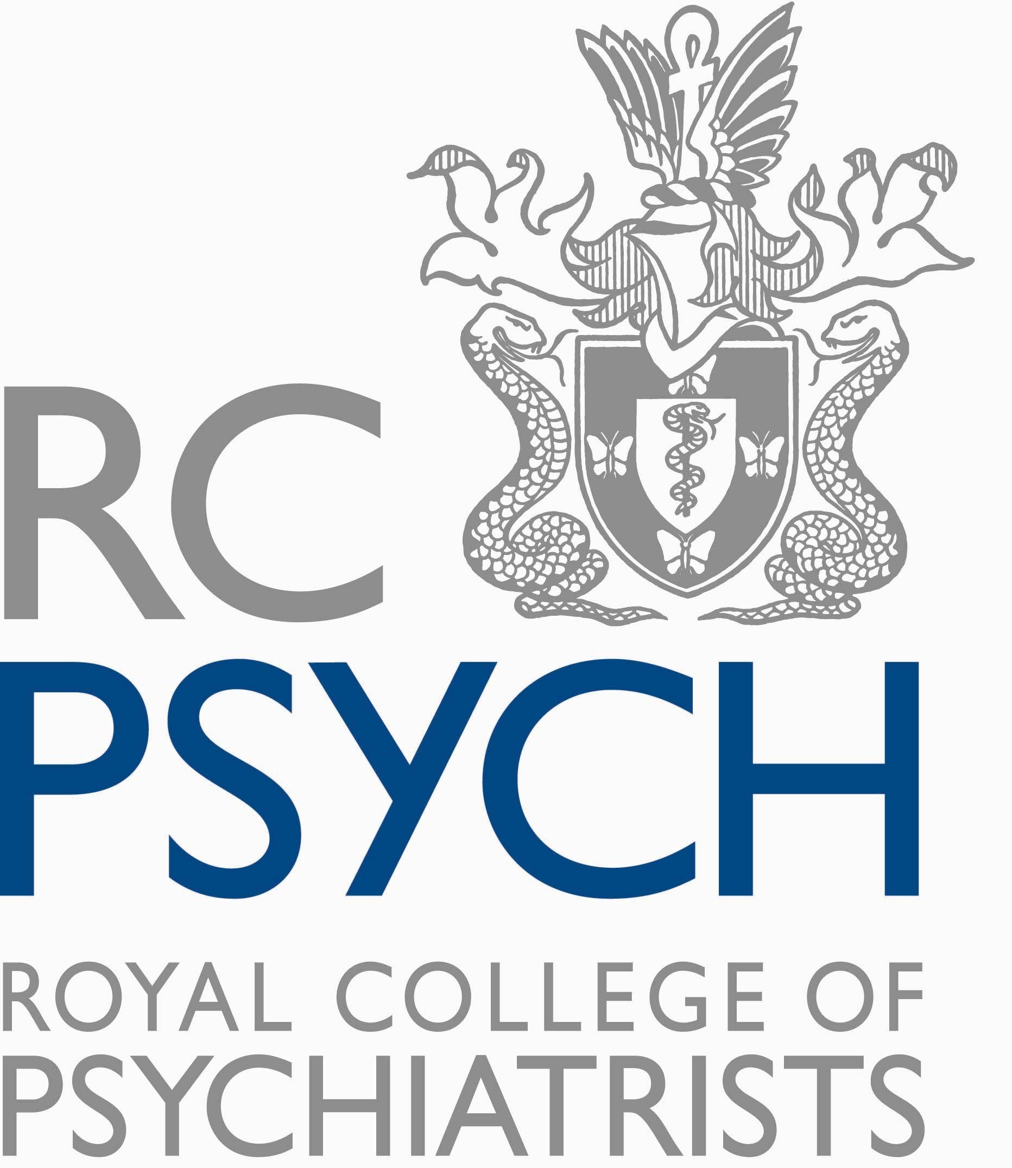
 | Time | Session
 | 9.30 | Registration and refreshments
 | 10.00 | Welcome
 | 10.05 | Chair: Dave Jolley  Val Harrington  The Golden Age of DGH Psychiatry? Withington Hospital Psychiatric Unit 1971-91  Eric Northey  Hearing Voices: making drama out of asylum archives.  Tommy Dickinson  “Curing Queers” Mental Nurses and their Patients, 1935-1974  Discussion
 | 12.45-13.30 | Lunch and archive exhibition
 | 13.30-15.15 | Chair: Val Harrington  Nicola Sugden  Donald Winnicott and the history of Child Psychiatry  Alistair Stewart  Psychiatry under the Third Reich - reflections on history  Discussion
 | 15.15-15.30 | Tea
 | 15.30-17.15 | Chair: Carsten Timmerman  Julian Simpson  Migrant doctors and mental healthcare in the NHS: Exploring the nature of ‘Dirty Work’ and the role of cultural transfer  Ross Overshott  The history of psychiatry in cinema - the good, the bad and the downright ugly  Discussion
 | 17.20 | Close

Abstracts and Biographies

Dr Val Harrington
The Golden Age of DGH Psychiatry? Withington Hospital Psychiatric Unit 1971-91
Abstract
Known as ‘The Maudsley of the North’, Withington Hospital Psychiatric Unit, which opened in 1971, had a dual role: to provide a district service to the people of South Manchester and to provide teaching facilities for doctors, nurses and social workers – including the explicit aim, articulated by Neil Kessel, Professor of Psychiatry, of training up a generation of psychiatrists to go out into the north west region and disseminate good practice. My paper will trace the origins and development of the unit, highlighting how, as a historical case study, Withington is doubly fascinating: as a window firstly onto the workings of a brand new, purpose built district unit and the emerging concept of district psychiatry; and secondly onto the education of key mental health professionals and the relationship between academia and practice. Of particular significance is the emergence of the multidisciplinary team. How these teams functioned in the context of a consultant-led, strongly medicalised service ethos will be a key focus of the paper.
Ironically, within less than twenty years of its highly lauded beginnings, Withington had become the subject of considerable external criticism. My paper will explore some of the underlying reasons for its decline, arguing that, although political and financial factors played a significant role, ultimately the problem lay within: in its internal structures and its relationships with the wider community; and, more systemically, in the tensions inherent in the DGH model − and in mental health services more generally.
The paper is based on research from my PhD (Harrington, 2008). It draws on oral history interviews with 17 informants alongside a range of documentary evidence including inspection reports, contemporaneous journal articles and a number of post-graduate theses − one of which, written three years after Withington opened has now become an invaluable historical resource (Percival, 1974).
References
V. Harrington, 'Voices Beyond the Asylum: A Post-War History of Mental Health Services in Manchester and Salford' Unpublished PhD thesis, University of Manchester, 2008.
V. Harrington, 'Between asylum and community: DGH psychiatric nurses at Withington General Hospital, 1971-91' in A. Borsay and P. Dale (eds.) Mental Health Nursing: The Working Lives of Paid Carers in the Nineteenth and Twentieth Centuries (Manchester: Manchester University Press), 2015.
C. Percival, 'The Origins and Development of a Department of Psychiatry in a Recently Established University Hospital', Unpublished MSc dissertation, University of Manchester, 1974.
Biography
After graduating in 1978 as one of the first generation of B. Nurses, Val Harrington worked in health visiting and childcare teaching until returning to the academic world in 1994. She spent nine years researching adolescent depression and deliberate self-harm in the Department of Psychiatry, University of Manchester, before moving to CHSTM (the Centre for the History of Science, Technology and Medicine) to take an MSc in the History of Science, Technology and Medicine, followed by a PhD. Her focus was on post-war mental health services in the Manchester and Salford area, writing her MSc dissertation on the run-down and closure of Prestwich Mental Hospital, and building her PhD thesis around three local case studies, each representing a site of innovation from a different time period, geographical district and service setting. Since completing her PhD Val has worked in the Personal Social Services Research Unit on a study of community mental health teams for older people and in CHSTM on the history of irritable bowel syndrome. She has now left academic life and is currently lead volunteer on a Macmillan-funded project recording life history interviews with people suffering from cancer.

Dr Eric Northey
Hearing Voices: making drama out of asylum archives
Abstract
The archival records of British asylums can sometimes be found tucked away in the bowels of county archives and local libraries. They vary in condition and range of materials but will often contain admission books, patient records, minutes of meetings, letters from relatives, invoices for goods and services, commissioners’ reports and, sometimes, hundreds of photographs of patients, with synopses of their physical and mental history, family lives, occupations, religious beliefs and accounts of whether they were discharged or died in the asylum. They are, almost without exception, the stuff of drama.
On first seeing the archives of Prestwich Asylum, I felt drawn to the photographs and life stories of people, from my city, who had lived over 100 years ago. Consider Ann Warbuton: whose notes say simply “Wound across throat inflicted by self. Tried to hang herself on Monday. Threatened her children’s lives.” Or John McGarrigal, a poor bookbinder who thought he was both ‘Jack the Ripper and Caminada’. The Caminada reference took a little research, but turned out to be Jerome Caminada, a (self) celebrated Manchester detective. How do you live with two such contrasting figures at the core of your psyche? Or Lily Handley, whose extraordinarily beautiful face gazes out at the viewer with a hopelessly wistful longing. For what? How can we know? The records say that she had a baby when she was 23 and suffered from puerperal melancholia. Whilst being interviewed she played an ‘imaginary piano’. The cause of her madness was put down as ‘disappointment in love’. (And who amongst us has not been there?) She died in the asylum twenty years later and is buried in a mass grave, alongside 5000 other ‘pauper lunatics’ in St Mary’s churchyard, Prestwich.
I felt their stories were worth the telling, hence the play ‘Telling Lives’ which was chosen for the 24:7 theatre festival in 2011 and now has had four different casts and been played in libraries, theatres, church halls, County Archives, miners’ clubs, medical schools and universities, across the North West.
I’m at present researching the Whittingham Asylum records in Preston. I suspect I’ll find many more lives that are worth the telling.
Biography
I served my time as a marine engineer in the merchant navy, but left to study English and Philosophy at Newcastle University in the 1960s, doing my doctoral work on the Scottish poet John Davidson. I then taught English and television studies in Kano, Northern Nigeria and made films for Nigerian Television. On coming back to the UK, I taught at Manchester Metropolitan University, in television, drama and communication studies to a wide range of students, ending up in Health & Social Care. Since retirement, I’ve spent much of my time writing plays and the funding bids required to put them on.
I’ve had a life-long interest in mental health and how we might learn to live more hopefully; in recent years, with some success.

Dr Tommy Dickinson
“Curing Queers” Mental Nurses and their Patients, 1935-1974
Abstract
Drawing on a rich array of source materials including previously unseen, fascinating (and often quite moving) oral histories, archival and news media sources, this paper examines the plight of men who were institutionalised in British mental hospitals to receive “treatment” for homosexuality and transvestism, and the perceptions and actions of the men and women who nursed them. It begins in 1935 with the first official report on the use of aversion therapy to combat homosexual desire and continues until 1974, when the American Psychiatric Association removed homosexuality from its diagnostic manual as a category of psychiatric disorder. It thereby covers a critical period in British queer history during which the reigning public and professional discourse surrounding homosexuality shifted from crime to sickness to tolerance. It examines why the majority of the nurses followed orders in administering the treatment—in spite of the zero success-rate in “straightening out” queer men—but also why a small number surreptitiously defied their superiors by engaging in fascinating subversive behaviours. “Curing Queers” makes a significant and substantial contribution to the history of nursing and the history of sexuality, bringing together two sub-disciplines that combine only infrequently.
Biography
Tommy graduated from Bournemouth University as a Registered Nurse in 2001. Upon graduation, he worked clinically across the UK and Australia, in a range of settings, where he took up various nursing and leadership roles.
He moved into academia in 2006 and has held lectureships at the University of Salford, the University of Central Lancashire, the University of Chester, and the University of Manchester. He is currently a Senior Lecturer in Mental Health at King’s College, London.
In 2013, Tommy established and is the Chief Executive of a theatre company called Mad 'Ed Theatre, which aims to educate the public and challenge perceptions regarding mental health. Since the company was founded they have written and produced three critically acclaimed plays.
Tommy has undertaken numerous consultancies. He was a Historical Advisor and Script Consultant to documentary drama “Britain’s Greatest Code Breaker” (2011) and the documentary “Undercover Doctor: Cure Me, I’m Gay” (2014) with Dr Christian Jessen. Both consultancies were for Channel 4. He has advised on the redevelopment of the Medical Galleries at the Science Museum, London (2013) and The Manchester Museum’s “Alan Turing and Life’s Enigma: Exhibition” (2012). He also writes for “Gay Times” magazine around issues relating to gay men’s mental health.

Nicola Sugden
Donald Winnicott and the History of Child Psychiatry: Winnicott in post-war London
Abstract
In the middle of the twentieth century - fifty years after psychoanalysis first reached the shores of Britain - central London remained the principal hub where most analysts lived, worked and socialised. The British Psychoanalytical Society was in the final throes of its ‘Controversial Discussions’ as London faced the long-term consequences of the Blitz, the war economy, and the division of families through evacuation, enlistment, and death. It was to this London that Donald Winnicott returned after his formative work with evacuees in Oxfordshire during the Second World War. This paper situates Winnicott’s private psychoanalytic consultations as well as his role at Paddington Green Children’s Hospital, and explores the nature of his work at each site during the post-war years (c.1945-1955).
Biography
Nicola Sugden is a PhD student at the Centre for the History of Science, Technology and Medicine (University of Manchester), researching the work of Donald Winnicott and the history of psychodynamic approaches in Psychiatric Services for Children and Adolescents in Britain since the Second World War. Previously she studied the History and Philosophy of Science (MSc) at University College London and Modern History and Politics (BA) at Balliol College, Oxford.

Dr Alistair Stewart
Psychiatry under the Third Reich - reflections on history
Abstract
The outline of the inhuman treatment of people with mental illness in Germany during the Third Reich has been known for a long time, although the first detailed account, written in 1948 by Alice von Platen-Hallermund, was pulped after publication. However, there is now a considerable literature, produced by German researchers like Thomas Stoeckle and his colleagues, which offers a greater understanding of how such dreadful events could happen. It is important for all mental health professionals to have an awareness of this history, because it could not have happened without at least the passive participation of large numbers of health care workers, and an ideology which identified people with mental illness as a burden for society.
The speaker will also offer some thoughts on how to get the relevant material translated into English.
Biography
Consultant in General Adult Psychiatry at the Royal Oldham Hospital since 1992. Lead consultant for over 10 years. Supervisor for higher trainees. Interests in descriptive psychopathology, epidemiology, philosophy, leadership, history. Various small articles published.

Dr Julian Simpson
Migrant doctors and mental healthcare in the NHS: Exploring the nature of ‘Dirty Work’ and the role of cultural transfer
Abstract
Migrant practitioners have played a central part in the history of the NHS since its inception. Although they have traditionally been perceived as ‘additional’ labour, helping to compensate for workforce shortages, they have in fact offered ‘special labour’ (Simpson et al, 2016), being overwhelmingly concentrated in less affluent areas and in unpopular specialties. General practice in materially deprived localities and psychiatry are two of these areas of care that have traditionally offered a career path to overseas-trained doctors. The treatment of mental illness in the UK has therefore been to a great extent delivered by doctors trained outside of the UK who can be considered to be doing ‘Dirty Work’. Little attention has so far been paid to the significance of this fact.
Building on the work of Claire L. Wendland (2010), I also draw attention to the fact that doctors are not simply vectors of the delivery of western healthcare models. Medicine is culturally and socially located and this is reflected in the training that doctors receive and the ways in which they work. Understanding how migrant doctors came to take responsibility for delivering mental healthcare, how they feel about these roles, and exploring the extent to which their training and culture is reflected in their practice is therefore key to understanding the evolution of the treatment of mental health in Britain. I will argue that oral history allied to archival research and the reuse of existing interviews can serve to answer some of these questions and in turn raise significant issues about who provides treatment for mental health in Britain (and the extent to which this matters).
References
Simpson JM, Snow SJ, Esmail A (2016) Providing “Special” types of labour and exerting agency: How migrant doctors have shaped the United Kingdom’s National Health Service in Monnais, L & Wright D Doctors Beyond Borders: The transnational migration of physicians in the twentieth century, University of Toronto Press: 208-229.
Goldacre M, Davidson J, Lambert T (2004) Country of Training and Ethnic Origin of UK Doctors: Database and Survey Studies, BMJ, 329 (7466): 597.
Wendland CL (2010) A Heart for the Work: Journeys through an African Medical School, The University of Chicago Press.
Biography
Julian M Simpson has degrees from the Institut d’Etudes Politiques de Paris and the Ecole Superieure de Journalisme de Lille, an MA in History from the University of Northumbria and a PhD from the University of Manchester awarded for his thesis on the influence of South Asian doctors on the so-called ‘renaissance’ of British general practice between the 1940s and the 1980s. This formed the basis of a book to be published shortly by Manchester University Press as Migrant Architects of the NHS: South Asian doctors and the reinvention of British general practice (1940s-1980s). He has published on the history of medical migration in journals such as the Journal of the Royal Society of Medicine, Oral History and Diversity and Equality in Health and Care and contributed a chapter to a recent University of Toronto Press volume on this topic (Doctors without Borders: The Transnational Migration of Physicians in the Twentieth Century). He is also a member of the committee of the Oral History Society.

Dr Ross Overshott
The history of psychiatry in cinema- the good, the bad and the downright ugly
Abstract
Psychiatry and cinema have had a long, tortuous and fascinating relationship. Cinema has helped shape and inform the public's views on mental illness. At times it has been a force for good, and help educate and develop empathy for people with mental illness. However, often cinema reinforces stereotypes and inaccurately depicts symptoms, disorders and psychiatrists. As public knowledge and awareness of mental illness improves, are film makers reflecting this? Or is it still the case of the good, the bad and the downright ugly when it comes to portrayals of psychiatry in the cinema?
Biography
Ross is a consultant Liaison psychiatrist in Greater Manchester West Mental Health NHS Foundation Trust and has been working in Salford since 2010. He is a former vice-chair of the North west Division of the Royal College of Psychiatrists and was member of the College's Policy Committee. He recently completed his term as president of the Psychiatry Section of the Manchester Medical Society. Ross previously co-owned a touring theatre company which won several festival awards.

Archive Exhibition
Kathryn Newman, Archivist from Lancashire County Council Archives, will be sharing facsimiles of some of the thousands of documents relating to Lancashire's Asylums which are held in the county archive. From the setting up of Lancaster Moor Hospital in 1816, to the closure of Whittingham Hospital in 1995, the records of these institutions cover some of the most significant periods in the development of psychiatric services and are an amazingly rich resource for illuminating the history of psychiatry and associated fields. Kathryn is also part of the Whittingham Lives Association which is a project designed to use the archives of Whittingham Hospital in supporting past and current service users.

A member of staff from Manchester Central Library will also be in attendance over lunchtime with a Prestwich Hospital case register.

Chairmen

Dr Dave Jolley is Honorary Reader at the Personal Social Services Research Unit, University of Manchester, and has recently retired from clinical work as a consultant old age psychiatrist.

Dr Carsten Timmerman is Senior Lecturer at the Centre for the History of Science, Technology and Medicine at the University of Manchester. His book, A History of Lung Cancer: The Recalcitrant Disease, was published in 2014.

Dr Val Harrington (see above)

