HISTORY OF PSYCHIATRY SPECIAL INTEREST GROUP

Spring Workshop

Wednesday 15th March 2017
1.20-5.20pm
Room 1.1, RCPsych, 21 Prescot St, E1 8BB
Programme
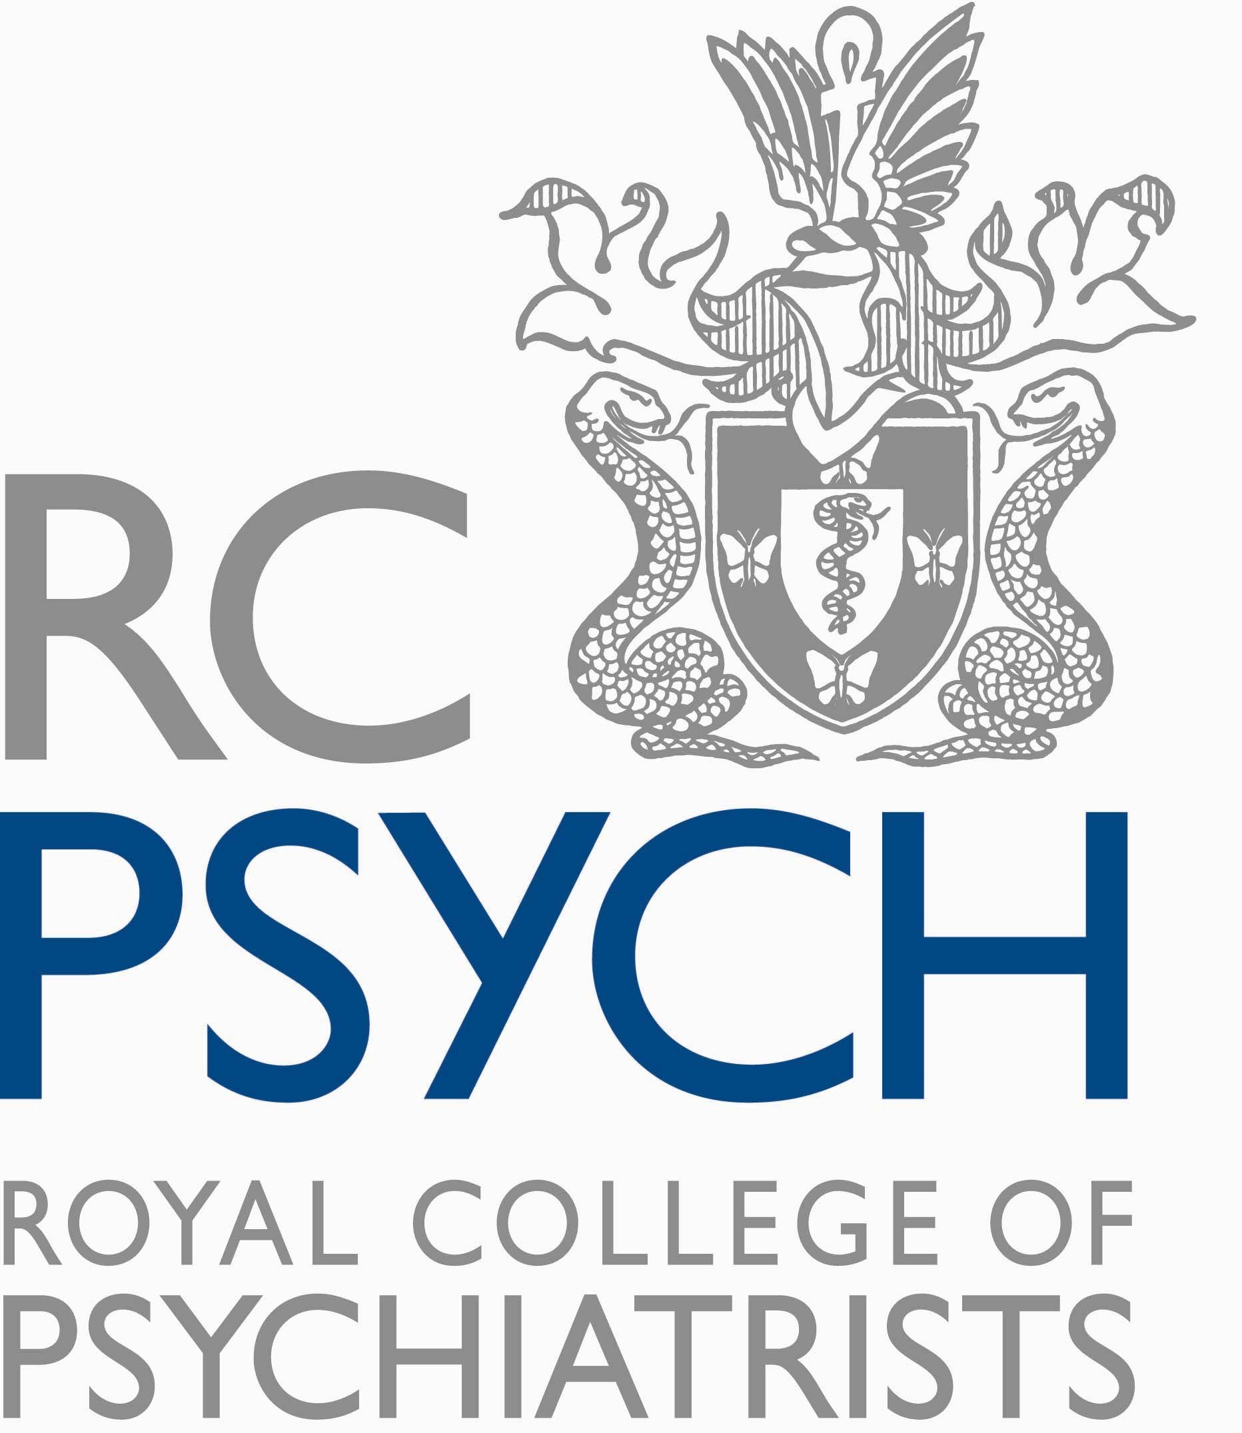
 | Time | Session
 | 13.20-13.45 | Registration and coffee
 | 13.45-13.50 | Welcome
 | 13.50-14.50 | Rhodri Hayward, Reader in History, Queen Mary, University of London (QMUL)  The Changing Shape of Psychiatry and Politics in Modern Britain  David Saunders, PhD student, QMUL School of History  La Petite Mort and the Petit Mal: Epilepsy, Sexuality, and Citizenship at the Guy’s-Maudsley Neurosurgical Unit, 1951-1968
 | 14.50-15.50 | Daniel Bell, St George’s University of London (SGUL), Medical School  From Gulags to Psychiatric Wards: How the abuse of psychiatry became a vital method of political repression in the former Soviet Union  Shashank Sivaji, SGUL, Medical School  Colonial Psychiatry in the Asia-Pacific
 | 15.50-16.10 | Tea / coffee
 | 16.10-17.10 | Sarah Chaney, QMUL School of History,  On the Borderline: Self-harm, psychosis and personality disorder, c.1950-1980  Rob Dickins, PhD student, QMUL School of History  Therapy, Hallucinogens & Literature, 1950-1965
 | 17.10-17.20 | Summing up, and ideas for future meetings

3 CPD points for the half day, subject to peer group approval

The Changing Shape of Psychiatry and Politics in Modern Britain

Rhodri Hayward
One of the most interesting, and for some dispiriting, political developments of the last decade has been the emergence of what is called ‘the happiness agenda’. Promoted by both left and right wing parties, the new programme sets out to replace the familiar economic criteria - unemployment levels, balance of trade etc. - that have traditionally been used to benchmark political interventions, with a more holistic set of measures. As Tony Blair noted in his introduction to the 1999 DEFRA white paper, A Better Quality of Life: “Money isn’t everything. But in the past governments have seemed to forget this.” Similarly David Cameron in 2006, argued that any future government should concentrate “not just what is good for putting money in people’s pockets but what is good for putting joy in people’s hearts”. And to a small extent both Labour and Tory governments have engaged in broad schemes of psychological welfare. In 1998, £540 million was invested in the Sure-Start programme - a system of coordinated early years support that was designed to increase resilience and well-being across the population. Almost ten years later, this was followed by the SEAL (social and emotional aspects of learning) programme, designed to encourage the development of psychological skills such as empathy and anger management among Britain’s primary school children - a programme which appears to be being resurrected in a government’s call this month (March 2017) for a series of trials of school based mental health interventions.
This talk will provide a short and rather compressed outline of how the language and practices of psychological medicine have worked to reshape the British political imagination across the nineteenth and twentieth century. It will look at the way the hereditarian approach of late nineteenth century psychiatry with its attendant eugenicist agenda was replaced by a psychosocial understanding which transformed the basis of industrial negotiation, opened up a new vision of urban planning and provided the philosophical framework that underwrote the emergence of the welfare state.
John Lorimer Halliday. Psychosocial Medicine: A Study of the Sick Society. William Heinemann Medical Books, 1949.
Mark Jackson, The Age of Stress: Science and the Search for Stability. Oxford University Press, 2013.

Biography
Rhodri is Reader in History at the Centre for the History of the Emotions at Queen Mary University of London. His work has largely focused on the way that new sciences, such as psychiatry and neurobiology, have reshaped the popular understanding of selfhood in modern Britain. He has published on the history of emotions, neuropsychiatry, prophecy, dreams, demonology, electrophysiology and cybernetics. His two recent books are Psychiatry in Modern Britain (London: Bloomsbury Continuum, 2013) and The Transformation of the Psyche in British Primary Care (London: Bloomsbury, 2014). Currently, funded by the Wellcome Trust, he is examining the long history of the happiness agenda and governmental attempts to secure the emotional wellbeing of the population.

La Petite Mort and the Petit Mal: Epilepsy, sexuality, and citizenship at the Guy’s-Maudsley Neurosurgical Unit, 1951-1968
David Saunders
Abstract
Between receiving its first patient in 1951 and its two-hundredth in 1968, the Guy’s-Maudsley Neurosurgical Unit established itself as a world-leading centre for the neurosurgical treatment of temporal lobe epilepsy. Led by neurosurgeon Dr Murray Falconer and psychiatrist Professor Denis Hill, the Unit offered patients with intractable and drug-resistant conditions a dramatic surgical intervention: the en bloc removal of the anterior temporal lobe. In examining this landmark – although relatively overlooked – chapter in the history of epileptology, this paper has two core objectives. Firstly, it will focus on the overlapping purposes of the seizure surgery programme, at once a therapeutic regime to reduce seizure frequency, an experimental project to produce knowledge about the physical structures of the brain and their relation to personality, emotion, and subjectivity, and a social mission to identify and eliminate “deviant” and potentially dangerous behaviours. Secondly, the paper will examine the motivations of patients in agreeing to undergo these new, experimental surgeries. Far from occupying passive roles as either the grateful recipients of pioneering medical progress or the unwitting subjects of unrestrained surgical ambition, these individuals went under the knife for a variety of reasons: to appease frustrated parents and spouses, to protect jobs and livelihoods, and to rid themselves of the embarrassment and stigma of being “epileptic”. For many patients, these motivations were underpinned by a desire for normality and social inclusion, with surgery perceived as a necessary corrective to regain the benefits and protections of a citizenship otherwise denied to them. To unpick these complex themes, this paper will particularly focus on the role of sexuality in the Guy’s-Maudsley neurosurgical programme. Sexuality became a foundation part of the Unit’s mission and a key indicator of the relative success or failure of their interventions. As such, the sex lives of temporal lobe epilepsy patients were subject to intense scrutiny, with data obsessively collected on the frequency, satisfaction, and intimate dynamics of their sexual behaviours. While a fixation on the sexual dimensions of epilepsy was not a new development in this period – being present in medical works from Hippocrates to Freud – the Unit’s interrogation of sexuality reveals distinctive strands of post-war medical curiosity and moral anxiety.
References
William Mitchell, Murray A. Falconer, and Denis Hill, “Epilepsy with Fetishism Relieved by Temporal Lobectomy,” Lancet 264/6839 (1954): 626-630.
Peter F. Bladin, “Murray Alexander Falconer and the Guy’s-Maudsley Hospital Seizure Surgery Program,” Journal of Clinical Neuroscience 11/6 (2004): 577-583.
Rachel Elder, “Speaking Secrets: Epilepsy, Neurosurgery, and Patient Testimony in the Age of the Explorable Brain, 1934-1960,” Bulletin for the History of Medicine 89/4 (2015): 761-789.
Biography
David Saunders is a first-year PhD student at the Centre for the History of the Emotions, Queen Mary University of London. His research focuses on human experimentation, medical research, and citizenship in twentieth-century Britain, and is supported by a doctoral studentship from the Wellcome Trust.

From Gulags to Psychiatric Wards: How the abuse of psychiatry became a vital method of political repression in the former Soviet Union
Darren Bell
Abstract
The Communist Party of the Soviet Union needed to develop new ways to control the people following the death of Stalin and its claims that the gulag forced-labour camp system had ended. Attempts to discredit ideological dissenters and remove them from society with the abuse of psychiatry appears to have become one of the most important methods of political repression.
A brief history of Soviet psychiatry describes its transformation since the Bolshevik Revolution of 1917 until the late 1970s and early 1980s, when the practice of political abuse of psychiatry for repression appears to have been most prevalent. The profession and its leading institutions appear to have changed from relatively benevolent organisations, who would institutionalise people to save them from harsher punishments in the gulags, to a profession that would work with the Communist Party and the KGB to ensure political dissent was silenced.
The main factors which provided the conditions for political psychiatry to become a method of repression in the Soviet Union are discussed. Unarguably, the dominant factor was the environment of totalitarianism that existed, and the desire of those in power to remove ‘hostile elements’ from society. Some argue that the nature of psychiatry is such that its potential for improper use is greater than any other field of medicine; other political scientists surmise that collectivist regimes, such as socialism and communism, allow the regime to systematically place the importance of the society over the rights of individuals. Also important was the compliance of psychiatrists working in the Soviet Union, either through greed and ambition, or through ignorance and fear.
Biography
I am a final year undergraduate medical student at St. George’s. I transferred after my preclinical medicine degree at Cambridge, where I had the opportunity to intercalate in psychology. I have always had a particular interest in psychiatry and I wish to train and practise as a psychiatrist once I qualify; indeed, that was the initial reason I decided to study medicine.
I chose to undertake a student-selected component (SSC) in the history of psychiatry as it gave me the opportunity to combine my interests in psychiatry and history. During a particularly busy final year, I found it hugely rewarding and beneficial to choose a topic which interested me, but which was not something that I would otherwise have had the chance to study as part of the course. Lectures and seminars gave me opportunities to broaden my knowledge and interest in the history of psychiatry through learning and debate.
For the written part of my SSC, I decided to focus on psychiatry within the Soviet Union; I had previously studied political repression in the Soviet Union at school, and this SSC gave me the opportunity to delve deeper into the reasons why the profession was so liable to corruption. Rather than simply reading individual opinions, I could study historical books and find genuine commentary from people who experienced these abuses, both within the Soviet Union and those looking on from outside.
References
Bloch S and Reddaway P. Russia's Political Hospitals: The Abuse of Psychiatry in the Soviet Union. Victor Gollancz Ltd, 1977.

Tomov T, Van Voren R, Keukens R and Puras D. Mental health policy in former eastern bloc countries, 397-425. In: Mental health policy and practice across Europe: the future direction of mental health care. Eds. Knapp M, McDaid D, Mossialos E and Thornicroft G. McGraw-Hill International, 2007.

Van Voren, R. Psychiatry as a tool for coercion in post-Soviet countries. European Parliament, 2013.

Colonial Psychiatry in the Asia-Pacific
Shashank Sivaji
Abstract
Though “Empire” as a concept and method of statecraft dates back thousands of years to the earliest days of civilisation, much of the modern world has its roots in the more recent colonial era and the heyday of western colonial expansion in the 19th and early 20th centuries. Given that modern psychiatry’s origins focus heavily on the 19th and 20th centuries, and considering that mental illness is an affliction that is universal to humanity, it is natural to raise the question as to the link between psychiatry and empire.
The examples of the Philippines and Indonesia illustrate the topic. Some similarity in the two countries’ colonial psychiatric experience can be noted, particularly regarding the application of the imperial powers “colonial lens” to classify local and native behaviours in terms of pathology and for the formal institutions of psychiatry to have origins as colonial impositions introduced by outsiders. On the other hand, while both countries are island nations in the Asia-Pacific previously ruled by distant powers, they experienced very different colonial contexts prior to attaining independence. These differences extended to psychiatry, with psychiatry’s role in the “colonial project” and its relation to local colonial power structures and independence movements, varying dramatically between the territories.
Examining this area allows not only for reflection on psychiatry’s colonial past but also allows for psychiatry to contribute to the broader historical narrative in ways not previously well explored. As with much else in society, psychiatry can be said to have “rode the coattails” of imperial conquest.
Suggested Reading
John Darwin, After Tamerlane: the global history of empire since 1405. Allen Lane, 2007. ISBN 9780713996678
Sloan Mahone, Megan Vaughan, Psychiatry and Empire. Palgrave Macmillan, 2007. ISBN 9780230593244
Biography
I am a final year medical student at St George’s University of London. I have long held an interest in psychiatry, stemming from early research experience in the field during an intercalated BSc year. I also have a longstanding interest in history and geopolitics, and within broader historical reading, imperial and colonial history. The ‘student selected component’ module offered me the opportunity to pursue a project that merged my interests, and to learn more about the field in which I aim to specialise.

On the Borderline: Self-harm, psychosis and personality disorder c.1950-1980
Sarah Chaney
Abstract
In 1967, eighteen-year-old Susanna Kaysen was admitted to McLean psychiatric hospital for eighteen months. Twenty-five years later, when she came to write her memoir Girl, Interrupted, Kaysen made a legal request for her case files and discovered she had been diagnosed with ‘borderline personality’. When the author looked up the diagnosis in the DSM-IIIR, she was particularly struck by the description of ‘self-mutilating behavior (e.g., wrist-scratching)’ and re-interpreted her own past actions in this light. Kaysen also assumed that the 1987 description of ‘borderline personality disorder’ (BPD) was directly equivalent to the ‘borderline personality’ she had been diagnosed with in 1967. This could not be further from the truth.
In this paper, I explore the transformation of the borderline between 1950 and 1980, with a particular focus on the symptom which, for many authors, came to define BPD: self-injurious behaviour. As Elizabeth Lunbeck has recognised, the ‘borderline’ shifted considerably in the post-war period, with the typical patient ‘transformed from a severely disturbed near-schizophrenic to a rather milder and far more common type and, in the hands of many, from a stock male to a paradigmatically female figure’. For some practitioners at least, this move was part of a conscious effort to shift diagnostic boundaries in an era of increasingly biomedical psychiatry, reducing the number of patients diagnosed with psychosis. The shift was also associated with North American literature on so-called ‘delicate self-cutting’ which, from the late 1960s on, had developed a heavily gendered stereotype of self-harm.
Drawing on examples from North America and the UK, including Susanna Kaysen, Joanne Greenberg and William Kurelek, this paper provides a contextual analysis of changing views of self-harm in the post war period. Just as self-harm became a symptom of borderline personality disorder, I conclude, so too did the borderline shift. Self-injurious behaviour moved from being seen as a psychotic symptom that was evidence of the severity of a near-psychotic condition, to a ‘nearly normal’ but attention-seeking response to the pressures of modern life.
References
Sarah Chaney, Psyche on the Skin: A History of Self-harm (London: Reaktion, 2017)
Barbara J Brickman, “‘Delicate’ Cutters: Gendered Self-Mutilation and Attractive Flesh in Medical Discourse,” Body & Society 10, no. 4 (2004): 87–111.
Susanna Kaysen, Girl, Interrupted (New York: Random House, 1993)
Elizabeth Lunbeck, “Borderline Histories: Psychoanalysis Inside and Out,” Science in Context 19, no. 1 (2006)
Chris Millard, “Making the Cut: The Production of ‘Self-Harm’ in Post-1945 Anglo-Saxon Psychiatry,” History of the Human Sciences 26, no. 2 (2013)
Biography
Sarah Chaney is a research project manager at the Queen Mary Centre for the History of Emotions, on the project ‘Living with Feeling: Emotional Health in History, Philosophy, and Experience’. My research to date has focused on self-inflicted injury, and my monograph 'Psyche on the Skin’ was published in February 2017. This expands on my PhD thesis to explore several models of self-inflicted injury proposed in the twentieth century.

Therapy, Hallucinogens and Literature 1950-1965
Rob Dickins
Abstract
This paper focuses on three approaches to hallucinogens that were utilised by psychiatrists and psychologists during the 1950s and 1960s; namely, the psychotomimetic, psycholytic and psychedelic. A number of researchers included writers as subjects in their work which led to the publication of several books detailing their experiences. A mutually effective dialogue was created between literary and psychiatric disciplines which led to novel approaches in the form and content of the literature, and simultaneously in the therapeutic methods and goals of the psychiatrists.
Biography
Rob is a PhD student in the Centre for the History of the Emotions at QMUL. His thesis title is: New spiritualities and domestic life c.1855-1939.

